SHOORTHY ENGINEERING COLLEGE

DEVOPS COURSE FILE


Department of Cyber Security

(2025 - 2026)

Faculty In-Charge HOD (CS)

Mr.J.Naresh Kumar Mrs.P.Sandhya Rani

COURSE FILE
SUBJECT | DEVOPS
ACADEMIC YEAR | 2025-2026
REGULATION | SR23

NAME OF THE FACULTY | J. NARESH KUMAR
DEPARTMENT | CYBER SECURITY
YEAR & SECTION | III & CS–A & CS-B
SUBJECT CODE | S23CY633PE

INDEX
COURSEFILE
S.NO | TOPIC | PAGE NO
1. | PEO’S, PO’S, PSO’S | 4
2 | Syllabus Copy | 6
3 | Class Time tables Individual Time table | 8
4 | Student Roll List | 10
5 | Lesson Plan | 13
6 | Unit Wise Lecture Notes  - Notes of Units  - Assignment Questions  - Short and long answer question with Blooms Taxonomy  - Beyond the syllabus topics and notes  - Objective Questions  - PPT’S / NPTEL VIDEOS / any other | 18
7 | Student Seminar Topics
8 | Previous University Question Papers to practice
9 | Sample Internal Examination Question papers with key | 191
10 | Course Attendance Register

PEO’S, PO’S, PSO’S

PROGRAM EDUCATIONAL OBJECTIVES:

PEO1: The graduates of the program will understand the concepts and principles of Computer Science and Engineering inclusive of basic sciences.

PEO2: The program enables the learners to provide the technical skills necessary to design and implement computer systems and applications, to conduct open-ended problem solving, and apply critical thinking.

PEO3: The graduates of the program will practice the profession with work effectively on teams to communicate in written and oral form, ethics, integrity, leadership and social responsibility through safe engineering leading them to contribute their might for the good of the human race.

PEO4: The program encourages the students to become lifelong activity and as a means to the creative discovery, development, and implementation of technology as well as to keep up with the dynamic nature of the Computer Science and Engineering discipline.

PROGRAM OUTCOMES

Engineering knowledge: Apply the knowledge of mathematics, science, engineering fundamentals, and an engineering specialization to the solution of complex engineering problems.

Problem analysis: Identify, formulate, review research literature, and analyze complex engineering problems reaching substantiated conclusions using first principles of mathematics, natural sciences, and engineering sciences.

Design/development of solutions: Design solutions for complex engineering problems and design system components or processes that meet the specified needs with appropriate consideration for the public health and safety, and the cultural, societal, and environmental considerations.

Conduct investigations of complex problems: Use research-based knowledge and research methods including design of experiments, analysis and interpretation of data, and synthesis of the information to provide valid conclusions.
Modern tool usage: Create, select, and apply appropriate techniques, resources, and Modern engineering and IT tools including prediction and modeling to complex engineering activities with an understanding of the limitations.

The engineer and society: Apply reasoning informed by the contextual knowledge to assess societal, health, safety, legal and cultural issues and the consequent responsibilities relevant to the professional

engineering practice.
Environment and sustainability: Understand the impact of the professional engineering solutions in societal and environmental contexts, and demonstrate the knowledge of, and need for sustainable development.
Ethics: Apply ethical principles and commit to professional ethics and responsibilities and norms of the engineering practice.
Individual and team work: Function effectively as an individual, and as a member or leader in diverse teams, and in multidisciplinary settings.
Communication: Communicate effectively on complex engineering activities with the engineering community and with society at large, such as, being able to comprehend and write effective reports and design documentation, make effective presentations, and give and receive clear instructions.
Project management and finance: Demonstrate knowledge and understanding of the engineering and management principles and apply these to one’s own work, as a member and leader in a team, to manage projects and in multidisciplinary environments.
Life-long learning: Recognize the need for, and have the preparation and ability to engageinindependentandlife-longlearninginthebroadestcontextoftechnological change.

ROGRAM SPECIFIC OUTCOMES:
PSO1: Design and development of software applications by using data mining techniques.
PSO2: Enrichment of graduates with global certifications to produce reliable software solutions.



VISION
To be a premier Institution of Excellence in Technical Education driven by human values.

MISSION
M1. To impart cutting-edge technologies on par with industry standards.

M2. To provide state of art infrastructure to create an ecosystem for nurturing research consultancy and Entrepreneurship.

M3. Inculcate professional behavior, ethical values to promote social responsibility through teaching – learning process and collaboration.

Course Objectives:
The main objectives of this course are to:

- Develop a sustainable infrastructure for applications and ensure high scalability.
- DevOps aims to shorten the software development lifecycle to provide continuous delivery with high-quality.

Course Outcomes:
On successful completion of this course, students will be able to:

- Understand the need of DevOps tools.
- Understand the environment for a software application development.
- Apply different project management, integration and development tools.
- Use Selenium tool for automated testing of application.

Syllabus

UNIT-I
Introduction:
Introduction, Agile development model, DevOps, and ITIL. DevOps process and Continuous Delivery, Release management, Scrum, Kanban, delivery pipeline, bottlenecks, examples.

UNIT-II
Software development models and DevOps:
DevOps Lifecycle for Business Agility, DevOps, and Continuous Testing. DevOps influence on Architecture: Introducing software architecture, The monolithic scenario, Architecture rules of thumb, The separation of concerns, Handling database migrations, Microservices, and the data tier, DevOps, architecture, and resilience.

UNIT–III
Introduction to project management: The need for source code control, The history of source code management, Roles and code, source code management system and migrations, Shared authentication, Hosted Git servers, Different Git server implementations, Docker intermission, Gerrit, The pull request model, GitLab.

UNIT-IV
Integrating the system:
Build systems, Jenkins build server, Managing build dependencies, Jenkins plugins, and file system layout, The host server, Build slaves, Software on the host, Triggers, Job chaining and
Build pipelines, Build servers and infrastructure as code, Building by dependency order, Build phases, Alternative build servers, Collating quality measures.

UNIT-V
Testing Tools and automation: Various types of testing, Automation of testing Pros and cons, Selenium - Introduction, Selenium features, JavaScript testing, Testing backend integration points, Test-driven development, REPL-driven development Deployment of the system: Deployment systems, Virtualization stacks, code execution at the client, Puppet master and agents, Ansible, Deployment tools: Chef, Salt Stack and Docker.

Lesson Plan

PROGRAM: B.TECH (CS) | DEGREE: UG | YEAR & SEM: III YEAR & II-SEM | A.Y: 2025-26
COURSE: DevOps |  | FACULTY NAME: J NARESH KUMAR

S.NO | Toppic to be Covered | Required Classes | Cumulative Classes | Date of Completi  on | Text Book | Teaching Aid
1 | UNIT-I: Introduction to DevOps | 1 | 1 |  | TB1 | Chalk & Talk
2 | Agile development model | 1 | 2 |  | TB1 | Chalk & Talk
3 | DevOps, and ITIL | 1 | 3 |  | TB1 | Chalk & Talk
4 | DevOps process and Continuous Delivery | 1 | 4 |  | TB1 | Chalk & Talk
5 | DevOps process and Continuous Delivery | 1 | 5 |  | TB1 | Chalk & Talk
6 | Release management | 1 | 6 |  | TB1 | Chalk & Talk
7 | Scrum, Kanban | 1 | 7 |  | TB1 | Chalk & Talk
8 | Scrum, Kanban | 1 | 8 |  | TB1 | Chalk & Talk
9 | delivery pipeline | 1 | 9 |  | TB1 | Chalk & Talk
10 | bottlenecks, examples. | 1 | 10 |  | TB1 | Chalk & Talk
11 | UNIT-II: DevOps Lifecycle for Business Agility | 1 | 11 |  | TB1 | Chalk & Talk
12 | DevOps, and Continuous Testing | 1 | 12 |  | TB1 | Chalk & Talk
13 | DevOps influence on Architecture | 1 | 13 |  | TB1 | Chalk & Talk
14 | Introducing software architecture | 1 | 14 |  | TB1 | Chalk & Talk
15 | The monolithic scenario | 1 | 15 |  | TB1 | Chalk & Talk
16 | Architecture rules of thumb | 1 | 16 |  | TB1 | Chalk & Talk
17 | The separation of concerns | 1 | 17 |  | TB1 | Chalk & Talk
18 | Handling database migrations | 1 | 18 |  | TB1 | Chalk & Talk
19 | Microservices, and the data tier | 1 | 19 |  | TB1 | Chalk & Talk
20 | DevOps, architecture, and resilience | 1 | 20 |  | TB1 | Chalk & Talk
21 | UNIT-III: The need for source code control | 1 | 21 |  | TB1 | Chalk & Talk
22 | The history of source code management 1 |  | 22 |  | TB1 | Chalk & Talk
23 | Roles and code, source code management  system and migrations | 1 | 23 |  | TB1 | Chalk & Talk
24 | Shared authentication | 1 | 24 |  | TB1 | Chalk & Talk
25 | Hosted Git servers | 1 | 25 |  | TB1 | Chalk & Talk
26 | Different Git server implementations | 1 | 26 |  | TB1 | Chalk & Talk
27 | Docker intermission | 1 | 27 |  | TB1 | Chalk & Talk

28 | Gerrit, The pull request model, GitLab | 2 | 28 |  | TB1 | Chalk & Talk
29 | Gerrit, The pull request model, GitLab | 1 | 29 |  | TB1 | Chalk & Talk
30 | UNIT-IV: Integrating the system: Build systems | 1 | 30 |  | TB1 | Chalk & Talk
31 | Jenkins build server | 1 | 31 |  | TB1 | Chalk & Talk
32 | Managing build dependencies | 1 | 32 |  | TB1 | Chalk & Talk
33 | Jenkins plugins and file system layout, | 1 | 33 |  | TB1 | Chalk & Talk
34 | The host server, Build slaves | 1 | 34 |  | TB1 | Chalk & Talk
35 | Software on the host, Triggers | 1 | 35 |  | TB1 | Chalk & Talk
36 | Job chaining and Build pipelines | 1 | 36 |  | TB2 | Chalk & Talk
37 | Build servers and infrastructure as code | 1 | 37 |  | TB2 | Chalk & Talk
38 | Building by dependency order | 1 | 38 |  | TB2 | Chalk & Talk
39 | Build phases | 1 | 39 |  | TB2 | Chalk & Talk
40 | Alternative build servers 1 |  | 40 |  | TB1 | Chalk & Talk
41 | Collating quality measures | 1 | 41 |  | TB2 | Chalk & Talk
42 | UNIT-V: Testing Tools and automation | 1 | 42 |  | TB2 | Chalk & Talk
43 | Various types of testing | 1 | 43 |  | TB2 | Chalk & Talk
44 | Automation of testing Pros and cons | 1 | 44 |  | TB2 | Chalk & Talk
45 | Selenium - Introduction, Selenium features | 1 | 45 |  | TB1 | Chalk & Talk
46 | JavaScript testing | 2 | 46 |  | TB2 | Chalk & Talk
47 | Testing backend integration points | 1 | 47 |  | TB1 | Chalk & Talk
48 | Test-driven development | 1 | 48 |  | TB2 | Chalk & Talk
49 | REPL-driven development Deployment of the  system | 1 | 49 |  | TB2 | Chalk & Talk
50 | Deployment systems, Virtualization stacks 1 |  | 50 |  | TB2 | Chalk & Talk
51 | code execution at the client | 1 | 51 |  | TB2 | Chalk & Talk
52 | Puppet master and agents | 1 | 52 |  | TB2 | Chalk & Talk
53 | Ansible, Deployment tools: | 1 | 53 |  | TB2 | Chalk & Talk
54 | Chef, Salt Stack and Docker | 1 | 54 |  | TB2 | Chalk & Talk

Lecture Notes

Unit 1

Introduction

History

Software Development Life Cycle (SDLC)

A software life cycle model (also termed process model) is a pictorial and diagrammatic representation of the software life cycle.A life cycle model represents all the methods requiredto make a software product transit through its life cycle stages. It also captures the structure in which these methods are to be undertaken.
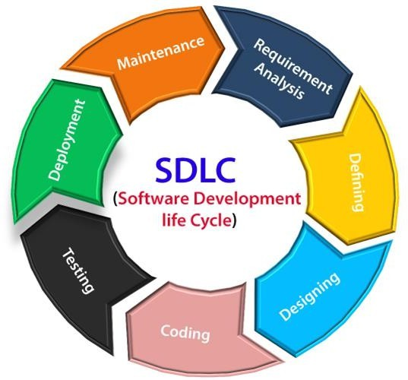

Stage1: Planning and requirement analysis

Requirement Analysis is the most important and necessary stage in SDLC.

The senior members of the team perform it with inputs from all the stakeholders and domain experts or SMEs in the industry.

Planning for the quality assurance requirements and identifications of the risks associated with the projects is also done at this stage.

Business analyst and Project organizer set up a meeting with the client to gather all the data like what the customer wants to build, who will be the end user, what is the objective ofthe product. Before creating a product, a core understanding or knowledge of the product is very necessary.

For Example, A client wants to have an application which concerns money transactions. In this method, the requirement has to be precise like what kind of operations will be done, how it will be done, in which currency it will be done, etc.

Once the required function is done, an analysis is complete with auditing the feasibility of the growthof a product. In case of anyambiguity, a signal is set up for further discussion.

Once the requirement is understood, the SRS (SoftwareRequirement Specification) document is created. The developers should thoroughly follow this document and also should be reviewed by the customer for future reference.

Stage2: DefiningRequirements

Once the requirement analysis is done, the next stage is to certainly represent and document the software requirements and get them accepted from the project stakeholders.

This is accomplished through "SRS"- Software Requirement Specification document which contains all the product requirements to be constructed and developed during the project life cycle.

Stage3:Designing the Software

The next phase isaboutto bring downallthe knowledge ofrequirements, analysis, and designof the software project. This phase is the product ofthe last two, like inputs fromthe customer and requirement gathering.

Stage4: Developing theproject

In this phase of SDLC, the actual development begins, and the programming is built. The implementation ofdesign begins concerning writing code. Developers have to follow the coding guidelines described by their management and programming tools like compilers, interpreters, debuggers, etc. are used to develop and implement the code.

Stage5:Testing

After the code is generated, it is tested against the requirements to make sure that the productsare solving the needs addressed and gathered during the requirements stage.

Duringthisstage, unittesting,integrationtesting,systemtesting,acceptancetestingaredone.

Stage6:Deployment

Oncethesoftwareiscertified, andnobugsorerrorsarestated,thenitisdeployed.

Then based on the assessment, the software may be released as it is or with suggested enhancement in the object segment.
Afterthesoftwareisdeployed,thenitsmaintenancebegins.

Stage7:Maintenance

Once when the client starts using the developed systems, then the real issues come up and requirements to be solved from time to time.

Thisprocedurewherethecareistaken forthedeveloped productisknownasmaintenance.

Waterfallmodel

Winston Royce introduced the Waterfall Model in 1970.This model has five phases: Requirements analysis and specification, design, implementation, and unit testing, integrationand systemtesting, and operationand maintenance. The steps always follow in this order and do not overlap. The developer must complete everyphase before the next phase begins. This model is named "Waterfall Model", because its diagrammatic representation resembles a cascade of waterfalls.

- Requirements analysis and specification phase: The aim of this phase is to understand the exact requirements of the customer and to document them properly. Both the customer and the software developer work together so as to document all the functions, performance, and interfacing requirement ofthe software. It describes the "what" ofthe systemto be produced and not"how."Inthisphase,alargedocumentcalled SoftwareRequirementSpecification (SRS)document is created which contained a detailed description of what the system will do in the common language.

- Design Phase:This phase aims to transform the requirements gathered in the SRS into a suitable form which permits further coding in a programming language. It defines the overall software architecture together with high level and detailed design. All this work is documentedas a Software Design Document (SDD).

- Implementation and unit testing: During this phase, design is implemented. If the SDD is complete, the implementation or coding phase proceeds smoothly, because all the information needed by software developers is contained in the SDD.

During testing, the code is thoroughly examined and modified. Small modules are tested in isolation initially. After that these modules are tested by writing some overhead code to checkthe interaction between these modules and the flow of intermediate output.

- Integration and System Testing: This phase is highly crucial as the quality of the end product is determined by the effectiveness of the testing carried out. The better output will leadto satisfied customers, lower maintenance costs, and accurate results. Unit testing determinesthe efficiency of individual modules. However, in this phase, the modules are tested for their interactions with each other and with the system.
- Operation and maintenance phase: Maintenance is the task performed by every user once the software has been delivered to the customer, installed, and operational.
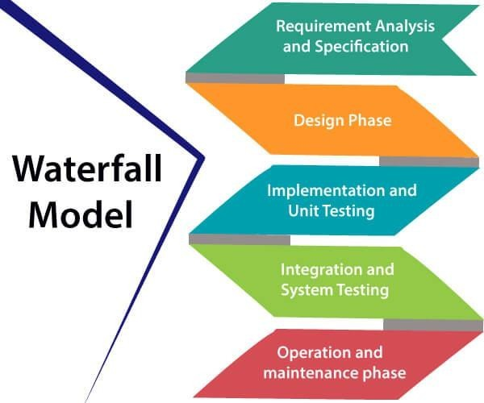

AdvantagesofWaterfallmodel
  - Thismodelissimpletoimplementalsothenumberofresourcesthatarerequiredforitis minimal.
  - Therequirementsaresimpleandexplicitlydeclared;theyremainunchangedduringtheentire project development.
  - Thestartandendpointsforeachphaseisfixed, whichmakesiteasytocoverprogress.
  - Thereleasedateforthecompleteproduct,aswellasitsfinalcost,canbedeterminedbefore development.

  - Itgiveseasytocontrolandclarityforthecustomerduetoastrictreportingsystem.

DisadvantagesofWaterfallmodel
  - Inthismodel,theriskfactorishigher,sothismodelisnotsuitableformoresignificantand complex projects.
  - Thismodelcannotacceptthechangesinrequirementsduringdevelopment.
  - It becomes tough to go back to the phase. For example, if the application has now shifted to thecoding phase, and there is a change in requirement, It becomes tough to go back and change it.
  - Sincethetestingdoneat a later stage, it does not allow identifyingthechallenges andrisks inthe earlier phase, so the risk reduction strategy is difficult to prepare.

Introduction

TheDevOpsisthecombinationoftwo words,one is Development andother isOperations.It is a culture to promote the development and operation process collectively.

The DevOps tutorial will help you to learn DevOps basics and provide depth knowledge of variousDevOpstoolssuchas Git,Ansible,Docker,Puppet,Jenkins,Chef,Nagios, and Kubernetes.

WhatisDevOps?

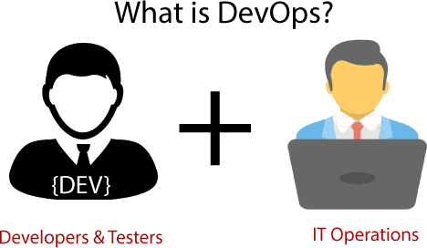

WhyDevOps?

Beforegoingfurther,weneedtounderstandwhyweneed theDevOpsover theothermethods.

  - Theoperationanddevelopment teamworkedincomplete isolation.
  - Afterthedesign-build,thetestinganddeployment areperformedrespectively.That'swhy they consumed more time than actual build cycles.
  - Without the use of DevOps,the teammembers are spending alargeamountof time on designing, testing, and deploying instead of building the project.
  - Manualcodedeploymentleadsto humanerrorsinproduction.
  - Coding and operation teams have their separate timelines and are notin synch, causingfurther delays.

DevOpsHistory

  - In 2009, the first conference named DevOpsdayswas held in Ghent Belgium. Belgian consultant and Patrick Debois founded the conference.
  - In 2012, the state of DevOps report was launched and conceived by Alanna Brown at Puppet.
  - In 2014, the annual State of DevOps report was published by Nicole Forsgren, Jez Humble, Gene Kim, and others. They found DevOps adoption was accelerating in 2014 also.
  - In 2015, Nicole Forsgren, Gene Kim, and Jez Humble founded DORA (DevOpsResearch and Assignment).
  - In 2017, Nicole Forsgren, Gene Kim, and Jez Humble published "Accelerate: Building and Scaling High Performing Technology Organizations".

Agiledevelopment

An agile methodology is an iterative approach to software development. Each iteration of agile methodology takes a short time interval of 1 to 4 weeks. The agile development process is aligned to deliver the changing business requirement. It distributes the software with faster and fewer changes.

The single-phase software development takes 6 to 18 months. In single-phase development, all the requirement gathering and risks management factors are predicted initially.

The agile software development process frequently takes the feedback ofworkable product. The workable product is delivered within 1 to 4 weeks of iteration.

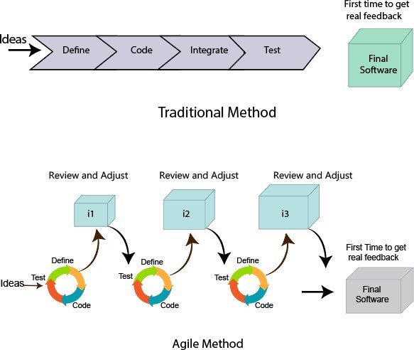

ITIL

ITILisanabbreviationofInformationTechnologyInfrastructure Library.

It is a framework which helps the IT professionals for delivering the best services of IT. This framework is a set of best practices to create and improve the process of ITSM (IT Service Management). It provides a framework within an organization, which helps in planning, measuring, and implementing the services of IT.

The main motive of this framework is that the resources are used in such a way so that the customer get the better services and business get the profit.

Itis notastandardbutacollectionofbestpracticesguidelines.

ServiceLifecycleinITIL
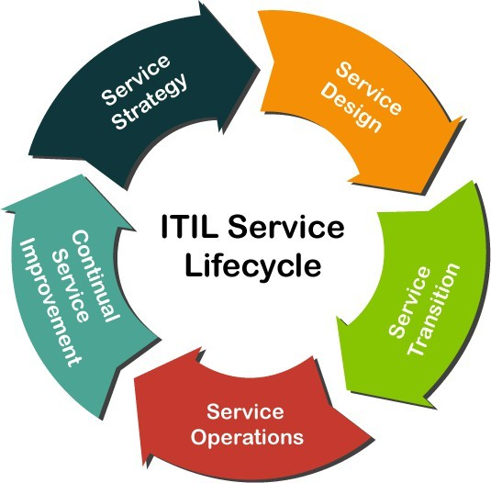

- ServiceStrategy.
- ServiceDesign.
- ServiceTransition.
- ServiceOperation.
- ContinualService Improvement.

ServiceStrategy

Service Strategy is the first and initial stage in the lifecycle of the ITIL framework. The main aim of this stage is that it offers a strategy on the basis of the current market scenario and business perspective for the services of IT.
This stage mainly defines the plans, position, patters, and perspective which are required for a service provider. It establishes the principles and policies which guide the whole lifecycle of IT service.

Following are the various essential services or processes which comes under the Service Strategy stage:

  - FinancialManagement
  - DemandManagement
  - ServicePortfolioManagement
  - BusinessRelationshipManagement
  - StrategyManagement

StrategyManagement:

Theaimofthismanagementprocessistodefinetheofferings,rivals,andcapabilitiesofa service provider to develop a strategy to serve customers.

Accordingtotheversion3(V3)ofITIL,thisprocessincludesthefollowingactivitiesforIT services:

- IdentificationofOpportunities
- IdentificationofConstraints
- OrganizationalPositioning
- Planning
- Execution

Followingarethethreesub-processeswhichcomesunderthis managementprocess:

- StrategicServiceAssessment
- ServiceStrategyDefinition
- ServiceStrategyExecution

FinancialManagement:

Thisprocesshelpsindeterminingandcontrollingallthecostswhichareassociatedwiththe services of an IT organization. It also contains the following three basic activities:
1.Accounting2. charging3. Budgeting

Followingarethefoursub-processeswhichcomesunderthismanagementprocess:

- FinancialManagementSupport
- FinancialPlanning
- FinancialAnalysisandReporting
- ServiceInvoicing

DemandManagement

This management process is critical and most important in this stage. It helps the service providers to understand and predict the customer demand for the IT services. Demand management is a process which also work with the process ofCapacityManagement. Following are basic objectives of this process:

  - Thisprocessbalancestheresourcesdemandandsupply.
  - Italsomanagesormaintainsthequalityofservice.

Accordingtotheversion3 (V3)ofITIL,thisprocessperformsthefollowing3 activities:

- AnalysingcurrentUsageofITservices
- AnticipatetheFutureDemandsfor theServicesofIT.
- InfluencingConsumptionbyTechnicalor FinancialMeans

Followingarethetwosub-processeswhichcomes underthismanagementprocess:

- DemandPrognosis
- DemandControl.

BusinessRelationshipManagement

This management process is responsible for maintaining a positive and good relationship betweenthe service provider and their customers. It also identifiesthe needsofa customer. And, thenensurethattheservicesareimplementedbytheserviceprovider tomeetthoserequirements.

ThisprocesshasbeenreleasedasanewprocessintheITIL 2011. Accordingtotheversion3(V3)ofITIL,thisprocessperformsthefollowingvarious activities:
  - Thisprocessisusedtorepresenttheserviceprovidertothecustomerinapositivemanner.
  - Thisprocessidentifiesthebusinessneedsofa customer.
  - Italsoactsasamediatorifthereisanycaseofconflictingrequirementsfromthedifferent businesses.

Followingarethesixsub-processeswhichcomesunder this managementprocess:

- MaintainCustomerRelationships
- IdentifyServiceRequirements
- SignupCustomerstostandardServices

- CustomerSatisfactionSurvey
- HandleCustomer Complaints
- MonitorCustomerComplaints.

ServicePortfolio Management

This management process defines the set of customer-oriented services which are provided by a service provider to meet the customer requirements. The primary goal of this process is to maintain the service portfolio.
Followingarethethreetypesofservicesunderthismanagementprocess: 1.LiveServices2.RetiredServices3.ServicePipeline.
Followingarethethreesub-processeswhichcomesunderthis managementprocess:

- DefineandAnalysethenewservicesor changedservicesofIT.
- ApprovethechangesornewITservices
- ServicePortfolioreview.

ServiceDesign

It is the second phase or astage inthe lifecycle ofa service inthe frameworkofITIL. This stage provides the blueprint for the IT services. The main goal of this stage is to design the new IT services. We can also change the existing services in this stage.
Following are the various essential services or processes which comes under the Service Design stage:

  - ServiceLevelManagement
  - CapacityManagement
  - AvailabilityManagement
  - RiskManagement
  - ServiceContinuityManagement
  - ServiceCatalogueManagement
  - InformationSecurityManagement
  - SupplierManagement
  - ComplianceManagement
  - ArchitectureManagement

ServiceLevelManagement

In this process, the Service Level Manager is the process owner. This management is fully redesigned in the ITIL 2011.
ServiceLevelManagementdealswiththefollowingtwodifferenttypesofagreements:

- OperationalLevelAgreement
- ServiceLevel Agreement

Accordingto theversion3 (V3)ofITIL,thisprocessperformsthefollowing activities:

  - ItmanagesandreviewsalltheITservicestomatchserviceLevelAgreements.
  - Itdetermines, negotiates, andagreesontherequirementsfor theneworchangedITservices.

Followingarethefoursub-processeswhichcomesunderthis managementprocess:

- MaintenanceofSLM framework
- Identifyingtherequirementsofservices
- Agreementssign-offandactivationoftheITservices
- ServicelevelMonitoringandReporting.

Capacity Management

This management process isaccountable forensuringthatthecapacityoftheIT servicecanmeet the agreed capacity in a cost-effective and timely manner. This management process is also working with other processes of ITIL for accessing the current infrastructure of IT.
Accordingtotheversion3 (V3)ofITIL,thisprocessperformsthefollowing activities:

  - Itmanagesthe performanceofthe resourcessothatthe ITservicescaneasilymeettheirSLA targets.
  - Itcreatesandmaintainsthecapacityplanwhichalignswiththestrategicplanofanorganization.
  - Itreviewstheperformanceofaserviceandthecapacityofcurrent serviceperiodically.
  - Itunderstandsthecurrentandfuturedemandsofcustomerfor theresourcesofIT.

Followingarethefoursub-processeswhichcomesunderthis managementprocess:

- BusinessCapacityManagement
- ServiceCapacityManagement
- ComponentCapacityManagement

- CapacityManagementReporting

AvailabilityManagement

In this process, the Availability Manager is the owner. This management process has a responsibility to ensure that the services of IT meet the agreed availability goals. This process also confirms that the servicewhich are new or changed does not affect the existing services.

Itisused for defining, planning, and analyzing alltheavailabilityaspectsoftheservicesofIT. According to the version 3 (V3) of ITIL, this process contains the following two activities:
- ReactiveActivity
- ProactiveActivity

Followingarethefoursub-processeswhichcomesunderthis managementprocess:

- DesigntheITservicesforavailability
- AvailabilityTesting
- AvailabilityMonitoringandReporting

RiskManagement

In this process, the Risk Manageris the owner. This management process allows the risk manager to check, assess, and controlthe business risks. Ifanyrisk is identified inthe processof business, the risk of that entry is created in the ITIL Risk Register.

According to the version 3 (V3) of ITIL, this process performs the following activities in the given order:

  - Itidentifiesthethreats.
  - Itfindstheprobabilityandimpact ofrisk.
  - Itchecksthewayforreducingthoserisks.
  - Italwaysmonitorstheriskfactors.

Followingarethefoursub-processeswhichcomes undertheRisk process:

- RiskManagement Support
- ImpactonbusinessandRiskanalysis
- MonitoringtheRisks.
- AssessmentofRequiredRiskMitigation

ServiceCatalogueManagement (SCM)

In this process, the Service Catalogue Manager is the owner. This management process allows the Catalogue Manager to give the huge information about all the other management processes.
Itcontainstheservicesintheserviceoperationphasewhicharepresentlyactive.

It is a process whichcertifies that the service catalogue is maintained, produced, and contains all the accurate information for all the operational IT services.
Followingarethetwo typesoraspectsofservicecatalogueinITIL framework:

- BSCorBusinessServiceCatalogue
- TSCorTechnicalServiceCatalogue

Underthismanagementprocess,nosub-processisspecifiedor defined.

ServiceContinuityManagement

In this process, the IT Service Continuity Manager is specified as the owner. It allows the continuity manager to maintain the risks which could impact on the service of IT.

Thisprocess is bound withother processesofITIL suchascapacityand availabilitymanagement to access and plan the resources which are needed to manage the desired service level.

TheITSCMconsistsofthefollowingfour activitiesorstages:

- Initiation
- RequirementsandStrategy
- Implementation
- OngoingOperation

InformationSecurityManagement

In this process, the Information Security Manager is specified as the owner. The main aim of this management process is to verify the confidentiality, integrity, and availability of the data, information, and services of an IT organization.

The mainobjectiveofthisprocessisto controltheaccessofinformationintheorganizations. According to the version 3 (V3) of ITIL, this process performs the following four activities:

1.Plan 2.Implement 3.Evaluation 4.Maintain

Accordingtotheversion3(V3)ofITIL,followingarethefoursub-processeswhichcomes under this management process:

- DesignofSecuritycontrols
- ValidationandTestingofSecurity
- ManagementofSecurityIncidents
- SecurityReview

SupplierManagement

Inthisprocess,the SupplierManagerplaysaroleasanowner.Thesuppliermanageris responsible to verify that all the suppliers meet their contractual commitments.

ItalsoworkswiththeFinancialandknowledgemanagement,whichhelpsinselectingthe suppliers on the basis of previous knowledge.
Followingarethevariousactivitieswhichareinvolvedinthisprocess:

  - Itmanagesthesub-contractedsuppliers.
  - Itmanagestherelationshipwiththesuppliers.
  - Ithelpsinimplementingthesupplierpolicy.
  - ItalsomanagesthesupplierpolicyandsupportstheSCMIS.
  - Italsomanagesormaintainstheperformanceofthesuppliers.

According to the version 3 (V3) ofITIL, following are the six sub-processes which comes under this management process:

- ProvidetheFrameworkofSupplierManagement
- Evaluationandselectionofnewcontractsandsuppliers
- Establishthenewcontractsandsuppliers
- Process thestandardorders
- ContractandSupplierReview
- ContractRenewalorTermination.

ComplianceManagement

In this process, the Compliance Managerplays a role as an owner. This management process allows the compliance manager to check and address all the issues which are associated with regulatory and non-regulatory compliances.

Underthiscompliancemanagementprocess,nosub-processisspecifiedor defined.

Here, the role of Compliance Manager is to certify that the guidelines, legal requirements, and standards are being followed properly or not. This manager works in parallel with the following three managers:

- InformationSecurityManager
- FinancialManager
- ServiceDesignManager.

ArchitectureManagement

In this process, the Enterprise Architect plays a role as an owner. The main aim of Enterprise Architect is to maintain and manage the architecture of the Enterprise.

Thismanagementprocesshelpsthe EnterpriseArchitect byverifyingthatallthedeployed services and products operate according to the specified architecture baseline in the Enterprise.

Thisprocessalso definesand managesabaseline forthe futuretechnologicaldevelopment. Under this Architecture management process, no sub-process is specified or defined.

ServiceTransition

ServiceTransitionisthethirdstageinthelifecycleofITILManagementFramework.

The maingoalofthis stage is to build, test, and develop the new ormodified services ofIT.This stageofservice lifecycle managesthe riskstotheexisting services. It also certifiesthat the value of a business is obtained.

This stage also makes sure that the new and changed IT services meet the expectation of the business as defined in the previous two stages of service strategy and service design in the lifecycle.

ItcanalsoeasilymanageormaintainsthetransitionofnewormodifiedITservicesfrom the Service Design stage to Service Operation stage.

There are following various essential services or processes which comes under the Service Transition stage:

- ChangeManagement
- ReleaseandDeployment Management
- ServiceAssetandConfigurationManagement
- KnowledgeManagement
- ProjectManagement(TransitionPlanningandSupport)
- ServiceValidationandTesting
- ChangeEvaluation

ChangeManagement

Inthis process, the ChangeManagerplays a role as anowner. The Change Manager controls or manages the service lifecycle ofall changes. It also allowsthe change Manager to implement all the essential changes to be required with the less disruption of IT services.
This management process also allows its owner to recognize and stop any unintended change activity. Actually, this management process is tightly bound with the process "Service Assetand Configuration Management".

Following arethe threetypesofchangeswhicharedefinedbythe ITIL.

- NormalChange
- StandardChange
- EmergencyChange

AllthesechangesarealsoknownastheChangeModels.

According to the version 3 (V3) of ITIL, following are the eleven sub-processes which comes under this Change management process:

- ChangeManagement Support
- RFC(RequestforChange)LoggingandReview
- ChangeAssessmentbytheOwner(ChangeManager)
- AssessandImplementtheEmergencyChanges
- Assessment ofchangeProposals

- ChangeSchedulingandPlanning
- ChangeAssessmentbytheCAB
- ChangeDevelopment Authorization
- ImplementationorDeploymentofChange
- MinorchangeDeployment
- PostImplementationReviewandchangeclosure

ReleaseandDeploymentManagement

In this process, the Release Managerplays a role as an owner. Sometimes, this process is alsoknown as the 'ITIL Release Management Process'.

This process allows the Release Manager for managing, planning, and controlling the updates & releases of IT services to the real environment.
Following arethethreetypesofreleaseswhichare definedbythe ITIL.

- Minorrelease
- MajorRelease
- EmergencyRelease

According to the version 3 (V3) ofITIL, following are the six sub-processes which comes under this Change management process:

- ReleaseManagementSupport
- ReleasePlanning
- Releasebuild
- ReleaseDeployment
- EarlyLifeSupport
- ReleaseClosure

ServiceAssetandConfigurationManagement Inthisprocess,theConfigurationManagerplaysaroleasanowner. This management process is a combinationoftwoimplicit processes:
- AssetManagement
- ConfigurationManagement

The aimofthis management process is to manage the information about the (CIs) Configuration Items which are needed to deliver the services of IT. It contains information about versions, baselines, and the relationships between assets.

Accordingtotheversion3(V3)ofITIL,following arethefivesub-processeswhichcomesunder this Change management process:

- PlanningandManagement
- ConfigurationControlandIdentification
- StatusAccountingandreporting
- Auditand Verification
- ManagetheInformation

Knowledge Management

In this process, the Knowledge Managerplays a role as an owner. This management process helps the Knowledge Manager by analysing, storing and sharing the knowledge and the data or information in an entire IT organization.

UnderthisKnowledgeManagementProcess,no sub-processisspecifiedor defined.

TransitionPlanningand Support

In this process, the Project Managerplays a role as an owner. This management process manages the service transition projects. Sometimes, this process is also known as the Project Management Process.

In this process, the project manager is accountable for planning and coordinating resources to deploy IT services within time, cost, and quality estimates.

Accordingtotheversion3 (V3)ofITIL,thisprocessperformsthefollowing activities:

- Itmanagestheissuesandrisks.
- Itdefines thetasks andactivities whicharetobeperformedbytheseparateprocesses.
- It makes agroup withthesametypeof releases.
- Itmanageseachindividualdeploymentasaseparateproject.

According to the version 3 (V3) of ITIL, following are the four sub-processes which comesunder this Project management process:

- InitiatetheProject
- PlanningandCoordinationofaProject
- ProjectControl
- ProjectCommunicationandReporting

ServiceValidationand Testing

In this process, the Test Managerplays a role as an owner. The main goal of this management process is that it verifies whether the deployed releases and the resulting IT service meets the customer expectations.

It also checks whether the operations of IT are able to support the new IT services after the deployment. This process allows the Test Manager to remove or delete the errors which are observed at the first phase of the service operation stage in the lifecycle.

Itprovidesthequalityassurance forboththeservicesand components.It also identifiestherisks, errors and issues, and then they are eliminated through this current stage.

Thismanagement processhasbeenreleased inthe version3ofITILasanewprocess. Following are the various activities which are performed under this process:
  - ValidationandTest Management
  - PlanningandDesign
  - VerificationofTestPlanandDesign
  - PreparationoftheTest Environment
  - Testing
  - EvaluateExitCriteriaandReport
  - Cleanup andclosure

Accordingtotheversion3(V3)ofITIL,followingarethefoursub-processeswhichcomes under this management process:

- TestModelDefinition
- ReleaseComponentAcquisition
- ReleaseTest
- ServiceAcceptanceTesting

ChangeEvaluation

In this process, the Change Managerplays a role as an owner. The goal of this management process is to avoid the risks which are associated with the major changes for reducing the chances of failures.

This process is started and controlled by the change management and performed by the change manager.
Followingarethevariousactivitieswhichareperformedunder thisprocess:

  - Itcaneasilyidentifytherisks.
  - Itevaluatestheeffectsofachange.

According to the version 3 (V3) of ITIL, following are the four sub-processes which comesunder this management process:

- ChangetheEvaluationpriortoPlanning
- ChangetheEvaluationpriorto Build
- ChangetheEvaluationpriortoDeployment
- ChangetheEvaluationpriorafterDeployment

ServiceOperations

Service Operations is the fourth stage in the lifecycle of ITIL. This stage provides theguidelines about how to maintain and manage the stability in services of IT, which helps in achieving the agreed level targets of service delivery.

This stage is also responsible for monitoring the services ofIT and fulfilling the requests. Inthis stage, alltheplansoftransitionanddesignare measuredandexecutedfortheactualefficiency. It is also responsible for resolving the incidents and carrying out the operational tasks.

There are following various essential services or processes which comes under the stage of Service Operations:

  - EventManagement
  - AccessManagement
  - ProblemManagement

  - IncidentManagement
  - ApplicationManagement
  - TechnicalManagement

Event Management

In this process, the IT Operations Managerplays a role as an owner. The main goal of this management process is to make sure that the services of IT and CIs are constantly monitored. It also helps in categorizing the events so that appropriate action can be taken if needed.

In this Management process, the process owner takes all the responsibilities of processes and functions for the multiple service operations.
FollowingarethevariouspurposesofEventManagementProcess:

  - ItallowstheITOperationsManagertodecidetheappropriateactionfortheevents.
  - Italsoprovidesthetriggerfortheexecutionofmanagementactivitiesofmanyservices.
  - Ithelpsinprovidingthebasisforserviceassuranceandserviceimprovement.

The Event Monitoring Toolsare divided intotwotypes, whichare defined bythe Version3 (V3) of ITIL:

- ActiveMonitoringTool
- PassiveMonitoringTool

Followingarethe threetypesofeventswhichare definedbythe ITIL:

- Warning
- Informational
- Exception

Accordingtotheversion3(V3)ofITIL,followingarethefoursub-processeswhichcomes under this management process:

- EventMonitoringandNotification
- FirstlevelCorrelationandEventFiltering
- SecondlevelCorrelationandResponseSelection
- EventReviewandClosure.

Access Management

Inthis process, the Access Managerplays a role as anowner. This type ofManagement process is also sometimes called as the 'Identity Management'or 'Rights Management'.

Theroleofaprocess manageristoprovidetherightstousetheservices forauthorizedusers.

In this Management process, the owner ofa process follows those policies and guidelines which are defined by the (ISM) 'Information Security Management'.

Following are the six activities which come under this management process and are followed sequentially:
- RequestAccess
- Verification
- ProvidingRights
- Monitoringor ObservingtheIdentityStatus
- LoggingandTrackingStatus
- RestrictingorRemovingRights

Accordingtotheversion3(V3) ofITIL, following arethetwo sub-processeswhichcomesunder this management process:

- MaintenanceofCatalogueofUserRolesandAccessprofiles
- ProcessingofUserAccessRequests.

ProblemManagement

In this process, the Problem Managerplays a role as an owner. The main goal of this management process is to maintain or manage the life cycle ofallthe problems which happen in the services of IT. In the ITIL Framework, the problem is referred to as "an unknown cause or event of one or more incident".

It helps in finding the root cause of the problem. It also helps in maintaining the information about the problems.

Following are the ten activities which come under this management process and are followed sequentially. These ten activities are also called as a lifecycle of Problem Management:

- ProblemDetection
- ProblemLogging
- Categorizationofa Problem

- Prioritizationofa Problem
- InvestigationandDiagnosisofaProblem
- IdentifyWorkaround
- RaisingaKnownErrorRecord
- ResolutionofaProblem
- ProblemClosure
- MajorProblemReview

IncidentManagement

In this process, the Incident Managerplays a role as an owner. The main goal of this management process is to maintain or manage the life cycle ofallthe incidents which happen in the services of IT.

An incident is a termwhich is defined as the failure of any Configuration Item(CI) or reduction in the quality of services of IT.
This management process maintains the satisfaction of users by managing the qualities of IT service. It increases the visibility of incidents.
According to the version 3 (V3) of ITIL, following are the nine sub-processes which comesunder this management process:

- IncidentManagementSupport
- IncidentLoggingandCategorization
- Pro-activeUser Information
- FirstLevelSupportfor ImmediateIncidentResolution
- SecondLevelSupportforIncident Resolution
- HandlingofMajor Incidents
- IncidentMonitoringandEscalation
- ClosureandEvaluationofIncident
- ManagementReportingofIncident

ApplicationManagement

Inthisfunction, theApplicationAnalystplaysaroleasanowner.

This management function maintains or improves the applications throughout the entire service lifecycle. This function plays an important and essential role in the applications and system management.

Under this management function, no sub-process is specified or defined. But, this management function into the following six activities or stages:

1.Define 2.Design 3.Build 4.Deploy 5.Operate 6.Optimize

TechnicalManagement

Inthis function, the TechnicalAnalyst plays aroleasanowner. This functionactsasstandalone in the IT organizations, which basicallyconsists oftechnicalpeople and teams. The main goalof this function is to provide or offer the technical expertise. And, it also supports for maintainingor managing of IT infrastructure throughout the entire lifecycle of a service.

TheroleoftheTechnicalAnalystistodeveloptheskills, whicharerequiredto

operate the day-to-dayoperations of IT infrastructure. Under this management function, no sub- process is specified or defined.

ContinualServiceImprovement

It is the fifth stage in the lifecycle of ITIL service. This stage helps to identify and implement strategies, which is used for providing better services in future.
Followingarethevarious objectivesor goalsunderthisCSI:

- Itimprovesthequalityservices bylearningfromthepastfailures.
- Italsohelpsinanalyzingandreviewingtheimprovementopportunitiesineveryphaseofthe service lifecycle.
- Italsoevaluatestheservicelevelachievement results.
- Italsodescribesthebestguidelinestoachievethelarge-scaleimprovementsinthequalityof service.
- It also helpsin describing the conceptof KPI,which isa processmetrics-driven forevaluating and reviewing the performance of the services.

Therearefollowingvariousessentialservicesorprocesseswhichcomesunder thestageofCSI:

- ServiceReview
- ProcessEvaluation

- DefinitionofCSIInitiatives
- MonitoringofCSIInitiatives

This stage follows the following six-step approach (pre-defined question) for planning, reviewing, and implementing the improvement process:

ServiceReview

In this process, the CSI Managerplays a role as an owner. The main aim of this management process is to review the services of business and infrastructure on a regular basis.

Sometimes, this process is also called as "ITIL Service Review and Reporting". Under this management process, no sub-process is specified or defined.

ProcessEvaluation

In this process, the Process Architect plays a role as an owner. The main aim of this management process is to evaluate the processes of IT services on a regular basis. This process acceptsinputsfromtheprocessofServiceReview andprovidesitsoutputtotheprocess of Definition of CSI Initiatives.

In this process, the process owner is responsible for maintaining and managing the process architecture and also ensures that all the processes of services cooperate in a seamless way.

Accordingtotheversion3(V3)ofITIL,following arethefivesub-processeswhichcomesunder this management process:

- ProcessManagementsupport
- ProcessBenchmarking
- ProcessMaturityAssessment
- Process Audit
- ProcessControlandReview

DefinitionofCSIInitiatives

In this process, the CSI Managerplays a role as an owner. This management process is also called/ known as a "Definition of Improvement Initiatives".

Definition of CSI Initiatives is a process, which is usedfor describing the particularinitiativeswhose aim is to improve the qualities of IT services and processes.

In this process, the CSI Manager (process owner) is accountable for managing and maintaining the CSI registers and also helps in taking the gooddecisions regarding improvement initiatives.
Underthismanagementprocess,nosub-processisspecifiedor defined.

MonitoringofCSI Initiatives

Inthisprocess,the CSIManagerplaysaroleasanowner.Thismanagementprocessisalso called as a "CSI Monitoring".
Underthismanagementprocess,nosub-processisspecifiedor defined.

AdvantagesofITIL

Followingarethevariousadvantagesor benefitsofITIL:

- OneofthebestadvantagesofITIListhatithelpsinincreasingthecustomer satisfaction.
- Itallowsmanagerstoimprovethedecision-makingprocess.
- Itisalsousedforcreatingtheclearstructureofanorganization.
- Italsohelpsmanagersbycontrollingtheinfrastructureservices.
- Itimprovestheinteractionbetweenthecustomersandtheserviceprovider.
- Withthehelpofthisframework, servicedeliveryisalsoimproved.
- ItestablishestheframeworkofITSMfor theorganization.

DevOpsProcess

TheDevOpsprocessflow

The DevOps process flow is all about agility and automation. Each phase in the DevOpslifecycle focuses on closing the loop between development and operations and drivingproduction through continuous development, integration, testing, monitoring and feedback, delivery, and deployment.

DevOps Process Flow (Click on image to modify

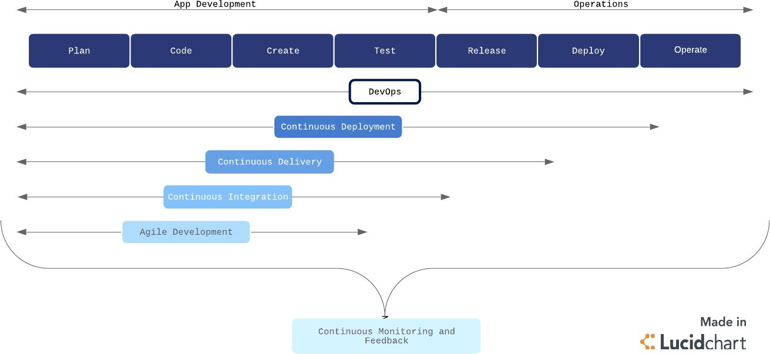

Continuousdevelopment

Continuous development is an umbrella term that describes the iterative process for developing software to be delivered to customers. It involves continuous integration, continuous testing, continuous delivery, and continuous deployment.

Byimplementingacontinuousdevelopment strategyand itsassociatedsub-strategies, businesses can achieve faster delivery of new features or products that are of higher quality and lower risk, without running into significantly bandwidth barriers.

Continuousintegration

Continuousintegration(CI)isasoftwaredevelopment practicecommonlyapplied intheDevOps process flow. Developers regularly merge their code changes into a shared repository where those updates are automatically tested.
Continuous integration ensures the most up-to-date and validated code is always readilyavailable to developers. CI helps prevent costly delays in development by allowing multiple developers to work on the same source code with confidence, rather than waiting to integrate separate sections of code all at once on release day.

This practice is a crucial component of the DevOps process flow, which aims to combine speed and agility with reliability and security.

Continuoustesting

Continuous testing is a verification process that allows developers to ensure the code actually works the way it was intended to in a live environment. Testing can surface bugs and particular aspects of the product that may need fixing or improvement, and can be pushed back to the development stages for continued improvement.

Continuousmonitoringandfeedback

Throughout the development pipeline, your team should have measures in place for continuous monitoring and feedback of the products and systems. Again, the majority of the monitoring process should be automated to provide continuous feedback.

This process allows IT operations to identify issues and notify developers in real time. Continuous feedback ensures higher security and system reliability as well as more agile responses when issues do arises.

Continuousdelivery

Continuous delivery(CD) is the next logicalstep fromCI. Code changes are automatically built, tested, and packaged for release into production. The goal is to release updates to the users rapidly and sustainably.

To do this, CD automates the release process (building on the automated testing in CI) so that new builds can be released at the click of a button.

Continuousdeployment

For the seasoned DevOps organization, continuous deployment may be the better option over CD. Continuous deployment is the fully automated version of CD with no human (i.e., manual) intervention necessary.

In acontinuous deployment process, every validated change is automatically released to users. This process eliminates the need for scheduled release days and accelerates the feedback loop. Smaller, more frequent releasesallow developersto get user feedback quicklyand address issues with more agility and accuracy.

Continuousdeployment isagreat goalforaDevOpsteam, but it isbest appliedaftertheDevOps process has been ironed out. For continuous deployment to work well, organizations need tohave a rigorous and reliable automated testing environment. If you’re not there yet, starting with CI and CD will help you get there.

ContinuousDelivery
Continuous delivery is an approach where teams release quality products frequently and predictably from source code repository to production in an automated fashion.

Some organizations release products manually by handing them off from one team to the next, which is illustrated in the diagram below. Typically, developers are at the left end of this spectrumand operations personnelare at the receiving end. This creates delays at everyhand-off that leads to frustrated teams and dissatisfied customers. The product eventually goes live through a tedious and error-prone process that delays revenue generation.

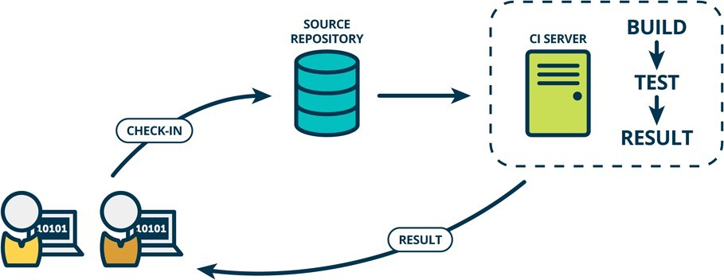

Howdoescontinuousdeliverywork?
Acontinuous delivery pipeline could have a manualgate right before production. A manual gate requires human intervention, and there could be scenarios in your organization that require manual gates in pipelines. Some manual gates might be questionable, whereas some could be legitimate. One legitimate scenario allows the business team to make a last-minute release decision. The engineering teamkeeps a shippable version ofthe product readyafter everysprint, and the business team makes the final call to release the product to all customers, or a cross- section of the population, or perhaps to people who live in a certain geographical location.

The architecture ofthe product that flows throughthe pipeline is a keyfactor that determines the anatomy of the continuous delivery pipeline. A highly coupled product architecture generates a complicated graphical pipeline pattern where various pipelines could get entangled before eventually making it to production.

Theproduct architecturealso influencesthedifferent phasesofthepipelineandwhat artifactsare produced in each phase. The pipeline first builds components - the smallest distributable and testable units of the product. For example, a library built by the pipeline can be termed a component. This is the component phase.

Loosely coupled components make up subsystems - the smallest deployable and runnable units. For example, a server is a subsystem. A microservice running in a container is also an exampleof a subsystem. This is the subsystem phase. As opposed to components, subsystems can be stood up and tested.

The software delivery pipeline is a product in its own right and should be a priority for businesses. Otherwise, you should not send revenue-generating products through it. Continuous delivery adds value in three ways. It improves velocity, productivity, and sustainability of software development teams.

Velocity
Velocity means responsible speed and not suicidal speed. Pipelines are meant to ship quality products to customers. Unless teams are disciplined, pipelines can shoot faulty code to production, only faster! Automated software delivery pipelines help organizations respond to market changes better.

Productivity
A spike in productivity results when tedious tasks, like submitting a change request for every changethatgoestoproduction,canbeperformedbypipelinesinsteadofhumans.This letsscrum teams focus on products that wow the world, instead of draining their energy on logistics. And that can make team members happier, more engaged in their work, and want to stay on the team longer.

Sustainability
Sustainability is key for all businesses, not just tech. “Software is eating the world” is no longer true — software has already consumed the world! Everycompany at the end ofthe day, whether in healthcare, finance, retail, or some other domain, uses technology to differentiate and outmaneuver their competition. Automation helps reduce/eliminate manual tasks that are error- prone and repetitive, thus positioning the business to innovate better and faster to meet their customers' needs.

ReleaseManagement

Release management is the process of overseeing the planning, scheduling, and controlling of software builds throughout each stage of development and across various environments. Release management typically included the testing and deployment of software releases as well.

Release management has had an important role in the software development lifecycle since before it was known as release management. Deciding when and how to release updates was its own unique problem even when software saw physical disc releases with updates occurring as seldom as every few years.

Nowthatmostsoftwarehasmovedfromhardandfastreleasedatestothe softwareasaservice(SaaS) business model, release management has become a constant process that works alongside development. This is especially true for businesses that have converted to utilizing continuous delivery pipelines that see new releases occurring at blistering rates. DevOps now plays a large role in many of the duties thatwere originally considered to be under the purviewof release management roles; however, DevOps has not resulted in the obsolescence of release management.

AdvantagesofReleaseManagementforDevOps
WiththetransitiontoDevOpspractices,deployment dutieshaveshiftedontotheshouldersofthe DevOps teams. This doesn’t remove the need for release management; instead, it modifies the data points that matter most to the new role release management performs.

Release management acts as a method for filling the data gap in DevOps. The planning of implementation and rollback safety nets is part of the DevOps world, but release management still needs to keep tabs on applications, its components, and the promotion schedule as part of change orders. The key to managing software releases in a way that keeps pace with DevOps deployment schedules is through automated management tools.

Aligningbusiness&IT goals

The modern business is under more pressure than ever to continuously deliver new features and boost their value to customers. Buyers have come to expect that their software evolves and continues to develop innovative ways to meet their needs. Businesses create an outside perspective to glean insights into their customer needs. However, IT has to have an inside perspective to develop these features.

Release management provides a critical bridge between these two gaps in perspective. It coordinatesbetweenITworkandbusinessgoalstomaximizethesuccessofeachrelease.

Release management balances customer desires with development work to deliver the greatest value to users.

Minimizesorganizationalrisk

Software products contain millions of interconnected parts that create an enormous risk offailure. Users are often affected differently by bugs depending on their other software, applications,andtools.Plus,fasterdeploymentstoproductionincreasetheoverallriskthat faulty code and bugs slip through the cracks.

Release management minimizes the risk of failure by employing various strategies. Testing and governance cancatchcritical faultysectionsofcode before theyreachthe customer. Deployment plansensurethereareenoughteammembersand resourcesto addressanypotential issues before affecting users. All dependencies between the millions of interconnected parts are recognizedand understood.

Directacceleratingchange

Release management is foundational to the discipline and skill of continuously producing enterprise-quality software. The rate of software delivery continues to accelerate and is unlikely to slow down anytime soon. The speed of changes makes release management more necessary than ever.

The move towards CI/CD and increases in automation ensure that the acceleration will only increase. However, it also means increased risk, unmet governance requirements, and potential disorder. Release management helps promote a culture of excellence to scale DevOps to an organizational level.

Releasemanagementbest practices
As DevOps increases and changes accelerate, itis critical to have best practices in place to ensurethat it movesasquicklyaspossible. Well-refinedprocessesenableDevOpsteamsto more effectively and efficiently. Some best practices to improve your processes include:

Defineclearcriteria forsuccess
Well-defined requirements in releases and testing will create more dependable releases.Everyone should clearly understand when things are actually ready to ship.

Well-defined means that the criteria cannot be subjective. Any subjective criteria will keep you from learning from mistakes and refining your release management process to identify what works best. It also needs to be defined for every team member. Release managers, quality supervisors, product vendors, and product owners must all have an agreed-upon set of criteria before starting a project.

Minimizedowntime

DevOps is about creating an ideal customer experience. Likewise, the goal of release management is to minimize the amount of disruptionthat customers feel with updates.

Strive to consistently reduce customer impact and downtime with active monitoring, proactive testing, and real-time collaborative alerts that enable you to quicklynotify you ofissues during a release. A good release manager will be able to identify any problems before the customer.

The team can resolve incidents quickly and experience a successful release when proactive efforts are combined with a collaborative response plan.

Optimizeyourstagingenvironment
The staging environment requires constant upkeep. Maintaining an environment that is as close aspossibletoyourproductiononeensuressmootherandmoresuccessfulreleases.FromQA toproduct owners, the whole team must maintain the staging environment by running tests and combing through staging to find potential issues with deployment. Identifying problems in staging before deploying to production is only possible with the right staging environment.
Maintaining a staging environment that is as close as possible to production will enable DevOps teams to confirm that all releases will meet acceptance criteria more quickly.

Striveforimmutable
Whenever possible, aim to create new updates as opposed to modifying new ones. Immutable programming drives teams to build entirely new configurations instead of changing existing structures. These new updates reduce the risk of bugs and errors that typically happen when modifying current configurations.

Theinherentlyreliablereleaseswillresultinmoresatisfiedcustomersandemployees.

Keepdetailedrecords

Good records management on any release/deployment artifacts is critical. From release notes to binaries to compilation ofknownerrors, records are vital for reproducing entire sets ofassets. In most cases, tacit knowledge is required.

Focusonthe team
Well-defined and implemented DevOps procedures will usually create a more effective release management structure. They enable best practices for testing and cooperation during the complete delivery lifecycle.

Although automation is a critical aspect of DevOps and release management, it aims to enhance team productivity. The more that release management and DevOps focus on decreasing human error and improving operational efficiency, the more they’ll start to quickly release dependable services.

Scrum
Scrumis a framework used by teams tomanage work and solve problems collaboratively in short cycles. Scrum implements the principles ofAgileas a concrete set of artifacts, practices, and roles.

TheScrumlifecycle

The diagram below details the iterative Scrum lifecycle. The entire lifecycle is completed in fixed time periods called sprints. A sprint is typically one-to-four weeks long

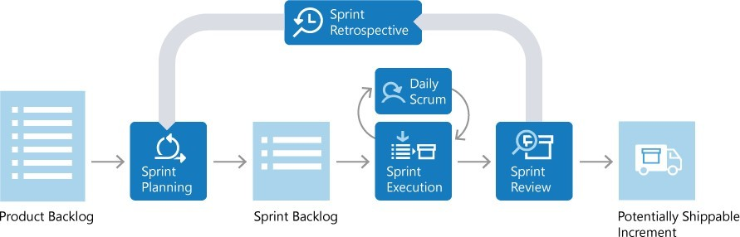

Scrumroles

TherearethreekeyrolesinScrum: theproductowner,theScrummaster,andthe Scrumteam.

Productowner

The product owner is responsible for what the team builds, and why they build it. The product owner is responsible for keeping the backlog of work up to date and in priorityorder.

Scrummaster

The Scrum master ensures that the Scrum process is followed by the team. Scrum masters are continuallyon the lookout for how the teamcan improve, while also resolving impediments and other blocking issues that arise during the sprint. Scrum masters are part coach, part team member, and part cheerleader.

Scrumteam

The members of the Scrum team actually build the product. The team owns the engineering of the product, and the quality that goes with it.

Productbacklog

Theproduct backlog is a prioritized list of work the team can deliver. The product owner is responsible for adding, changing, and reprioritizing the backlog as needed. The items at the topof the backlog should always be ready for the team to execute on.

Planthesprint

In sprint planning, the teamchooses backlog items to workon in the upcoming sprint. The team chooses backlog items based on priority and what they believe they can complete in the sprint. Thesprint backlog is the list of items the teamplans to deliver in the sprint. Often, each itemon the sprint backlog is broken down into tasks. Once all members agree the sprint backlog is achievable, the sprint starts.

Executethesprint

Once the sprint starts, the team executes on the sprint backlog. Scrum does not specify how the team should execute. The team decides how to manage its own work.

Scrumdefines a practice called a daily Scrum, oftencalled the daily standup. The dailyScrumis a daily meeting limited to fifteen minutes. Team members often stand during the meeting to ensure it stays brief. Each team member briefly reports their progress since yesterday, the plans for today, and anything impeding their progress.

Toaid thedailyScrum,teamsoftenreviewtwoartifacts:

Task board

The task board lists each backlog item the team is working on, broken down into the tasks required tocomplete it. Tasks are placedin To do, In progress, andDonecolumns based on their status. The board provides a visual way to track the progress of each backlog item.

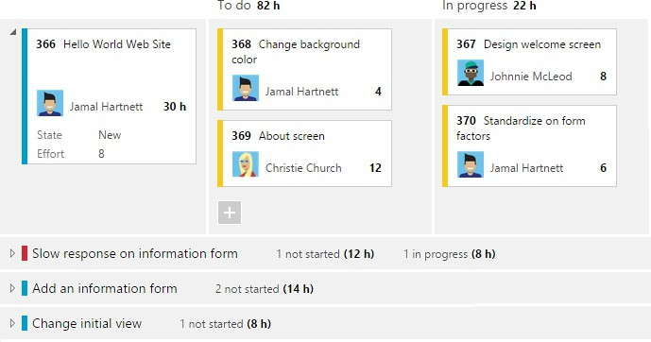

.

Sprintburndownchart

The sprint burndown is a graph that plots the daily total of remaining work, typically shown in hours. The burndown chart provides a visual way of showing whether the team is on track to complete all the work by the end of the sprint.

Sprintreviewandsprintretrospective

Atthe endofthesprint,theteamperformstwopractices:

Sprint review

The teamdemonstrates what they've accomplished to stakeholders. They demo the software and show its value.

Sprint retrospective

The team takes time to reflect on what went well and which areas need improvement. The outcome of the retrospective are actions for the next sprint.

Increment

The product of a sprint is called the incrementorpotentially shippable increment. Regardless of theterm, asprint'soutput should beofshippablequality, evenif it'spartofsomething bigger and can't ship by itself. It should meet allthe qualitycriteria set bythe teamand product owner.

Repeat,learn,improve

The entire cycle is repeated for the next sprint. Sprint planning selects the next items on the product backlog and the cycle repeats. While the team executes the sprint, the product owner ensures the items at the topof the backlog are readyto execute in the following sprint.

This shorter, iterative cycle provides the team with lots of opportunities to learn and improve. A traditional project often has a long lifecycle, say 6-12 months. While a team can learn from a traditional project, the opportunities are far less than a team who executes in two-week sprints, for example.

Thisiterativecycleis,inmanyways,theessenceofAgile.

Scrum is very popular because it provides just enough framework to guide teams while giving them flexibility in how they execute. Its concepts are simple and easy to learn. Teams can get started quickly and learn as they go. All of this makes Scrum a great choice for teams juststarting to implement Agile principles.

Kanban

Kanban is a Japanese term that means signboard or billboard. An industrial engineer named Taiichi Ohno developed Kanban at Toyota Motor Corporation to improve manufacturing efficiency.

Although Kanban was created for manufacturing, software development shares many of thesame goals, such as increasing flow and throughput. Software development teams can improve their efficiency and deliver value to users faster by using Kanban guiding principles andmethods.

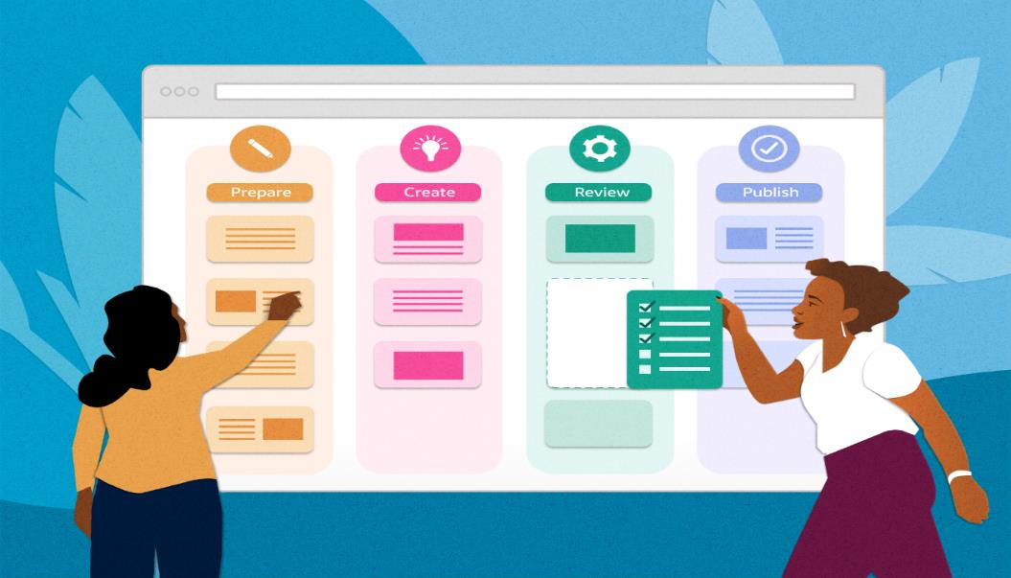

Kanbanprinciples

Adopting Kanbanrequires adherence to some fundamentalpractices that might vary fromteams' previous methods.

Visualizework

Understanding development team status and work progress can be challenging. Work progress and current state is easier to understand when presented visually rather than as a list of work items or a document.

Visualization of work is a key principle that Kanban addresses primarily through Kanbanboards. Theseboardsusecardsorganized byprogressto communicateoverallstatus.Visualizing work as cards in different states on a board helps to easily see the big picture of where a project currently stands, as well as identify potential bottlenecks that could affect productivity.

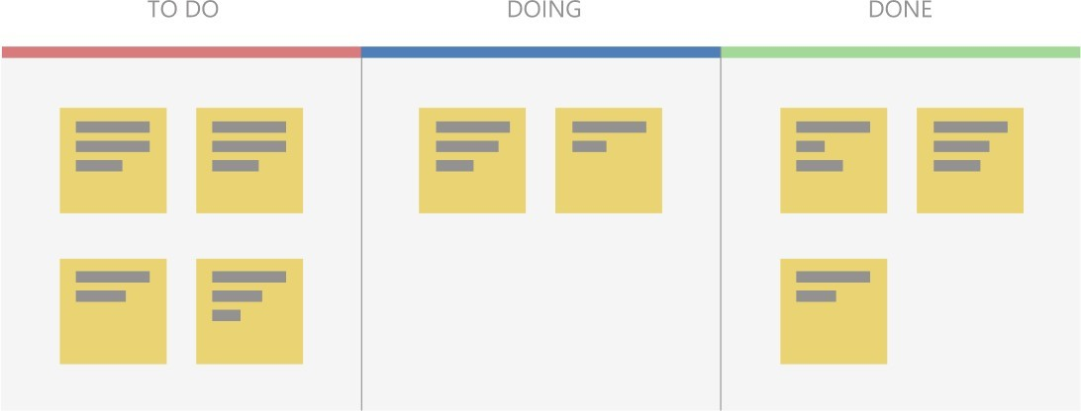

Useapullmodel

Historically, stakeholders requested functionality by pushing work onto development teams, often with tight deadlines. Quality suffered if teams had to take shortcuts to deliver the functionality within the timeframe.

Kanban focuses on maintaining an agreed-upon level of quality that must be met before considering work done. To support this model, stakeholders don't push work on teams that are alreadyworkingat capacity. Instead, stakeholdersaddrequeststo abacklogthat ateampulls into their workflow as capacity becomes available.

ImposeaWIPlimit

Teams that try to work on too many things at once can suffer from reduced productivity due to frequent and costly context switching. The team is busy, but work doesn't get done, resulting in unacceptably high lead times. Limiting the number of backlog items a team can workon at a time helps increase focus while reducing context switching. The items the team is currently working on are called work in progress (WIP).

Teams decide on a WIP limit, or maximum number of items they can work on at one time. A well-disciplinedteammakessure notto exceedtheirWIP limit.Ifteamsexceedtheir WIP limits, they investigate the reason and work to address the root cause.

Measurecontinuous improvement

To practice continuous improvement, development teams need a way to measure effectiveness and throughput. Kanban boards provide a dynamic view of the states of work in a workflow, so teams can experiment with processes and more easily evaluate impact on workflows. Teams that embrace Kanban for continuous improvement use measurements like lead time and cycle time.

Kanbanboards

TheKanbanboard isoneofthetoolsteamsusetoimplement Kanbanpractices. AKanbanboard can be a physical board or a software application that shows cards arranged into columns.Typical column names are To-do, Doing, and Done,but teams can customize the names to matchtheirworkflowstates.Forexample,ateammightpreferto use New, Development, Testing, UAT, and Done.

Software development-based Kanban boards display cards that correspond to product backlog items. The cards include links to other items, such as tasks and test cases. Teams can customize the cards to include information relevant to their process.
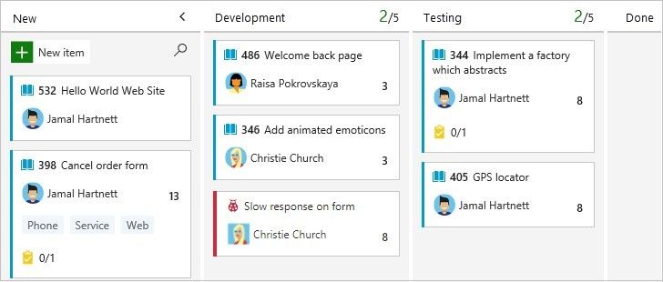

On a Kanban board, the WIP limit applies to all in-progress columns. WIP limits don't apply to the first and last columns, because those columns represent work that hasn't started or is completed. Kanban boards help teams stay within WIP limits by drawing attention to columns that exceed the limits. Teams can then determine a course of action to remove the bottleneck.

Cumulativeflowdiagrams

Acommonadditionto software development-based Kanbanboardsisa chart called a cumulative flow diagram (CFD). The CFD illustrates the number of items in each state over time, typically across several weeks. The horizontal axis shows the timeline, while the vertical axis shows the number of product backlog items. Colored areas indicate the states or columns the cards are currently in.

The CFD is particularly useful for identifying trends over time, including bottlenecks and other disruptions to progress velocity. A good CFD shows a consistent upward trend while a team is working on a project. The colored areas across the chart should be roughly parallel if the team is working within their WIP limits.
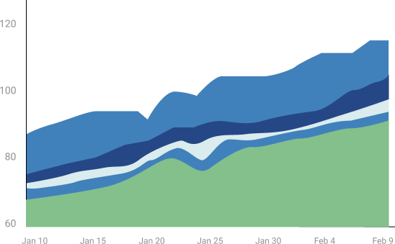

A bulge in one or more of the colored areas usually indicates a bottleneck or impediment in the team's flow. Inthe following CFD, the completed work in green is flat, while the testing state in blue is growing, probably due to a bottleneck.

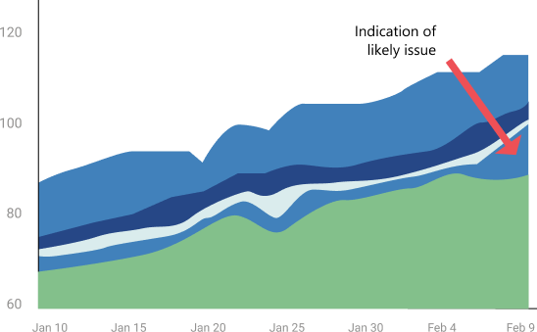

KanbanandScruminAgiledevelopment

While broadly fitting under the umbrella ofAgiledevelopment, Scrumand Kanban are quite different.

- Scrumfocusesonfixedlengthsprints, whileKanbanisacontinuousflowmodel.
- Scrumhasdefinedroles,whileKanbandoesn't defineanyteamroles.
- Scrumusesvelocityasakeymetric,whileKanbanusescycletime.

Teams commonly adopt aspects of both Scrum and Kanban to help them work most effectively. Regardless of which characteristics they choose, teams can always review and adapt until they find the best fit. Teams should start simple and not lose sight of the importance of delivering value regularly to users.

Kanban withGitHub

GitHuboffersaKanbanexperiencethrough projectboards(classic).Theseboardshelp youorganize and prioritize work for specific feature development, comprehensive roadmaps, or release checklists. You canautomate project boards (classic) to sync card status with associated issues and pull requests.

KanbanwithAzureBoards

Azure Boardsprovides a comprehensive Kanban solution for DevOps planning. Azure Boards has deep integration across Azure DevOps, and can also be part of Azure Boards- GitHubintegration.

- Formoreinformation, seeReasonstouseAzureBoardstoplanandtrackyourwork.
- The Learn moduleChoose an Agile approach to software development provides hands-on Kanban experience in Azure Boards.

DeliveryPipeline
A DevOps pipeline is a set of automated processes and toolsthat allows both developers and operations professionals to work cohesively to build and deploy code to a production environment.
WhileaDevOpspipelinecandifferbyorganization,ittypicallyincludes buildautomation/continuous integration,automation testing, validation, and reporting. It may also include one or more manualgates that require human intervention before code is allowed to proceed.
Continuous is a differentiated characteristic of a DevOps pipeline. This includes continuous integration, continuous delivery/deployment (CI/CD), continuous feedback, and continuous operations. Instead of one-off tests or scheduled deployments, each function occurs on an ongoing basis.

ConsiderationsforbuildingaDevOpspipeline

Since there isn’t one standard DevOps pipeline, an organization’s design and implementation of aDevOps pipeline depends on its technology stack, a DevOps engineer’s level of experience, budget, and more. ADevOps engineer should have a wide-ranging knowledge of both development and operations, including coding, infrastructure management, system administration, and DevOps toolchains.

Plus, each organization has a different technology stack that can impact the process. Forexample, ifyour codebase is node.js, factorsinclude whether you use alocalproxynpmregistry, whether you download the source code and run`npminstall` at everystage inthe pipeline, or do it onceandgenerateanartifactthat movesthroughthepipeline. Or, ifanapplicationiscontainer- based,you need to decide to use a local or remote container registry,build the container once and move it through the pipeline, or rebuild it at every stage.

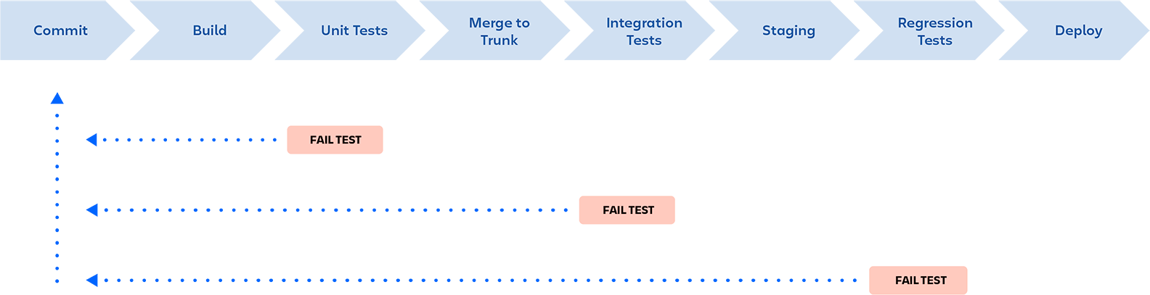

While every pipeline is unique, most organizations use similar fundamental components. Each step is evaluated for success before moving on to the next stage of the pipeline. In the event ofa failure, the pipeline is stopped, and feedback is provided to the developer.

ComponentsofaDevOpspipeline

1.Continuousintegration/continuousdelivery/deployment (CI/CD)
Continuous integration is the practice of making frequent commits to a common source code repository. It’s continuously integrating code changes into existing code base so that anyconflicts betweendifferent developer’s code changes are quicklyidentified and relativelyeasyto remediate. This practice is critically important to increasing deployment efficiency.
We believe that trunk-based development is a requirement of continuous integration. If you are not making frequent commits to a common branch in a shared source code repository, you arenot doing continuous integration. If your build and test processes are automated but your developers are working on isolated, long-living feature branches that are infrequently integrated into a shared branch, you are also not doing continuous integration.

Continuous delivery ensures that the “main” or “trunk” branch of an application's source codeis always ina releasable state. Inother words, ifmanagement came to your desk at 4:30PMona Fridayand said, “We need the latest version released right now,”that version could be deployed with the push of a button and without fear of failure.
This means having a pre-production environment that is as close to identical to the production environment as possible and ensuring that automated tests are executed, so that every variable that might cause a failure is identified before code is merged into the main or trunk branch.

Continuous deployment entails having a level of continuous testing and operations that is so robust, new versions of software are validated and deployed into a production environment without requiring any human intervention.
This is rare and in most cases unnecessary. It is typically only the unicorn businesses who have hundreds or thousands ofdevelopers and have many releases each day that require, or even want to have, this level of automation.

To simplify the difference between continuous delivery and continuous deployment, think of delivery as the FedEx person handing you a box, and deployment as you opening that box and using what’s inside. If a change to the product is required between the time you receive the box and when you open it, the manufacturer is in trouble!
- Continuousfeedback
- The single biggest painpoint ofthe old waterfallmethodofsoftware development —and consequently whyagilemethodologies weredesigned—wasthelackof timely feedback. When new featurestook months or years to go from idea to implementation, it was almost guaranteed that the end result would be something other than what the customerexpectedorwanted.Agilesucceededinensuringthat developers receivedfaster feedback from stakeholders. Now with DevOps, developers receive continuous feedback not not only from stakeholders, but from systematic testing and monitoring of their code in the pipeline.
Continuous testing is a critical component of every DevOps pipeline and one of the primary enablers of continuous feedback. In a DevOps process, changes move continuously from development to testing to deployment, which leads not only to faster releases, but a higherqualityproduct.Thismeanshavingautomatedteststhroughout yourpipeline, includingunit tests that run on every build change, smoke tests, functional tests, and end-to-end tests.
Continuous monitoring is another important component of continuous feedback. A DevOps approach entails using continuous monitoring in the staging, testing, and even development environments. It is sometimes useful to monitor pre-production environments for anomalous behavior, but in general this is an approach used to continuously assess the health and performance of applications in production.
Numerous tools and services exist to provide this functionality, and this may involve anything from monitoring your on-premise or cloud infrastructure such as server resources, networking, etc. or the performance of your application or its API interfaces.

3.Continuous operations
Continuous operations is a relatively new and less common term, and definitions vary. Onewayto interpret it isas “continuousuptime”. Forexample inthecaseofa blue/greendeployment

strategy in which you have two separate production environments, one that is “blue” (publicly accessible) and onethat is“green” (not publiclyaccessible). Inthissituation, new code would be deployed to the green environment, and when it was confirmed to be functional then a switch would be flipped (usuallyona load-balancer) and traffic would switch fromthe “blue” systemto the “green” system. The result is no downtime for the end-users.
Another wayto think ofContinuous operations is as continuous alerting. This is the notionthat engineering staff is on-call and notified if any performance anomalies in the application or infrastructure occur. In most cases, continuous alerting goes hand in hand with continuous monitoring.

One of the main goals of DevOps is to improve the overall workflow in the softwaredevelopment lifecycle(SDLC). The flowofworkisoftendescribedas WIPor workinprogress.Improving WIP can be accomplished by a variety of means. In order to effectively removebottlenecks that decrease the flow of WIP, one must first analyze the people, process, andtechnology aspects of the entire SDLC.
Thesearethe11bottlenecksthathavethebiggestimpactontheflowofwork.
- InconsistentEnvironments
In almost every company I have worked for or consulted with, a huge amount ofwaste exists because the various environments (dev, test, stage, prod) are configured differently. I call this “environment hell”. How many times have you heard a developer say“it workedonmylaptop”? As codemoves fromoneenvironment tothe next,softwarebreaksbecauseofthedifferentconfigurations withineachenvironment. I have seen teams waste days and even weeks fixing bugs that are due to environmental issues and are not due to errors within the code. Inconsistent environments are the number one killer of agility.
Create standard infrastructure blueprints and implement continuousdelivery to ensure all environments are identical.
- Manual Intervention
Manual intervention leads to human error and non-repeatable processes. Two areas wheremanual intervention can disrupt agility the most are in testing and deployments. If testing is performed manually, it is impossible to implement continuous integration and continuous delivery in an agile manner (if at all). Also, manual testing increases the chance of producing defects,creatingunplannedwork.Whendeploymentsareperformedfullyorpartially

manual,therisk ofdeploymentfailureincreasessignificantlywhichlowersquality and reliability and increases unplanned work.
Automatethebuildanddeploymentprocessesandimplementatestautomationmethodology like test driven development (TDD)
3. SDLCMaturity
The maturity of a team’s software development lifecycle (SDLC) has a direct impact on their ability to deliver software. There is nothing new here; SDLC maturity has plagued IT for decades. In the age of DevOps, where we strive to deliver software in shorter increments with a highdegree ofreliabilityand quality, it iseven more critical for ateam to have a mature process.
Some companies I visit are still practicing waterfall methodologies. These companies struggle with DevOps because they don’t have any experience with agile. But not all companies that practice agile do it well. Some are early in their agile journey, while others have implemented what I call“Wagile”: waterfalltendencieswithagile terminologysprinkled in. I have seenteams who have implemented Kanban but struggle with the prioritization and control of WIP. I have seen scrum teams struggle to complete the story points that they promised. It takes time to get really good at agile.

Invest in training and hold blameless post mortems to continously solicit feedback and improve.
4. LegacyChangeManagementProcesses
Many companies have had their change management processes in place for years and are comfortablewithit. Theproblemisthat theseprocesseswerecreatedbackwhencompanieswere deploying and updating back office solutions or infrastructure changes that happened infrequently. Fast forward to today’s environments where applications are made of many small componentsor micro servicesthat canbe changed and deployed quickly, now allofa suddenthe process gets in the way.
Many large companies with well-established ITIL processes struggle with DevOps. In these environmentsIhave seendevelopmentteamsimplement highlyautomatedCI/CDprocessesonly to stop and wait for weekly manual review gates. Sometimes these teams have to go through multiple reviews (security, operations, code, and change control). What is worse is that there is often a long line to wait in for reviews, causing a review process to slip another week. Many of these reviews are just rubber stamp approvals that could be entirely avoided with some minor modifications to the existing processes.

Companies with legacy processes need to look at how they can modernize processes to be more agile instead of being the reason why their company can’t move fast enough.
- LackofOperationalMaturity
Moving to a DevOps model often requires a different approach to operations. Some companies accustomed to supporting back office applications that change infrequently. It requires adifferent mindset to support software delivered as a service that is always on, and deployed frequently. With DevOps, operations is no longer just something Ops does. Developers nowmust have tools so theycansupport applications. OftenI encounter companies that only monitor infrastructure. In the DevOps model developers need access to logging solutions, application performance monitoring (APM) tools, web and mobile analytics, advanced alerting and notification solutions. Processes like change management, problem management, request management, incident management, access management, and many others often need to be modernized to allow for more agilityand transparency. WithDevOps, operations isa teamsport.

Assess youroperationalprocesses, tools, and organizationandmodernize to increase agility and transparency.

- Outdatedtestingpractices
Too often I see clients who have a separate QA department that is not fully integrated with the development team. The code is thrown over the wall and then testing begins. Bugs are detected and sent back to developers who then have to quickly fix, build, and redeploy. This process is repeated until there is no time remaining and teams are left to agree on what defects they can tolerate and promote to production. This is a death spiral in action. With every release, they introduce more technicaldebt into the system lowering its quality and reliability, and increasing unplanned work. There is a better way.
The better way is to block bugs from moving forward in the development process. This is accomplished by building automated test harnesses and by automatically failing the build if any of the tests fail. This is what continuous integration is designed for. Testing must be part of the development process, not a handoff that is performed after development. Developers need toplay a bigger part in testing and testers need to play a bigger part in development. This strikes fear in some testers and not all testers can make the transition.

Qualityiseveryone’s responsibility, notjusttheQAteam.

- Automatingwaste
A very common pattern I run into is the automation of waste. This occurs when a team declares itself a DevOps teamor a person declares themselves a DevOps engineer and immediately starts writing hundreds or thousands of lines of Chef or Puppet scripts to automate their existing processes. The problem is that many of the existing processes are bottlenecks and need to be changed. Automating waste is like pouring concrete around unbalanced support beams. It makes bad design permanent.

Automateprocessesafterthebottlenecksare removed.

- CompetingorMisaligned Incentivesand LackofShared Ownership
This bottleneck has plagued IT for years but is more profound when attempting to be agile. In fact, this issue is at the heart of why DevOps came to be in the first place. Developers are incentedforspeedtomarket andoperationsisincentedtoensuresecurity,reliability,availability, and governance. The incentives are conflicting. Instead, everyone should be incented for customer satisfaction, with a high degree of agility, reliability, and quality (which is what DevOps is all about). If every team is not marching towards the same goals, then there will be a never-ending battle of priorities and resources. If all teams’ goals are in support of the goals I mentioned above, and everyone is measured in a way that enforces those incentives, then everyone wins --- especially the customer.

WorkwithHR tohelp changetherewardandincentivestofosterthedesired behaviors.
- DependenceonHeroicEfforts
When heroic efforts are necessary to succeed, then a team is in a dark place. This often means working insane hours, being reactive instead of proactive, and being highly reliant on luck and chance. The biggest causes of this are a lack of automation, too much tribal knowledge,immature operational processes, and even poor management. The culture of heroism often leads to burnout, high turnover, and poor customer satisfaction.

If your organization relies on heroes, find out what the root causes are that creates these dependencies and fix them fast.

- Governanceasan Afterthought
When DevOps starts as a grassroots initiative there is typically little attention paid to thequestion “how does this scale?” It is much easier to show some success in a small isolated team andforaninitialproject.ButoncetheDevOpsinitiativestartsscalingtolargerprojectsrunning

onwaymore infrastructuresoronce it startsspreadingtoother teams, it cancomecrashingdown without proper governance in place. This is very similar to building software in the cloud. How many times have you seen a smallteam whip out their credit card and build an amazing solution on AWS? Easy to do, right? Then a year later the costs are spiraling out of control as they lose sight of how many servers are in use and what is running on them. They all have different versions of third partyproducts and libraries onthem. Suddenly, it is not so easyanymore.

With DevOps, the same thing can happen without the appropriate controls in place. Many companies start their DevOps journey with a team of innovators and are able to score somemajor wins. But when they take that model to other teams it all falls down. There are numerous reasons that this happens. Is the organization ready to manage infrastructure and operations across multiple teams? Are there common shared services available like central logging and monitoring solutions or is each team rolling their own? Is there a common security architecture that everyone canadhere to?Cantheteams provisiontheir owninfrastructurefroma self-service portalor aretheyalldependent on a single queue ticketing system?I could go on but you get the point. It is easier to cut some corners when thereis one team to manage but to scale we mustlook at the entire service catalog. DevOps will not scale without the appropriate level of governance in place.

AssignanownerandstartbuildingaplanforscalingDevOpsacrosstheorganization.

- LimitedtoNoExecutive Sponsorship
The most successful companies have top level support for their DevOps initiative. One of my clients is making a heavy investment in DevOps training and it will run a large number of employees through the program. Companies with top level support make DevOps a priority.They break down barriers, drive organizational change, improve incentive plans, communicate “Why” they are doing Devops, and fund the initiative. When there is no top level support, DevOps becomes much more challenging and often becomes a new silo. Don’t let this stop you from starting a grass roots initiative. Many sponsored initiatives started as grassroots initiatives. These grassroots teams measured their success and pitched their executives. Sometimes when executives see the results and the ROI they become the champions for furthering the cause. My point is, it is hard to get dev and ops to work together with common goals when it is not supported at the highest levels. It is difficult to transform a company to DevOps if it is not supported at the highest levels.

If running a grassroots effort, gather before and after metrics and be prepared to sell and evangelize DevOps upward.

Unit 2
Software Development Life Cycle models and Devops

Software Development Life Cycle models

- Agile
- Lean
- Waterfall
- Iterative
- Spiral
- DevOps

Each of these approaches varies in some ways from the others, but all have a common purpose: to help teams deliver high-quality software as quickly and cost-effectively as possible.

Agile
The Agile model first emerged in 2001 and has since become the de facto industry standard. Some businesses value the Agile methodology so much that they apply it to other types of projects, including nontech initiatives.
In the Agile model, fast failure is a good thing. This approach produces ongoing release cycles, each featuring small, incremental changes from the previous release. At each iteration, the product is tested. The Agile model helps teams identify and address small issues on projects before they evolve into more significant problems, and it engages business stakeholders to give feedback throughout the development process.
Aspartoftheirembraceofthis methodology, manyteamsalso applyanAgile frameworkknown as Scrum to help structure more complex development projects. Scrum teams work in sprints, whichusuallylasttwotofour weeks,tocompleteassignedtasks.DailyScrummeetingshelpthe

whole team monitor progress throughout the project. And the ScrumMaster is tasked with keeping the team focused on its goal.

Lean
The Lean model for software development is inspired by "lean" manufacturing practices and principles. The seven Lean principles (in this order) are: eliminate waste, amplify learning, decideaslateaspossible,deliverasfast aspossible,empowertheteam, build inintegrityandsee the whole.
The Lean process is about working only on what must be worked on at the time, so there’s no room for multitasking. Project teams are also focused on finding opportunities to cut waste at every turn throughout the SDLC process, from dropping unnecessary meetings to reducing documentation.
The Agile model is actually a Lean method for the SDLC, but with some notable differences. One ishow eachprioritizescustomer satisfaction: Agile makes it thetoppriorityfromtheoutset, creating a flexible process where project teams can respond quickly to stakeholder feedback throughout the SDLC. Lean, meanwhile, emphasizes the elimination of waste as a way to create more overall value for customers — which, in turn, helps to enhance satisfaction.

Waterfall
Some experts argue that the Waterfall model was never meant to be a process model for real projects. Regardless, Waterfall is widely considered the oldest of the structured SDLC methodologies. It’s also a very straightforward approach: finish one phase, then move on to the next. No going back. Each stage relies on information from the previous stage and has its own project plan.
The downside ofWaterfallis itsrigidity. Sure,it’s easyto understand and simple to manage. But early delays can throw off the entire project timeline. With little room for revisions once a stage is completed, problems can’t be fixed untilyou getto the maintenance stage. This modeldoesn’t work well if flexibility is needed or if the project is long-term and ongoing.
Even more rigid is the related Verification and Validation model — or V-shaped model. This linear development methodology sprang from the Waterfall approach. It’s characterized by a corresponding testing phase for each development stage. Like Waterfall, each stage begins only after the previous one has ended. This SDLC model can be useful, provided your project has no unknown requirements.

Iterative

The Iterative model is repetition incarnate. Instead of starting with fully known requirements, project teams implement a set of software requirements, then test, evaluate and pinpoint further requirements. Anew versionofthe software is produced witheachphase, or iteration. Rinse and repeat until the complete system is ready.
Advantages ofthe Iterative modelover other commonSDLC methodologies isthat it producesa working version of the project early in the process and makes it less expensive to implement changes. One disadvantage: Repetitive processes can consume resources quickly.
One example of an Iterative model is the Rational Unified Process (RUP), developed by IBM’s RationalSoftware division. RUP is a process product, designed to enhance teamproductivity for a wide range of projects and organizations.
RUPdividesthedevelopmentprocessintofourphases:

- Inception,whenthe idea foraprojectis set
- Elaboration,whentheprojectisfurtherdefinedandresourcesareevaluated
- Construction,whentheprojectisdevelopedandcompleted
- Transition,whentheproductisreleased

Each phase of the project involves business modeling, analysis and design, implementation, testing, and deployment.

Spiral
One of the most flexible SDLC methodologies, Spiral takes a cue from the Iterative model andits repetition. The project passes through four phases (planning, risk analysis, engineering and evaluation) over and over in a figurative spiral until completed, allowing for multiple rounds of refinement.
The Spiral model is typically used for large projects. It enables development teams to build a highlycustomized product and incorporateuserfeedback earlyon. Another benefit ofthis SDLC model is risk management. Each iteration starts by looking ahead to potential risks and figuring out how best to avoid or mitigate them.

DevOps
The DevOps methodology is a relative newcomer to the SDLC scene. It emerged from two trends: the application of Agile and Lean practices to operations work, and the general shift in business toward seeing the value of collaboration between development and operationsstaff at all stages of the SDLC process.

In a DevOps model, Developers and Operations teams work together closely — and sometimes as one team — to accelerate innovation and the deployment of higher-quality and more reliable software products and functionalities. Updates to products are small but frequent. Discipline, continuous feedback and process improvement, and automation of manual development processes are all hallmarks of the DevOps model.
Amazon Web Services describes DevOps as the combination of cultural philosophies, practices, and tools that increases an organization’s ability to deliver applications and services at high velocity, evolving and improving products at a faster pace than organizations using traditional software development and infrastructure management processes. So like many SDLC models, DevOps is not only an approach to planning and executing work, but also a philosophy that demands a nontraditional mindset in an organization.
Choosing the right SDLC methodology for your software development project requires careful thought. But keep in mind that a model for planning and guiding your project is only one ingredient for success. Even more important is assembling a solid team of skilled talent committed to moving the project forward through every unexpected challenge or setback.

DevOpsLifecycle

DevOps defines anagile relationship betweenoperations and Development. It is a process that is practiced by the development team and operational engineers together from beginning to thefinal stage of the product.
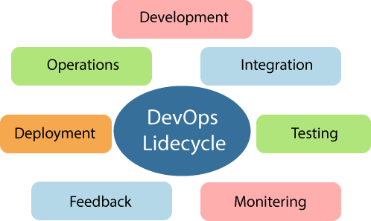

Learning DevOps is not complete without understanding the DevOps lifecycle phases. The DevOps lifecycle includes seven phases as given below:

ContinuousDevelopment

This phase involves the planning and coding ofthe software. The visionofthe project is decided during the planning phase. And the developers begin developing the code for the application. There are no DevOps tools that are required for planning, but there are several tools for maintaining the code.

ContinuousIntegration

This stage is the heart of the entire DevOps lifecycle. It is a software development practice in whichthedevelopersrequireto commit changestothesourcecodemorefrequently. This maybe on a daily or weekly basis. Then every commit is built, and this allows early detection of problemsiftheyarepresent.Buildingcodeisnotonlyinvolvedcompilation,butitalso includes unit testing, integration testing, code review, and packaging.

The code supporting new functionality is continuously integrated with the existing code. Therefore, there is continuous development ofsoftware. The updated codeneeds to be integrated continuously and smoothly with the systems to reflect changes to the end-users.
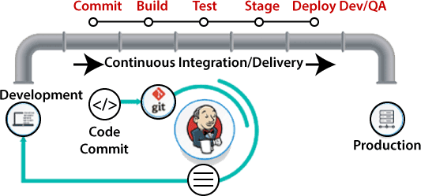

Jenkins is a popular tool used in this phase. Whenever there is a change in the Git repository, then Jenkins fetches the updated code and prepares a build of that code, which is an executable file in the form of war or jar. Then this build is forwarded to the test server or the production server.

ContinuousTesting

This phase, where the developed software is continuously testing for bugs. For constant testing, automation testing tools such as TestNG, JUnit, Selenium, etc are used. These tools allow QAs to test multiple code-bases thoroughly in parallel to ensure that there is no flaw in the functionality. In this phase, Docker Containers can be used for simulating the test environment.

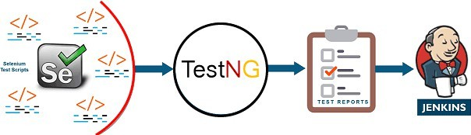

Seleniumdoes the automation testing, and TestNG generates the reports. This entire testing phase can automate with the help of a Continuous Integration tool called Jenkins.

Automation testing saves a lot of time and effort for executing the tests instead of doing this manually. Apart from that, report generation is a big plus. The task of evaluating the test cases that failed in a test suite gets simpler. Also, we can schedule the execution of the test cases at predefined times. After testing, the code is continuously integrated with the existing code.

ContinuousMonitoring

Monitoring is a phase that involves all the operational factors of the entire DevOps process, where important informationabout the use ofthe software is recordedand carefullyprocessed to find out trends and identify problem areas. Usually, the monitoring is integrated within the operational capabilities of the software application.

It may occur in the form of documentation files or maybe produce large-scale data about the application parameters when it is in a continuous use position. The system errors such as server not reachable, low memory, etc are resolved in this phase. It maintains the security and availability of the service.

ContinuousFeedback

The application development is consistently improved by analyzing the results from the operations of the software. This is carried out by placing the critical phase of constant feedback between the operations and the development of the next version of the current software application.

The continuity is the essential factor in the DevOps as it removes the unnecessary steps whichare required to take a software application from development, using it to find out its issues and then producing a better version. It kills the efficiency that may be possible with the app and reduce the number of interested customers.

ContinuousDeployment

In this phase, the code is deployed to the production servers. Also, it is essential to ensure thatthe code is correctly used on all the servers.

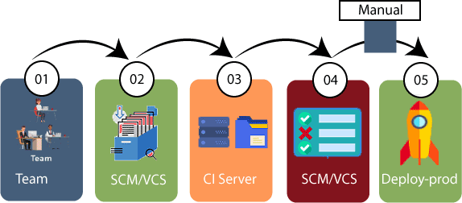

The new code is deployed continuously, and configuration management tools play an essential role in executing tasks frequently and quickly. Here are some popular tools which are used inthis phase, such as Chef, Puppet, Ansible, and SaltStack.

Containerizationtoolsarealsoplayinganessentialroleinthedeployment phase. Vagrant andDockerare popular tools that are used for this purpose. These tools help to produce consistency across development, staging, testing, and production environment. Theyalso help in scaling up and scaling down instances softly.

Containerization tools help to maintain consistency across the environments where the application is tested, developed, and deployed. There is no chance of errors or failure in the production environment as theypackage and replicatethe same dependencies and packages used in the testing, development, and staging environment. It makes the application easy to run on different computers.

Devops influence on Architecture Introducingsoftwarearchitecture DevOps Model
The DevOps model goes through several phases governed by cross-discipline teams. Those phases are as follows:

Planning,Identify,andTrack Using the latest in project management tools and agile practices, track ideas and workflows visually. This gives all important stakeholders a clear pathway to prioritization and better results. With better oversight, project managers can ensure teams are on the right track and aware ofpotentialobstacles and pitfalls. All applicable teams can better work together to solve any problems in the development process.

Development Phase Version control systems help developers continuously code, ensuring one patch connects seamlessly with the master branch. Each complete feature triggers the developer tosubmit arequestthat,ifapproved,allowsthechangestoreplaceexistingcode.Development is ongoing.

Testing Phase After a build iscompleted indevelopment, it issent to QAtesting. Catching bugs is importanttotheuserexperience, inDevOps bug testing happensearlyandoften. Practices like continuous integration allow developers to use automation to build and test as a cornerstone of continuous development.

Deployment Phase In the deployment phase, most businesses strive to achieve continuous delivery. This means enterprises have mastered the art of manual deployment. After bugs have been detected and resolved, and the user experience has been perfected, a final team is responsible for the manual deployment. By contrast, continuous deployment is a DevOps approach that automates deployment after QA testing has been completed.

Management Phase During the post-deployment management phase, organizations monitor and maintain the DevOps architecture in place. This is achieved byreading and interpreting data from users, ensuring security, availability and more.

BenefitsofDevOpsArchitecture
A properly implemented DevOps approach comes with a number of benefits. These include the following that we selected to highlight:

Decrease Cost Of primary concern for businesses is operational cost, DevOps helps organizations keep their costs low. Because efficiency gets a boost with DevOps practices, software production increases and businesses see decreases in overall cost for production.

IncreasedProductivity and ReleaseTime With shorter development cycles and streamlined processes, teams are more productive and software is deployed more quickly.

Customers are Served User experience, and by design, user feedback is important to the DevOps process. By gathering information from clients and acting on it, those who practice DevOps ensure that clients wants and needs get honored, and customer satisfaction reaches new highs
.
It Gets More Efficient with TimeDevOps simplifies the development lifecycle, which in previous iterations had been increasingly complex. This ensures greater efficiency throughout a DevOps organization, as does the fact that gathering requirements also gets easier. In DevOps, requirements gathering is a streamlined process, a culture of accountability, collaboration and transparency makes requirements gathering a smooth going team effort where no stone is left unturned.

Themonolithicscenario
Monolithic software is designed to be self-contained, wherein the program's components or functionsaretightlycoupledratherthan looselycoupled, like inmodularsoftwareprograms. Ina monolithic architecture, each component and its associated components must all be present for code to be executed or compiled and for the software to run.

Monolithic applications are single-tiered, which means multiple components are combined into one large application. Consequently, they tend to have large codebases, which can be cumbersome to manage over time.

Furthermore, if one program component must be updated, other elements may also require rewriting, and the whole application has to be recompiled and tested. The process can be time- consuming and may limit the agility and speed of software development teams. Despite these issues, the approach is still in use because it does offer some advantages. Also, many early applications were developed as monolithic software, so the approach cannot be completely disregarded when those applications are still in use and require updates.

What ismonolithicarchitecture?
A monolithic architecture is the traditional unified model for the design of a softwareprogram. Monolithic, in this context, means "composed all in one piece." According to the Cambridge dictionary, the adjective monolithic also means both "too large"and "unable to be changed."

Benefitsofmonolithic architecture

There are benefits to monolithic architectures, which is why many applications are still created usingthisdevelopment paradigm.Forone,monolithic programsmayhavebetterthroughputthan modular applications. They may also be easier to test and debugbecause, with fewer elements, there are fewer testing variables and scenarios that come into play.

At the beginning of the software development lifecycle, it is usually easier to go with the monolithic architecture since development can be simpler during the early stages. A single codebase also simplifies logging, configuration management, application performancemonitoring and other development concerns. Deployment can also be easier by copying the packaged applicationto aserver. Finally, multiple copiesofthe applicationcan be placed behind a load balancer to scale it horizontally.

That said, the monolithic approach is usually better for simple, lightweight applications. Formore complex applications with frequent expected code changes or evolving scalability requirements, this approach is not suitable.

Drawbacksofmonolithicarchitecture
Generally, monolithic architectures suffer from drawbacks that can delay application development and deployment. These drawbacks become especially significant when theproduct's complexity increases or when the development team grows in size.

The code base of monolithic applications can be difficult to understand because they may be extensive, which can make it difficult for new developers to modify the code to meet changing businessortechnicalrequirements.Asrequirementsevolveorbecomemorecomplex,it

becomes difficult to correctly implement changes without hampering the qualityofthe code and affecting the overall operation of the application.

Following each update to a monolithic application, developers must compile the entire codebase and redeploy the full application rather than just the part that was updated. This makes continuous or regular deployments difficult, which then affects the application's and team's agility.

The application's size can also increase startup time and add to delays. In some cases, different partsofthe application may have conflicting resource requirements. This makes it harder to find the resources required to scale the application.

ArchitectureRulesofThumb

  - There is always a bottleneck. Even in a serverless system or one you think will “infinitely” scale, pressure will always be created elsewhere. For example, if your API scales, doesyour database also scale?Ifyour database scales, doesyour emailsystem?In modern cloud systems, there are so many components that scalability is not always the goal. Throttling systems are sometimes the best choice.
  - Yourdatamodelis linked tothescalabilityofyourapplication. Ifyour tabledesignis garbage, your queries will be cumbersome, so accessing data will be slow. When designing a database (NoSQL or SQL), carefully consider your access pattern and what data you will have to filter. For example, with DynamoDB, you need to consider what “Key” you will have to retrieve data. If that field is not set as the primary or sort key, it will force you to use a scan rather than a faster query.
  - Scalability is mainly linked with cost. When you get to a large scale, considersystems where this relationship does not track linearly. If, like many, you have systems on RDS and ECS; these will scale nicely. But the downside is that as you scale, you willpaydirectlyfor that increased capacity. It’s common forthese workloads to cost
$50,000 per month at scale. The solution is to migrate these workloads to serverless systems proactively.
  - Favour systems that require little tuning to make fast. The days of configuring your ownserversare over. AWS, GCP and Azure allprovide fantastic systemsthat don’t need expert knowledge to achieve outstanding performance.
  - Use infrastructure as code. Terraform makes it easy to build repeatable and version- controlled infrastructure. It creates an ethos of collaboration and reduces errors by defining them in code rather than “missing” a critical checkbox.
  - UseaPaaSifyou’reatlessthan100k MAUs.WithHeroku,FlyandRender,thereis no needtospendhoursconfiguring AWSand messingaroundwithyourapplicationbuild

process. Platform-as-a-service should be leveraged to deploy quickly and focus on the product.
  - Outsource systems outside of the market you are in. Don’t roll your own CMS or Auth, even if it costs you tonnes. If you go to the pricing page of many third-party systems, for enterprise-scale, the cost is insane - think $10,000 a month for an authentication system! “I could make that in a week,” you think. That may be true, but it doesn’t consider the long-term maintenance and the time you cannot spend on your core product. Where possible, buy off the shelf.
  - You have three levers, quality, cost and time. You have to balance themaccordingly. You have, at best, 100 “points” to distribute between the three. Of course, you always want to maintain quality, so the other levers to pull are time and cost.
  - Design your APIs as open-source contracts. Leveraging tools such as OpenAPI/Swagger(not a sponsor, just a fan!) allows you to create “contracts” between your front-end and back-end teams. This reduces bugs by having the shape ofthe request and responses agreed upon ahead of time.
  - Start with a simple system first (Gall’s law).Galls’ law states, “all complex systems that work evolved from simpler systems that worked. If you want to build a complex system that works, build a simpler system first, and then improve it over time.”. You should avoid going after shiny technology when creating a new software architecture. Focus on simple, proven systems. S3 for your static website, ECS for your API, RDS for your database, etc.Afterthat, you canchop and change your workload to addthese fancy technologies into the mix.

TheSeparationofConcerns

Separation of concerns is a software architecture design pattern/principle for separating an application into distinct sections, so each section addresses a separate concern. At its essence, Separation ofconcerns is about order. The overall goalofseparation ofconcerns is to establish a well-organized systemwhere each part fulfills a meaningfuland intuitive role while maximizing its ability to adapt to change.

Howisseparationofconcerns achieved
Separationofconcernsin softwarearchitectureisachieved bytheestablishment ofboundaries. A boundary is any logical or physical constraint which delineates a given set of responsibilities. Some examples of boundaries would include the use of methods, objects, components, and services to define core behavior within an application; projects, solutions, and folder hierarchies forsourceorganization;applicationlayersandtiersforprocessingorganization.

Separation ofconcerns -advantages
SeparationofConcerns implementedinsoftwarearchitecturewouldhaveseveraladvantages:

- Lack of duplication and singularity of purpose of the individual components render the overall system easier to maintain.
- Thesystembecomesmorestableasabyproductoftheincreasedmaintainability.
- The strategies required to ensure that each component only concerns itself with a single set of cohesive responsibilities often result in natural extensibility points.
- The decoupling which results from requiring components to focus on a single purpose leads to components whichare more easilyreused inother systems, ordifferent contexts within the same system.
- The increase in maintainability and extensibility can have a major impact on the marketability and adoption rate of the system.
There are several flavors of Separation of Concerns. Horizontal Separation, Vertical Separation, Data Separation and Aspect Separation. In this article, we will restrict ourselves to Horizontal and Aspect separation of concern.

Handlingdatabasemigrations Introduction

Databaseschemasdefinethestructureand interrelationsofdatamanaged byrelationaldatabases. While it is important to develop a well-thought out schema at the beginning of your projects, evolving requirements make changesto your initialschema difficult or impossible to avoid. And since the schema manages the shape and boundaries of your data, changes must be carefully applied to match the expectations of the applications that use it and avoid losing data currently held by the database system.

What aredatabasemigrations?

Database migrations, also known asschema migrations, database schema migrations, or simply migrations, are controlled setsofchanges developedto modifythe structureofthe objects within arelational database. Migrations help transition database schemas from their current state to a new desired state,whetherthat involvesadding tablesandcolumns, removing elements, splitting fields, or changing types and constraints.

Migrations manage incremental, often reversible, changes to data structures in a programmatic way. The goals of database migration software are to make database changes repeatable, shareable,andtestablewithoutloss ofdata.Generally,migrationsoftwareproduces artifactsthat

describe the exact set of operations required to transform a database from a known state to the new state. These can be checked into and managed by normal version control software to track changes and share among team members.

While preventing data loss is generallyone ofthe goals of migrationsoftware, changes that drop or destructively modify structures that currently house data can result in deletion. To cope with this, migrationisoftenasupervisedprocessinvolving inspectingtheresultingchangescriptsand making any modifications necessary to preserve important information.

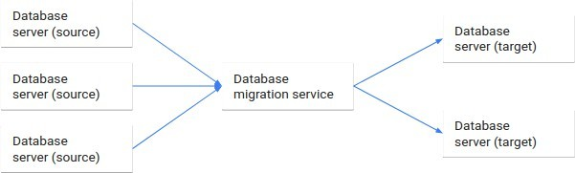

Whataretheadvantagesofmigration tools?

Migrations are helpful because they allow database schemas to evolve as requirements change. They help developers plan, validate, and safely apply schema changes to their environments. These compartmentalized changes are defined on a granular level and describe the transformations that must take place to move between various "versions" of the database.

In general, migration systems create artifacts or files that can be shared, applied to multiple databasesystems, andstoredinversioncontrol. This helpsconstructahistoryofmodificationsto the database that can be closely tied to accompanying code changes in the client applications. The database schema and the application's assumptions about that structure can evolve intandem.

Some other benefits include being allowed (and sometimes required) to manually tweak the process by separating the generation of the list of operations from the execution of them. Each change can be audited, tested, and modified to ensure that the correct results are obtained while still relying on automation for the majority of the process.

Statebasedmigration

State based migration software creates artifacts that describe how to recreate the desired database state from scratch. The files that it produces can be applied to an empty relational database system to bring it fully up to date.
After the artifacts describing the desired state are created, the actual migration involves comparing the generated files against the current state of the database. This process allows the softwareto analyze the difference betweenthe two statesand generate anew file orfiles to bring the current database schema in line with the schema described by the files. These change operations are then applied to the database to reach the goal state.

Whattokeep inmindwithstatebasedmigrations

Like almost all migrations, state based migration files must be carefully examined by knowledgeable developerstooversee the process. Boththe filesdescribing the desired finalstate and the files that outline the operations to bring the current database into compliance must be reviewed to ensure that the transformations will not lead to data loss. For example, if the generated operations attempt to rename a table by deleting the current one and recreating it with its new name, a knowledgable human must recognize this and intervene to prevent data loss.

State based migrations can feel rather clumsy if there are frequent major changes to the database schema that require this type of manual intervention. Because of this overhead, this technique is often better suited for scenarios where the schema is well-thought out ahead of time with fundamental changes occurring infrequently.

However, state based migrations do have the advantage ofproducing files that fullydescribe the databasestateinasinglecontext. Thiscanhelp newdevelopersonboard morequicklyandworks well with workflows in version control systems since conflicting changes introduced by code branches can be resolved easily.

Changebasedmigrations

The major alternative to state based migrations is a change based migration system. Change based migrations also produce files that alter the existing structures in a database to arrive at the desired state. Rather than discovering the differences between the desired database state and the current one, thisapproach buildsoffofaknowndatabasestateto definetheoperationsto bring it into the new state. Successive migration files are produced to modify the database further, creating a series of change files that can reproduce the final database state when applied consecutively.

Because change based migrations work by outlining the operations required from a known database state to the desired one, an unbroken chain of migration files is necessary from the initial starting point. This system requires an initial state, which may be an empty database systemor a files describing the starting structure, the files describing the operations that takethe schema through each transformation, and a defined order which the migration files must be applied.

Whattokeepinmindwithchange basedmigrations

Changebased migrationstracetheprovenanceofthedatabaseschemadesignbacktotheoriginal structure through the series of transformation scripts that it creates. This can help illustrate the evolutionofthe database structure, but is less helpfulfor understanding the complete stateofthe database at anyone point since the changes described in each file modifythe structure produced by the last migration file.

Since the previous state is so important to change based systems, the system often uses adatabase within the database system itselfto track which migration files have been applied. This helps the software understand what statethe system is currentlyin without having to analyze the current structure and compare it against the desired state, known only by compiling the entire series of migration files.

The disadvantage of this approach is that the current state of the database isn't described in the code base after the initial point. Each migration file builds off of the previous one, so while the changes are nicely compartmentalized, the entire database state at any one point is much harder to reason about. Furthermore, because the order of operations is so important, it can be more difficult to resolve conflicts produced by developers making conflicting changes.

Change based systems, however, do have the advantage of allowing for quick, iterative changes to the database structure. Instead of the time intensive process of analyzing the current state of the database, comparing it tothe desired state, creating files to performthe necessaryoperations, andapplyingthemtothedatabase, change basedsystemsassumethecurrent stateofthedatabase based on the previous changes. This generally makes changes more light weight, but does make out of band changes to the database especially dangerous since migrations can leave the target systems in an undefined state.

Microservices

Micro services, often referred to as Micro services architecture, is an architecturalapproach that involves dividing large applications into smaller, functional units capable of functioning and communicating independently.

This approach arose in response to the limitations of monolithic architecture. Because monoliths are large containers holding allsoftware components ofanapplication, theyare severelylimited: inflexible, unreliable, and often develop slowly.

With micro services, however, each unit is independently deployable but can communicate with each other when necessary. Developers can now achieve thescalability, simplicity, andflexibility needed to create highly sophisticated software.

Howdoesmicroservicesarchitecturework?
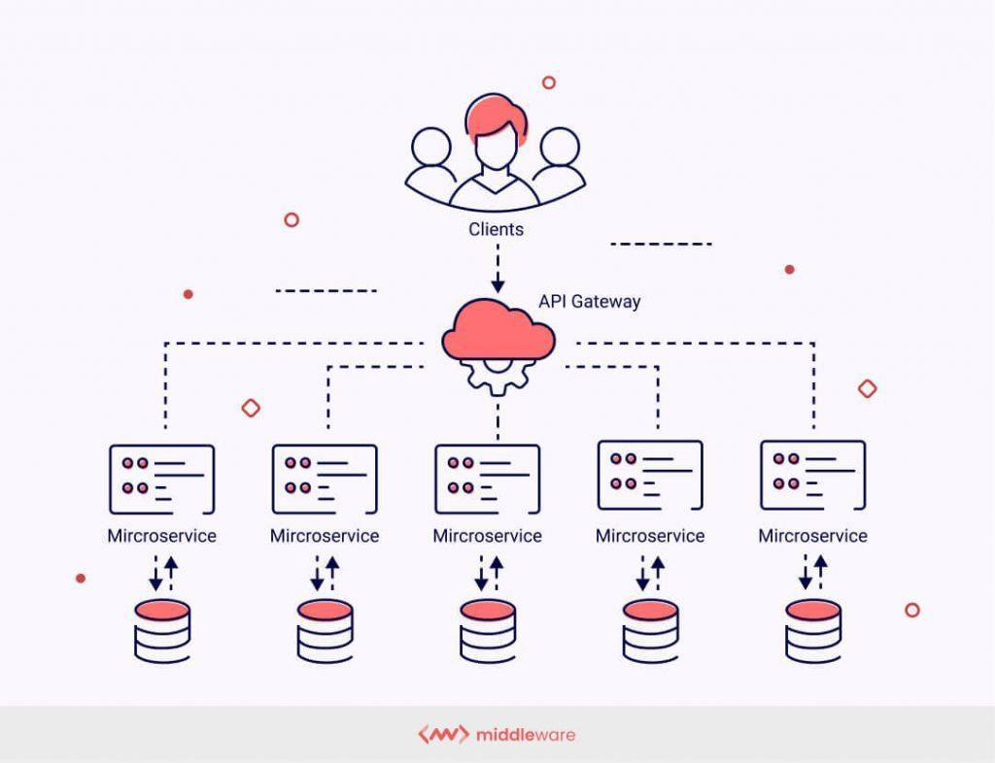

Thekeybenefitsofmicroservicesarchitecture

Microservices architecture presents developers and engineers with a number of benefits that monoliths cannot provide. Here are a few of the most notable.

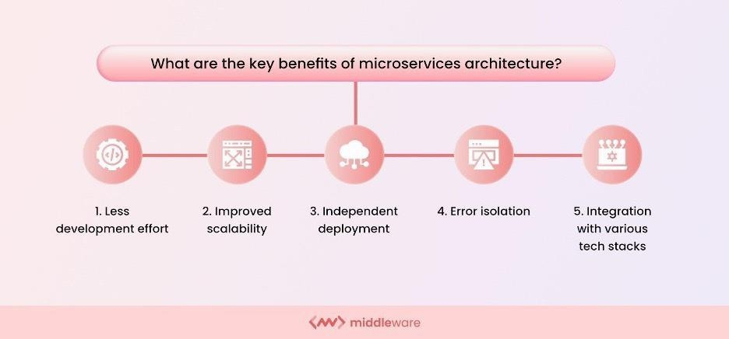

- Lessdevelopmenteffort

Smaller development teams can work in parallel on different components to update existing functionalities. This makes it significantly easier to identify hot services, scale independently from the rest of the application, and improve the application.

- Improvedscalability

Microservices launch individual services independently, developed in different languages or technologies;alltechstacksarecompatible, allowingDevOpsto chooseanyofthe most efficient tech stacks without fearing if they will work well together. These small services work on relatively less infrastructure than monolithic applications by choosing the precise scalability of selected components per their requirements.

- Independentdeployment

Eachmicroserviceconstitutinganapplicationneedstobea fullstack.Thisenablesmicroservices to be deployed independently at any point. Since microservices are granular in nature, development teams can work on one microservice, fix errors, then redeploy it without redeploying the entire application.

Microservice architecture is agile and thus does not need a congressional act to modify the program by adding or changing a line of code or adding or eliminating features. The software offers to streamline business structures through resilience improvisation and fault separation.

- Errorisolation

In monolithic applications, the failure of even a small component of the overall application can make it inaccessible. In some cases, determining the error could also be tedious. With microservices, isolating the problem-causing component is easy since the entire application is divided into standalone, fully functional software units. If errors occur, other non-related units will still continue to function.

- Integrationwithvarioustechstacks

With microservices, developers have the freedom to pick the tech stack best suited for one particular microservice and its functions. Instead of opting for one standardized tech stack encompassing all of an application’s functions, they have complete control over their options.

What isthemicroservicesarchitectureused for?

Putsimply: microservicesarchitecturemakesappdevelopment quicker and moreefficient. Agile deployment capabilities combined with the flexible application of different technologies drastically reduce the duration of the development cycle. The following are some of the most vital applications of microservices architecture.

Dataprocessing

Since applications running on microservice architecture can handle more simultaneous requests, microservices can process large amounts of information in less time. This allows for faster and more efficient application performance.

Mediacontent

Companies like Netflix and AmazonPrime Video handle billionsofAPI requestsdaily. Services such as OTT platforms offering users massive media content will benefit from deploying a microservices architecture. Microservices will ensure that the plethora of requests for different subdomains worldwide is processed without delays or errors.

Website migration

Website migration involves a substantial change and redevelopment of a website’s major areas, suchasitsdomain,structure,userinterface,etc.Usingmicroserviceswillhelpyouavoid

business-damaging downtime and ensure your migration plans execute smoothly without any hassles.

Transactionsandinvoices

Microservices are perfect for applications handling high payments and transaction volumes and generating invoices for the same. The failure of an application to process payments can cause huge losses for companies. With the help of microservices, the transaction functionality can be made more robust without changing the rest of the application.

Microservicestools

Building a microservices architecture requires a mix of tools and processes to perform the core building tasks and support the overall framework. Some of these tools are listed below.
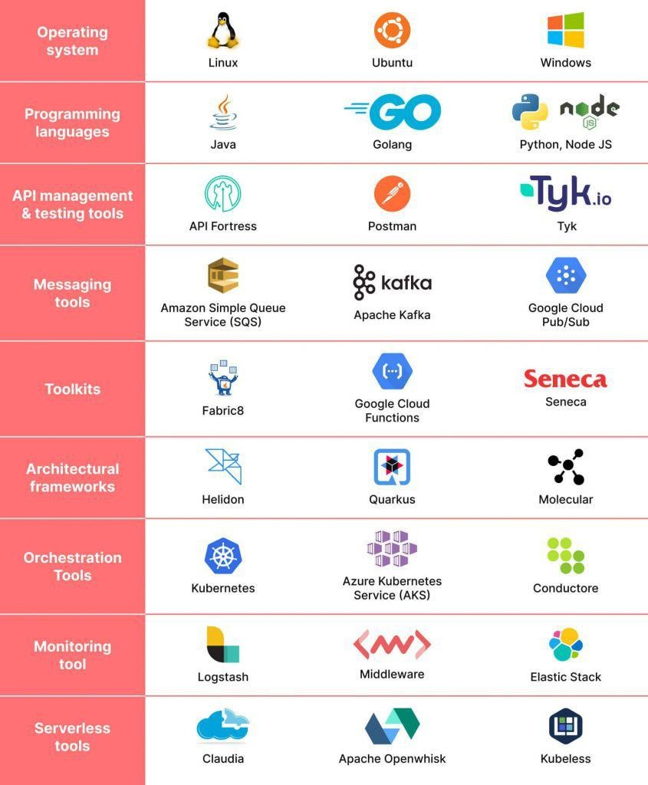

- Operating system

The most basic tool required to build an application is an operating system (OS). One such operating system allows great flexibility in development and uses in Linux. It offers a largely self-contained environment for executing program codes and a series of options for large and small applications in terms of security, storage, and networking.

- Programminglanguages

One of the benefits of using a microservices architecture is that you can use a variety of programming languages across applications for different services. Different programming languages have different utilities deployed based on the nature of the microservice.

- APImanagementandtestingtools

The various services need to communicate when building an application using a microservices architecture. This is accomplished using applicationprogramming interfaces (APIs). For APIs to work optimally and desirably, they need to be constantly monitored, managed and tested, and API management and testing tools are essential for this.

- Messagingtools

Messagingtoolsenablemicroservicestocommunicatebothinternallyandexternally.Rabbit MQ and Apache Kafka are examples of messaging tools deployed as part of a microservice system.

- Toolkits

Toolkits in a microservices architecture are tools used to build and develop applications. Different toolkits are available to developers, and these kits fulfill different purposes. Fabric8and Seneca are some examples of microservices toolkits.

- Architecturalframeworks

Microservices architectural frameworks offer convenient solutions for application development and usually contain a libraryof code and tools to help configure and deployan application.

- Orchestrationtools

A container is a set of executables, codes, libraries, and files necessary to run a microservice. Container orchestration tools provide a framework to manage and optimize containers within microservices architecture systems.

- Monitoringtools

Once a microservices application is up and running, you must constantly monitor it to ensure everything is working smoothlyand as intended. Monitoring toolshelp developers stayontopof the application’s work and avoid potential bugs or glitches.

- Serverless tools Serverless tools further add flexibility and mobility to the various microservices within an application by eliminating server dependency. This helps in the easier rationalization and division of application tasks.

Microservicesvsmonolithic architecture

With monolithic architectures, all processes are tightly coupled and run as a single service. This means that if one process of the application experiences a spike in demand, the entirearchitecture must be scaled. Adding or improving a monolithic application’s features becomes more complex as the code base grows. This complexity limits experimentation and makes it difficult to implement new ideas. Monolithic architectures add risk for application availability because many dependent and tightly coupled processes increase the impact of a single process failure.
With a microservices architecture, an application is built as independent components that run each application process as a service. These services communicate via a well-defined interface using lightweight APIs. Services are built for business capabilities and each service performs a single function. Because theyare independently run, each service can be updated, deployed, and scaled to meet demand for specific functions of an application.

Datatier
The data tier in DevOps refers to the layer of the application architecture that is responsible for storing, retrieving, and processing data. The data tier is typically composed of databases, data warehouses, and data processing systems that manage large amounts of structured and unstructured data.

In DevOps, the data tier is considered an important aspect of the overall application architecture and is typically managed as part of the DevOps process. This includes:
- Datamanagement andmigration:Ensuringthatdataisproperlymanagedand migratedas part of the software delivery pipeline.
- Data backup and recovery: Implementing data backup and recovery strategies to ensure that data can be recovered in case of failures or disruptions.
- Data security: Implementing data security measures to protect sensitive information and comply with regulations.
- Data performance optimization: Optimizing dataperformance to ensure that applications and services perform well, even with large amounts of data.
- Data integration: Integrating data frommultiple sources to provide a unified view ofdata and support business decisions.
Byintegrating data management intothe DevOps process, teams canensure that data is properly managed and protected, and that data-driven applications and services perform well and deliver value to customers.

Devopsarchitectureandresilience

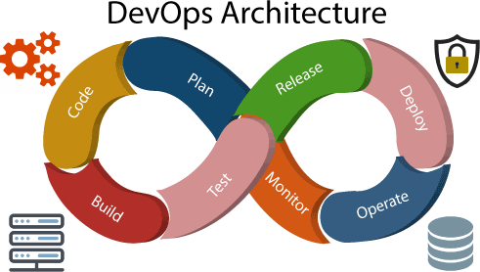

Development and operations both play essential roles in order to deliver applications. The deployment comprises analyzing the requirements, designing, developing, andtestingof the software components or frameworks.

The operation consists of the administrative processes, services, and support for the software. When both the development and operations are combined with collaborating, then the DevOps architecture is the solution to fix the gap between deployment and operation terms; therefore, delivery can be faster.

DevOps architecture is used for the applications hosted on the cloud platform and large distributed applications. Agile Development is used in the DevOps architecture so that integration and delivery can be contiguous. When the development and operations team works separately from each other, then it is time-consuming to design, test, and deploy. And if the terms are not in sync with each other, then it may cause a delay in the delivery. So DevOps enables the teams to change their shortcomings and increases productivity.

BelowarethevariouscomponentsthatareusedintheDevOpsarchitecture
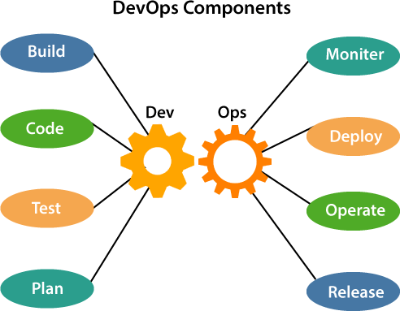

- Build

Without DevOps, the cost of the consumption of the resources was evaluated based on the pre- definedindividual usage with fixedhardware allocation. And with DevOps, the usage of cloud,

sharing of resources comes into the picture, and the build is dependent upon the user's need, which is a mechanism to control the usage of resources or capacity.

- Code

Manygood practices such as Git enables the code to be used, which ensures writing the code for business, helps to track changes, getting notified about the reason behind the difference in the actual and the expected output, and if necessary reverting to the original code developed. The code can be appropriately arranged in files, folders, etc. And theycan be reused.

- Test

The application will be ready for production after testing. In the case of manual testing, it consumes more time in testing and moving the code to the output. The testing can be automated, which decreases the time for testing so that the time to deploy the code to production can be reduced as automating the running of the scripts will remove many manual steps.

- Plan

DevOps use Agile methodology to plan the development. With the operations and development team in sync, it helps in organizing the workto plan accordingly to increase productivity.

- Monitor

Continuous monitoring isusedto identifyanyrisk offailure. Also, it helps intrackingthesystem accurately so that the health of the application can be checked. The monitoring becomes more comfortable with services where the log data may get monitored through many third-party tools such as Splunk.

- Deploy

Many systems can support the scheduler for automated deployment. The cloud management platformenables users to capture accurate insights and view the optimization scenario, analytics on trends by the deployment of dashboards.

- Operate

DevOps changes the way traditional approach of developing and testing separately. The teams operate in a collaborative way where both the teams actively participate throughout the service lifecycle. Theoperationteaminteractswithdevelopers, and theycomeup witha monitoring plan which serves the IT and business requirements.

- Release

Deployment to anenvironment canbe done byautomation. But whenthe deployment is made to the productionenvironment, it is done by manual triggering. Manyprocesses involved inrelease management commonly used to do the deployment in the production environment manually to lessen the impact on the customers.

DevOpsresilience

DevOps resilience refers to the ability of a DevOps system to withstand and recover fromfailures and disruptions. This means ensuring that the systems and processes used inDevOps are robust, scalable, and able to adapt to changing conditions. Some of the key components of DevOps resilience include:
  - Infrastructure automation: Automating infrastructure deployment, scaling, and management helps to ensure that systems are deployed consistently and are easier to manage in case of failures or disruptions.
  - Monitoringand logging:Monitoringsystems, applications, and infrastructureinreal-time and collecting logs can help detect and diagnose issues quickly, reducing downtime.
  - Disaster recovery: Having a well-designed disaster recovery plan and regularly testing it can help ensure that systems can quickly recover from disruptions.
  - Continuous testing: Continuously testing systems and applications can help identify and fix issues before they become critical.
  - High availability: Designing systems for high availability helps to ensure that systems remain up and running even in the event of failures or disruptions.
By focusing on these components, DevOps teams can create a resilient and adaptive DevOps system that is able to deliver high-quality applications and services, even in the face of failures and disruptions.

Unit 3 Introduction to project management

The need for source code control:
Source code control (also known as version control) is an essential part of DevOps practices. Here are a few reasons why:
Collaboration: Source code control allows multiple team members to work on the same codebase simultaneously and track each other's changes.
Traceability: Source code control systems provide a complete history of changes to the code, enabling teams to trace bugs, understand why specific changes were made, and roll back to previous versions if necessary.
Branching andmerging: Teamscancreate separatebranches for different featuresorbug fixes, then merge the changes back into the main codebase. This helps to ensure that different parts of the code can be developed independently, without interfering with each other.
Continuous integration and delivery: Source code control systems are integral to continuous integration and delivery (CI/CD) pipelines, where changes to the code are automatically built, tested, and deployed to production.
Insummary, source codecontrolisa criticalcomponent ofDevOps practices, asit enablesteams to collaborate, manage changes to code, and automate the delivery of software.

History of source code management
The history of source code management (SCM) in DevOps dates back to the early days of software development. Early SCM systems were simple and focused on tracking changes to source code over time.
In the late 1990s and early2000s, the open-source movement and the rise ofthe internet led to a proliferation of new SCM tools, including CVS (Concurrent Versions System), Subversion, and Git. These systems made it easier for developers to collaborate on projects, manage multiple versions of code, and automate the build, test, and deployment process.
AsDevOps emergedasa softwaredevelopment methodologyinthe mid-2000s, SCM becamean integral part of the DevOps toolchain. DevOps teams adopted Git as their SCM tool of choice, leveraging its distributed nature, branch and merge capabilities, and integration with CI/CD pipelines.
Today, Git is the most widely used SCM system in the world, and is a critical component of DevOps practices. With the rise of cloud-based platforms, modern SCM systems also offer features like collaboration, code reviews, and integrated issue tracking.

RolesandcodeinDevops
In DevOps, roles and code play a critical role in the development, delivery, and operation of software.
Roles:
- Developmentteam:responsibleforwritingandtestingcode.
- Operationsteam:responsibleforthedeploymentandmaintenanceofthecodein production.
- DevOpsteam:responsibleforbridgingthegapbetweendevelopmentandoperations, ensuring that code is delivered quickly and reliably to production.
Code:
- Code is the backbone of DevOps and represents the software that is being developed, tested, deployed, and maintained.
- Code is managed using source code control systems like Git, which provide a way to track changes to the code over time, collaborate on the code with other team members, and automate the build, test, and deployment process.
- Code is continuously integrated and tested, ensuring that any changes to the code do not cause unintended consequences in the production environment.
Inconclusion, bothroles and code playa criticalrole inDevOps. Teams worktogether to ensure that code is developed, tested, and delivered quicklyand reliablyto production, while operations teams maintain the code in production and respond to any issues that arise.

Overall, SCM has been an important part of the evolution of DevOps, enabling teams to collaborate, manage code changes, and automate the software delivery process.

Sourcecodemanagementsystemandmigrations
- Asource codemanagement (SCM) systemis a softwareapplicationthat provides versioncontrol for source code. It tracks changes made to the code over time, enabling
teams torevertto previousversionsifnecessary,andhelpsensurethat
codecanbecollaboratedonby multiple team members.
- SCMsystemstypicallyprovide featuressuchasversiontracking, branchingand merging,change history, and rollback capabilities. Some popular SCM systems include Git,Subversion, Mercurial, and Microsoft Team Foundation Server.
- Source code management (SCM) systems are often used to manage code migrations, which are the process of moving code fromone environment to another. This is typically done as part of a software development project, where code is moved from adevelopment environment to a testing environment and finally to a production environment.
SCMsystemsprovideanumberofbenefits formanagingcodemigrations,including:
- Versioncontrol
- Branching and merging
- Rollback
- Collaboration
- Automation
- Versioncontrol:SCMsystemskeeparecord of all changesto thecode, enablingteamsto track the code as it moves through different environments.
PurposeofVersionControl:
  - Multiple people can work simultaneously on a single project. Everyone works on and edits their owncopyofthe files and it is up to themwhen they wish to share the changes made by them with the rest of the team.
  - It also enables one person to use multiple computers to work on a project, so it is valuable even if you are working by yourself.
  - It integrates the workthat is done simultaneously bydifferent members of the team. In some rare cases, when conflicting edits are made by two people to the same line of a file, then humanassistance isrequestedbythe versioncontrolsystemindecidingwhat shouldbedone.
  - Version control provides access to the historical versions of a project. This is insurance against computer crashes or data loss. If any mistake is made, you can easily roll back to a previousversion.Itisalsopossibletoundospecificeditsthattoowithoutlosingthework

donein themeanwhile.Itcan beeasily known when,why,andby whom any partof afile was edited.

Benefitsoftheversion controlsystem:

  - Enhancestheprojectdevelopmentspeedbyprovidingefficientcollaboration,
  - Leverages the productivity, expedites product delivery, and skills of the employees through better communication and assistance,
  - Reduce possibilities of errors and conflicts meanwhile project development through traceability to every small change,
  - Employees or contributors of the project can contribute from anywhere irrespective of the different geographical locations through this VCS,
  - For each different contributor to the project, a different working copy is maintained and not mergedtothemainfileunlesstheworkingcopyisvalidated.Themostpopularexample is Git, Helix core, Microsoft TFS,
  - Helps inrecoveryincaseofanydisasterorcontingentsituation,
  - InformsusaboutWho,What, When,Whychanges havebeenmade.

TypesofVersionControlSystems:

  - LocalVersionControlSystems
  - Centralized VersionControlSystems
  - DistributedVersionControlSystems

Local Version Control Systems: It is one ofthe simplest forms and has a database that kept all the changes to files under revision control. RCS is one ofthe most common VCS tools. It keeps patch sets (differences between files) in a special format on disk. Byadding up all the patches it can then re-create what any file looked like at any point in time.
Centralized Version Control Systems: Centralized version control systems contain just one repositorygloballyand everyuser need to commit for reflecting one’s changes in the repository. It is possible for others to see your changes by updating.
Twothingsarerequiredtomakeyour changesvisibletootherswhichare:
  - Youcommit
  - Theyupdate

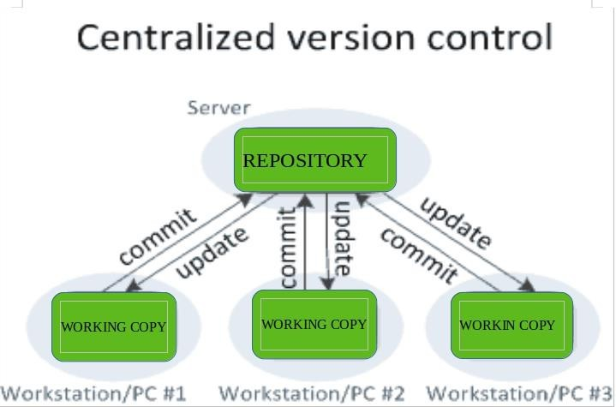

Thebenefit of CVCS (Centralized Version Control Systems) makes collaboration amongst developers along with providing an insight to a certain extent on what everyone else is doing on the project. It allows administrators to fine-grained control over who can do what.
It has some downsidesas well which led to the development of DVS. The most obvious is the single point offailure thatthe centralized repositoryrepresents ifit goes downduring that period collaboration and saving versioned changes is not possible. What if the hard disk of the central database becomes corrupted, and proper backups haven’t been kept? You lose absolutely everything.

DistributedVersionControlSystems:
Distributed version control systems contain multiple repositories. Each user has their own repository and working copy. Just committing your changes will not give others access to your changes. This is because commit willreflect those changes in your localrepositoryand you need to push them in order to make them visible on the central repository. Similarly, When you update, you do not get others’ changes unless you have first pulled those changes into your repository.
Tomakeyour changesvisibletoothers,4thingsarerequired:
  - Youcommit
  - You push
  - They pull
  - Theyupdate
The most popular distributed version control systems are Git, and Mercurial. They helpus overcome the problem of single point of failure.

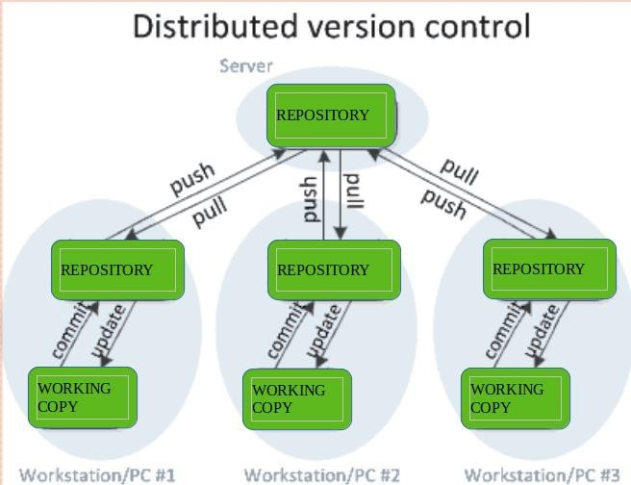

- Branching and merging: Teams can create separate branches of code for different environments, making it easier to manage the migration process.
Branching and merging are key concepts in Git-based version control systems, and are widely used in DevOps to manage the development of software.
Branching in Git allows developers to create a separate line ofdevelopment for a new feature or bug fix. This allows developers to make changes to the code without affecting the main branch, and to collaborate with others on the same feature or bug fix.
Merging in Git is the process of integrating changes made in one branch into another branch. In DevOps, merging is often used to integrate changes made in a feature branch into the main branch, incorporating the changes into the codebase.
Branchingandmergingprovideseveralbenefitsin DevOps:
Improved collaboration: Byallowing multiple developers to workonthe same codebase at the same time, branching and merging facilitate collaboration and coordination among team members.
Improved code quality: By isolating changes made in a feature branch, branching and merging make it easier to thoroughly review and test changes before they are integrated into the main codebase, reducing the risk of introducing bugs or other issues.
Increased transparency: Bytracking allchanges made to the codebase, branching and merging provide a clear audit trail of how code has evolved over time.

Overall, branching and merging are essential tools in the DevOps toolkit, helping to improve collaboration, code quality, and transparency in the software development process.
Rollback: In the event of a problem during a migration, teams can quickly revert to a previous version of the code.
Rollback inDevOps refers tothe processofreverting a change orreturning to aprevious version of a system, application, or infrastructure component. Rollback is an important capability in DevOps, as it provides a way to quickly and efficiently revert changes that have unintended consequences or cause problems in production.
Thereareseveralapproachesto rollbackinDevOps,including:
Version control: By using a version control system, such as Git, DevOps teams can revert to a previous version of the code by checking out an earlier commit.
Infrastructure as code: By using infrastructure as code tools, such as Terraform or Ansible, DevOps teams can roll back changes to their infrastructure by re-applying an earlier version of the code.
Continuous delivery pipelines: DevOps teams can use continuous delivery pipelines to automate the rollback process, by automatically reverting changes to a previous version of the code or infrastructure if tests fail or other problems are detected.
Snapshots: DevOps teams can use snapshots to quickly restore an earlier version of a system or infrastructure component.
Overall, rollback is an important capability in DevOps, providing a way to quickly revertchanges that have unintended consequences or cause problems in production. By using a combination of version control, infrastructure as code, continuous delivery pipelines, and snapshots, DevOps teams can ensure that their systems and applications can be quickly andeasily rolled back to a previous version if needed.
Collaboration: SCM systems enable teams to collaborate on code migrations, with team members working on different aspects of the migration process simultaneously.
Collaboration is a key aspect of DevOps, as it helps to bring together development, operations, and other teams to work together towards a common goal of delivering high-quality software quickly and efficiently.
InDevOps,collaborationisfacilitatedbyarangeoftoolsand practices,including:
Version control systems: By using a version control system, such as Git, teams can collaborate on code development, track changes to source code, and merge code changes from multiple contributors.

Continuous integration and continuous deployment (CI/CD): By automating the build, test, and deployment ofcode,CI/CD pipelines help to streamline the development processand reduce the risk of introducing bugs or other issues into the codebase.
Code review: By using code review tools, such as pull requests, teams can collaborate on code development, share feedback, and ensure that changesare thoroughlyreviewed and tested before they are integrated into the codebase.
Issue tracking: By using issue tracking tools, such as JIRA or GitHub Issues, teams can collaborateonresolving bugs, trackingprogress, and managingthedevelopmentofnew features.
Communicationtools: Byusingcommunicationtools, suchasSlackorMicrosoft Teams, teams can collaborate and coordinate their work, share information, and resolve problems quickly and efficiently.
Overall, collaboration is a critical component of DevOps, helping teams to work together effectively and efficiently to deliver high-quality software. By using a range of tools and practices to facilitate collaboration, DevOps teams can improve the transparency, speed, and quality of their software development processes.

Automation: Many SCM systems integrate with continuous integration and delivery (CI/CD) pipelines, enabling teams to automate the migration process.
In conclusion, SCM systems play a critical role in managing code migrations. They provide a way to track code changes, collaborate on migrations, and automate the migration process, enabling teams to deliver code quickly and reliably to production.

Sharedauthentication
SharedauthenticationinDevOps refers tothepracticeof usinga commonidentity management system tocontrol access to the various tools, resources, and systems used in software development and operations.This helps to simplify the process of managing users and permissions and ensures that everyone has thenecessary access to perform their jobs. Examples of shared authentication systems include ActiveDirectory, LDAP, and SAML-based identity providers.

HostedGitservers
Hosted Git servers are online platforms that provide Git repository hosting services for softwaredevelopment teams. They are widely used in DevOps to centralize version control of source code, trackchanges, andcollaborateoncode development. Some popular hostedGit servers includeGitHub, GitLab,and Bitbucket. These platforms offer features such as pull requests, code reviews, issue tracking, andcontinuous integration/continuous deployment (CI/CD) pipelines. By using a hosted Git server, DevOpsteams can streamline their development processes and collaborate more efficiently on code projects.

DifferentGitserverimplementations
Thereareseveraldifferent Git server implementationsthatorganizationscanuseto hosttheirGit repositories. Some of the most popular include:
GitHub: One ofthe largest Git repository hosting services, GitHub is widely used bydevelopers for version control, collaboration, and code sharing.
GitLab: An open-source Git repository management platform that provides version control, issue tracking, code review, and more.
Bitbucket: A web-based Git repository hosting service that provides version control, issue tracking, and project management tools.
Gitea: Anopen-sourceGitserverthatisdesignedtobelightweight, fast, andeasytouse.
Gogs: Another open-source Git server, Gogs is designed for small teams and organizations and provides a simple, user-friendly interface.
GitBucket: A Git server written in Scala that provides a wide range of features, including issue tracking, pull requests, and code reviews.
Organizations can choose the Git server implementation that best fits their needs, taking into account factors such as cost, scalability, and security requirements.

Dockerintermission

Docker is an open-source project with a friendly-whale logo that facilitates the deployment of applications in software containers. It is a set of PaaS products that deliver containers (software packages) using OS-level virtualization. It embodies resource isolation features of the Linux kernel but offers a friendly API.
In simple words, Docker is a tool or platform design to simplify the process of creating, deploying, and packaging and shipping out applications along with its parts such as libraries and other dependencies. Its primary purpose is to automate the application deployment process and operating-system-level virtualization on Linux. It allows multiple containers to run on the same hardware and provides high productivity, along with maintaining isolated applications and facilitating seamless configuration.

Dockerbenefits include:
- HighROIandcostsavings
- Productivityand standardization
- Maintenanceandcompatibility
- Rapiddeployment

- Fasterconfigurations
- Seamlessportability
- Continuoustestingand deployment
- Isolation,segregation,andsecurity
Dockervs.VirtualMachines

Virtual Machine is an application environment that imitates dedicated hardware by providing an emulation of the computer system. Docker and Vmboth have their set of benefits and uses, but when it comes to running applications in multiple environments, both can be utilized. So which one wins? Let's get into a quick Docker vs. VM comparison.

OS Support: VM requires a lot of memorywhen installed in an OS, whereas Docker containers occupy less space.

Performance: Running severalVMscanaffect theperformance,whereas,Dockercontainersare stored in a single Docker engine; thus, they provide better performance.
Boot-uptime:VMshavealongerbootingtimecomparedtoDocker. Efficiency: VMs have lower efficiency than Docker.

Scaling: VMsaredifficulttoscaleup, whereasDockeriseasytoscaleup.

Space allocation: You cannot share data volumes with VMs, but you can share and reuse them among various Docker containers.

Portability: With VMs, you can face compatibility issues while porting across different platforms; Docker is easily portable. Clearly, Docker is a hands-down winner.

Gerrit
Gerritis a web based code review tool which is integrated with Gitand builton top of Git version control system (helps developers to work together and maintain the history of their work). It allows to merge changes to Git repository when you are done with the code reviews.
Gerritwas developedbyShawn Pearce atGoogle which is written in Java,Servlet, GWT(Google Web Toolkit). The stable release of Gerrit is 2.12.2 and published on March 11, 2016 licensed under Apache License v2.

WhyUseGerrit?
Followingarecertainreasons, whyyoushoulduseGerrit.

- Youcaneasilyfind theerror inthesourcecodeusing Gerrit.
- YoucanworkwithGerrit,ifyouhaveregularGitclient;noneedtoinstallanyGerrit client.
- Gerrit canbeusedasanintermediatebetweendevelopersandgitrepositories.

FeaturesofGerrit
- GerritisafreeandanopensourceGitversioncontrolsystem.
- TheuserinterfaceofGerritis formedon GoogleWebToolkit.
- Itisalightweightframeworkforreviewingeverycommit.
- Gerrit acts as a repository, whichallows pushing the code and creates the review for your commit.

AdvantagesofGerrit
- GerritprovidesaccesscontrolforGitrepositoriesandwebfrontendforcodereview.
- Youcanpushthecodewithoutusingadditionalcommandline tools.
- Gerrit can allow or decline the permission on the repository level and downto the branch level.
- GerritissupportedbyEclipse.

DisadvantagesofGerrit
- Reviewing,verifyingandresubmittingthecodecommitsslowsdownthetimetomarket.
- GerritcanworkonlywithGit.
- Gerritisslowandit'snotpossibletochangethesortorderinwhichchangesarelisted.
- Youneed administratorrightstoadd repositoryonGerrit.

Whatis Gerrit?

Gerrit is an exceptionally extensible and configurable apparatus for online code survey and storehouse the executives for projects utilizing the Git rendition control framework. Gerrit is similarlyhelpfulwhereallclientsarebelieved committers,forexample, might bethesituation with shut source business advancement.

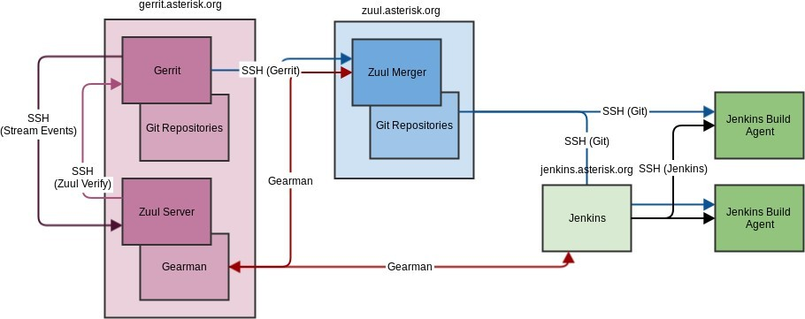

Itisusedtostorethe mergedcodebaseandthechangesunderreviewthat havenot being merged yet. Gerrit has the limitation of a single repository per project.

Gerrit isfirst andforemost anarrangingregionwherechangescanbelookedat priortoturning into apieceofthecodebase.Itislikewiseanempoweringagent forthissurveycycle,catching notes and remarks about the progressions to empower conversation of the change. This is especially valuable with conveyed groups where this discussion can’t occur eye to eye.

HowGerrit WorksArchitecture?
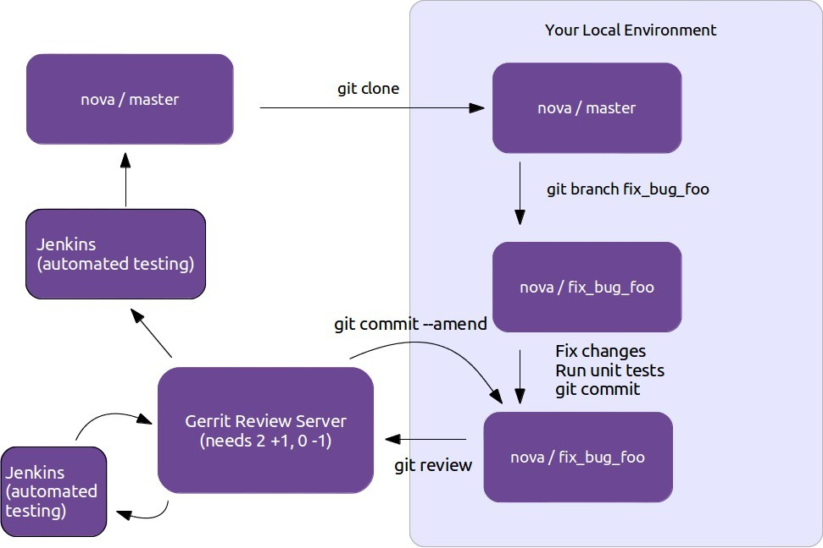
UsecaseofGerrit

- Knowledgeexchange:
  - Thecodereviewprocessallowsnewcomersto seethecodeofother more experienced developers.
  - Developerscangetfeedbackontheirsuggestedchanges.
  - Experienceddeveloperscanhelptoevaluatetheimpactonthewholecode.
  - Sharedcodeownership: byreviewingcodeofotherdevelopersthewholeteamgetsasolid knowledge of the complete code base.

Thepullrequestmodel
Pull request is a feature of Git-based version control systems that allows developers to propose changes to a Git repository and request feedback or approval f rom other team members. It is widely used in DevOps to facilitate collaboration and code review in the software development process.

Inthepullrequest model, adeveloper createsanewbranchinaGit repository, makeschangesto the code, and then opens a pull request to merge the changes into the main branch. Other team members can then review the changes, provide feedback, and approve or reject the request.
Pull Requests are a mechanism popularized bygithub, used to help facilitate merging of work, particularly inthe context ofopen-sourceprojects. Acontributorworksontheir contribution ina fork (clone) of the central repository. Once their contribution is finished theycreate a pull requesttonotifytheowner ofthecentralrepositorythattheir workisreadytobe merged intothe mainline. Tooling supports and encourages code review ofthe contribution before accepting the request. Pull requests have become widely used in software development, but critics are concerned by the addition of integration friction which can prevent continuous integration.
Pullrequests essentiallyprovide convenient tooling for a development workflow that existed in manyopen-sourceprojects, particularlythoseusingadistributedsource-controlsystem(suchas git). This workflow begins witha contributor creating a new logicalbranch, either bystarting a new branchinthecentralrepository,cloning into apersonalrepository,orboth.Thecontributor then works on that branch, typically in the style of a Feature Branch, pulling anyupdates
from Mainline into their branch. When they are done theycommunicate with the maintainer of the central repository indicating that theyare done, together with a reference to their commits. ThisreferencecouldbetheURLofabranchthat needsto beintegrated,orasetofpatches inan email.
Once the maintainer gets the message, she can then examine the commits to decide if they are readyto go into mainline. Ifnot, she can then suggest changes to the contributor, who then has opportunitytoadjusttheirsubmission.Onceallisok,themaintainercanthenmerge,eitherwith a regular merge/rebase or applying the patches from the final email.
Github's pullrequest mechanismmakes this flow mucheasier. It keepstrackofthe clones throughitsforkmechanism,andautomaticallycreatesamessagethreadto discussthepull request,together withbehavior to handle the various steps inthe review workflow. These conveniences were a major part of what made github successful and led to "pull request" becoming a fundamental part of the developer's lexicon.
So that's how pullrequests work, but should we use them, and if so how? To answer that question, Iliketostepback fromthe mechanismandthinkabouthowit worksinthecontextofa source code management workflow. To help me think about that, I wrote down a series ofpatternsformanagingsourcecodebranching.Ifindunderstandingthese(specificallytheBase and Integration patterns) clarifies the role of pull requests.
In terms of these patterns, pull requests are a mechanism designed to implement a combination ofFeatureBranching andPre-IntegrationReviews. Thustoassesstheusefulnessofpullrequests we first need to consider how applicable those patterns are to our situation. Like most patterns,

theyaresometimesvaluable, andsometimesapainintheneck - wehaveto examinethembased onour specific context. Feature Branching is a good wayof packaging together a logical contributionso that it canbe assessed, accepted,ordeferred as a single unit. This makes a lot of sense when contributors are not trusted to commit directlyto mainline. But Feature Branching comes at a cost, which is that it usually limits the frequency of integration, leading to complicated merges and deterring refactoring. Pre-Integration Reviews provide a clear place to do code review at the cost of a significant increase in integration friction. [1]
That's a drastic summary of the situation (I need a lot more words to explain this further in the feature branching article), but it boils down to the fact that the value ofthese patterns, and thus thevalueofpullrequests, rest mostlyonthesocial structureoftheteam. Someteamsworkbetter with pull requests, some teams would find pull requests a severe drag onthe effectiveness. I suspect thatsincepullrequestsaresopopular, a lotofteamsareusingthembydefault whenthey would do better without them.
While pull requests are built for Feature Branches, teams can use them within a ContinuousIntegration environment. To dothis theyneed to ensure that pullrequests are smallenough, and the team responsive enough, to follow the CI rule of thumb that everybody does MainlineIntegration at least daily. (And I should remind everyone that Mainline Integration is more than just mergingthecurrentmainlineintothefeaturebranch).Usingthe ship/show/askclassification can be an effective way to integrate pull requests into a more CI- friendly workflow.
The wide usage of pull requests has encouraged a wider use of code review, since pull requests provide a clear point for Pre-Integration Review, together with tooling that encourages it. Code review is a Good Thing, but we must remember that a pull request isn't the only mechanismwe can use for it. Manyteams find great value in the continuous review afforded by Pair Programming. To avoid reducing integration frquency we can carry out post-integration code review inseveralways. Aformalprocesscanrecordareview foreachcommit, oratechleadcan examine risky commits every couple ofdays. Perhaps the most powerful formofcode review is one that's frequently ignored. A teamthat takes the attitude that the codebase is a fluid system, one that can be steadily refined with repeated iteration carries out Refinement Code Revieweverytimeadeveloper looksat existingcode.Ioftenhearpeoplesaythat pullrequests are necessary because without them you can't do code reviews - that's rubbish. Pre-integration code review is just one wayto do code reviews, and for many teams it isn't the best choice.

ThepullrequestmodelprovidesseveralbenefitsinDevOps:
Improvedcodequality: Pullrequestsencouragecollaborationandcodereview,helpingtocatch potential bugs and issues before they make it into the main codebase.
Increasedtransparency:Pullrequestsprovideaclearaudittrailofallchangesmadetothe code, making

it easier to understand how code has evolved over time.

Better collaboration: Pull requests allow developers to share their work and get feedback from others, improving collaboration and communication within the development team.
Overall, thepullrequest modelisanimportanttoolintheDevOpstoolkit, helpingtoimprovethe quality, transparency, and collaboration of software development processes.

GitLab
GitLab is an open-source Git repository management platform that provides a wide range of features for software development teams. It is commonly used in DevOps for version control, issue tracking, code review, and continuous integration/continuous deployment (CI/CD) pipelines.
GitLab provides a centralized platform for teams to manage their Git repositories, track changes to source code, and collaborate on code development. It offers a range of tools to support code review and collaboration, including pull requests, code comments, and merge request approvals.
In addition, GitLab provides a CI/CD pipeline tool that allows teams to automate the process of building, testing, and deploying code. This helps to streamline the development process and reduce the risk of introducing bugs or other issues into the codebase.
Overall, GitLab is a comprehensive Git repository management platform that provides a wide rangeoftoolsand features forsoftwaredevelopment teams. Byusing GitLab, DevOpsteamscan improve the efficiency, transparency, and collaborationoftheir software development processes.

Whatis Git?

Git is a distributed version control system, which means that a local clone of the project is a complete version control repository. These fully functional local repositories make it easy to work offline or remotely. Developers commit their work locally, and then sync their copy of the repository with the copy on the server. This paradigm differs from centralized version control where clients must synchronize code with a server before creating new versions of code.

Git's flexibilityand popularitymake it a great choice for anyteam. Manydevelopers and college graduates already know how to use Git. Git's user community has created resources to train developersand Git'spopularitymake it easyto get help whenneeded. Nearlyeverydevelopment environment has Git support and Git command linetools implemented oneverymajor operating system.

Gitbasics

Everytime work is saved, Git creates a commit. A commit is a snapshot of all files at a point in time.Ifafilehasn'tchangedfromonecommittothenext,Gitusesthepreviouslystoredfile.

This design differs from other systems that store an initial version of a file and keep a record of deltas over time.
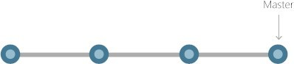

Commits create links to other commits, forming a graph ofthedevelopment history. It's possible to revert codeto a previouscommit, inspect how fileschanged fromone commit to the next, and review information such as where and when changes were made. Commits are identified in Git by a unique cryptographic hash ofthe contents ofthe commit. Because everything is hashed, it's impossible to make changes, lose information, or corrupt files without Git detecting it.

Branches

Each developer saves changes to their own localcode repository. As a result, there can be many different changes based off the same commit. Git provides tools for isolating changes and later merging them back together. Branches, which are lightweight pointers to work in progress, managethis separation. Onceworkcreatedina branchis finished, it canbe merged back intothe team's main (or trunk) branch.
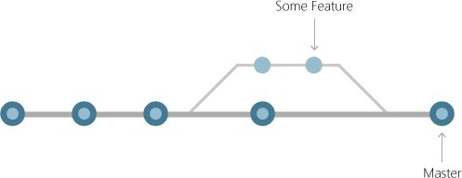

Filesand commits

Files in Git are in one of three states: modified, staged, or committed. When a file is first modified, the changesexist onlyinthe working directory. Theyaren't yet partofa commit orthe development history. The developer must stagethe changed files to be included in the commit. Thestaging areacontainsallchangestoincludeinthe nextcommit.Once the developerishappy

withthestagedfiles,the filesarepackagedasa commitwitha messagedescribingwhat changed. This commit becomes part of the development history.
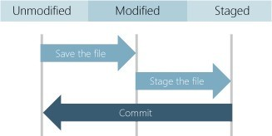

Staging lets developers pick which file changes tosave ina commit inorderto break downlarge changes into a series ofsmaller commits. Byreducing the scope ofcommits, it's easier to review the commit history to find specific file changes.

BenefitsofGit

ThebenefitsofGitaremany.

Simultaneousdevelopment

Everyone has their own local copy of code and can work simultaneously on their own branches. Git works offline since almost every operation is local.

Fasterreleases

Branches allow for flexible and simultaneous development. The main branch contains stable, high-quality code fromwhich you release. Feature branches contain work in progress, which are merged into the main branch upon completion. By separating the release branch from development in progress, it's easier to manage stable code and ship updates more quickly.

Built-inintegration

Due to its popularity, Git integrates into most tools and products. Every major IDE has built-in Git support, and many tools support continuous integration, continuous deployment, automated testing, work item tracking, metrics, and reporting feature integration with Git. This integration simplifies the day-to-day workflow.

Strongcommunitysupport

Git isopen-sourceand has becomethede facto standard forversioncontrol. There is no shortage oftools and resources available for teams to leverage. The volume ofcommunity support for Git compared to other version control systems makes it easyto get help when needed.

Gitworkswithany team

Using Git with a source code management tool increases a team's productivity by encouraging collaboration, enforcing policies, automating processes, and improving visibilityand traceability of work. The team can settle on individual tools for version control, work item tracking, and continuous integration and deployment. Or, they can choose a solution like GitHubor AzureDevOps that supports all of these tasks in one place.

Pull requests

Usepull requeststo discuss code changes with the team before merging them into the main branch. The discussions in pull requests are invaluable to ensuring code quality and increase knowledge across your team. Platforms like GitHub and Azure DevOps offer a rich pull request experience where developers can browse file changes, leave comments, inspect commits, view builds, and vote to approve the code.

Branchpolicies

Teams can configure GitHub and Azure DevOps to enforce consistent workflows and process across the team. They can set up branch policiesto ensure that pull requests meet requirements before completion. Branch policies protect important branches by preventing direct pushes, requiring reviewers, and ensuring clean builds.

Unit 4Integratingthesystem

Buildsystems
A build system is a key component in DevOps, and it plays an important role in the software development and delivery process. It automates the process of compiling and packaging source code into a deployable artifact, allowing for efficient and consistent builds.
Herearesomeofthekeyfunctionsperformedbyabuild system:
Compilation: The build system compiles the source code into a machine-executable format,such as a binary or an executable jar file.
Dependency Management: The build system ensures that all required dependencies are available and properly integrated into the build artifact. This can include external libraries, components, and other resources needed to run the application.
Testing: The build system runs automated tests to ensure that the code is functioning asintended, and to catch any issues early in the development process.
Packaging: The build system packages the compiled code and its dependencies into a single, deployable artifact, such as a Docker image or a tar archive.
Version Control: The build systemintegrates with versioncontrolsystems, suchas Git, totrack changes to the code and manage releases.
Continuous Integration: The build system can be configured to run builds automatically whenever changesaremadetothecode,allowingfor fast feedbackandcontinuous integrationof new code into the main branch.
Deployment: The build system can be integrated with deployment tools and processes to automate the deployment of the build artifact to production environments.
In DevOps, it's important to have a build system that is fast, reliable, and scalable, and that can integratewithother toolsandprocesses inthesoftwaredevelopment anddeliverypipeline. There are manybuildsystemsavailable, eachwithitsownset offeaturesandcapabilities, andchoosing the right one will depend on the specific needs of the project and team.

Jenkinsbuildserver

WhatisJenkin?

Jenkins is an open source automation tool written in Java programming language that allows continuous integration.

Jenkinsbuildsand testsoursoftwareprojectswhichcontinuouslymakingiteasierfor developers to integrate changes to the project, and making it easier for users to obtain a fresh build.
It also allows us to continuously deliverour software by integrating with a large number of testing and deployment technologies.

Jenkins offers a straightforward way to set up a continuous integration or continuous delivery environment for almost any combination of languages and source code repositories using pipelines, as well as automating other routine development tasks.

With the help of Jenkins, organizations can speed up the software development process through automation. Jenkins adds development life-cycle processes of all kinds, including build, document, test, package, stage, deploy static analysis and much more.

Jenkins achieves CI (Continuous Integration) with the help of plugins. Plugins is used to allow the integration of various DevOps stages. If you want to integrate a particular tool, you have to install the plugins for that tool. For example: Maven 2 Project, Git, HTML Publisher, Amazon EC2, etc.

For example: If any organization is developing a project, then Jenkinswill continuously test your project builds and show you the errors in early stages of your development.

PossiblestepsexecutedbyJenkinsareforexample:

- PerformasoftwarebuildusingabuildsystemlikeGradleorMaven Apache
- Executeashellscript
- Archiveabuild result
- Runningsoftwaretests

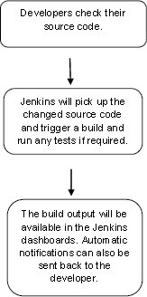

Jenkinworkflow

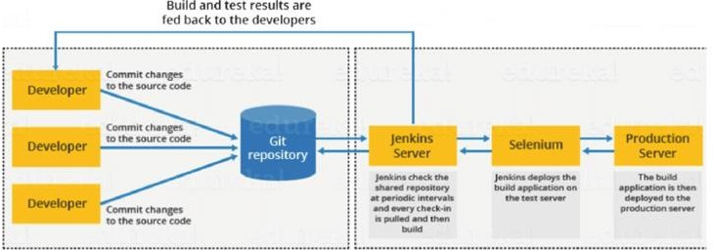

JenkinsMaster-SlaveArchitecture

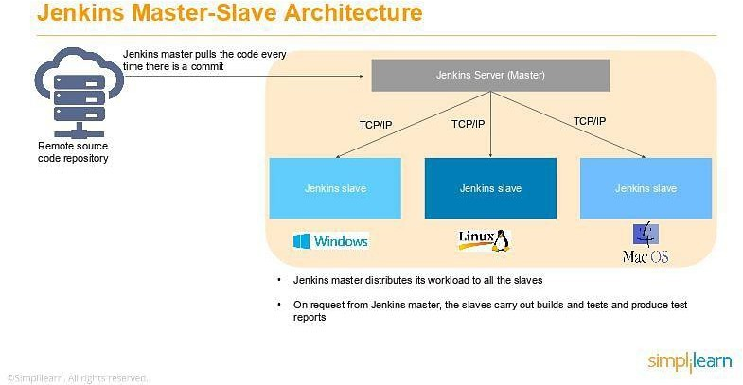

As you can see in the diagramprovided above, onthe left is the Remote source code repository. The Jenkins server accesses the master environment onthe left side and the master environment can push down to multiple other Jenkins Slave environments to distribute the workload.

That lets you run multiple builds, tests, and product environment across the entire architecture. JenkinsSlaves canberunningdifferent build versionsofthecode fordifferent operating systems and the server Master controls how each of the builds operates.

Supported on a master-slave architecture, Jenkins comprises many slaves working for a master. This architecture - the Jenkins Distributed Build - can run identical test cases in different environments. Results are collected and combined on the master node for monitoring.

JenkinsApplications

Jenkins helpsto automateandacceleratethesoftwaredevelopment process. Herearesomeofthe most common applications of Jenkins:

- IncreasedCodeCoverage

Code coverage is determined by the number of lines of code a component has and how many of them get executed. Jenkins increases code coverage which ultimately promotes a transparent development process among the team members.

- NoBrokenCode

Jenkins ensures that the code is good and tested well through continuous integration. The final code is merged only when all the tests are successful. This makes sure that no broken code is shipped into production.

What aretheJenkins Features?

Jenkinsoffersmanyattractivefeaturesfor developers:

  - EasyInstallation

Jenkinsisaplatform-agnostic,self-containedJava-basedprogram,readytorunwithpackagesfor Windows, Mac OS, and Unix-like operating systems.

  - EasyConfiguration

Jenkinsiseasily setup and configured using itswebinterface,featuringerrorchecksand abuilt-in help function.

  - AvailablePlugins

Therearehundreds of plugins availableinthe UpdateCenter, integratingwitheverytool intheCIand CD toolchain.

  - Extensible

Jenkins can be extended by means of its plugin architecture, providing nearly endless possibilities for what it can do.

  - EasyDistribution

Jenkins can easily distribute work across multiple machines for faster builds, tests, and deployments across multiple platforms.

  - FreeOpenSource

Jenkinsisanopen-sourceresourcebackedbyheavycommunitysupport.
AsapartofourlearningaboutwhatisJenkins,letusnextlearnabouttheJenkinsarchitecture.

Jenkinsbuild server

Jenkins is a popular open-source automation server that helps developers automate parts of the software development process. A Jenkins build server is responsible for building, testing, and deploying software projects.
A Jenkins build server is typically set up on a dedicated machine or a virtual machine, and is used to manage the continuous integration and continuous delivery (CI/CD) pipeline for a software project. The buildserver isconfiguredwithallthenecessarytools, dependencies, andpluginstobuild, test, anddeploy the project.
Thebuild process in Jenkins typically starts with code being committed to a version control system (such as Git), which triggers a build on the Jenkins server. The Jenkins server then checks out the code, buildsit, runs tests on it, and if everything is successful, deploys the code to a staging orproduction environment.
Jenkins has a large community of developers who have created hundreds of plugins that extend its functionality, so it's easy to find plugins to support specific tools, technologies, and workflows. For example, there are plugins for integrating with cloud infrastructure, running security scans, deploying to various platforms, and more.
Overall, a Jenkins build server can greatly improve the efficiency and reliability of the software development process by automating repetitive tasks, reducing the risk of manual errors, and enabling developers to focus on writing code.
Managingbuilddependencies
Managing build dependencies is an important aspect of continuous integration and continuous delivery (CI/CD) pipelines. In software development, dependencies refer to external libraries, tools, or resources that a project relies on to build, test, and deploy. Proper management of dependencies can ensure that builds are repeatable and that the build environment is consistent and up-to-date.

Herearesomecommonpracticesformanagingbuilddependencies inJenkins:
Dependency Management Tools: Utilize tools such as Maven, Gradle, or npm to manage dependencies and automate the process ofdownloading and installing required dependencies for a build.
Version Pinning: Specify exact versions of dependencies to ensure builds are consistent and repeatable.
Caching:Cachedependencieslocallyonthebuildservertoimprovebuildperformanceand reduce the time it takes to download dependencies.
ContinuousMonitoring:Regularlycheck
forupdatesandsecurityvulnerabilitiesindependen cies to ensure the build environment is secure and up-to-date.
AutomatedTesting:Automatedtestingcancatchissuesrelatedtodependenciesearlyinthe development process.
By following these practices,you can effectively manage build dependencies and maintain thereliability and consistency of your CI/CD pipeline.
Jenkinsplugins
Jenkins plugins are packages of software that extend the functionality of the Jenkins automation server. Plugins allow you to integrate Jenkins with various tools, technologies, and workflows, and can be easily installed and configured through the Jenkins web interface.
SomepopularJenkinspluginsinclude:
Git Plugin: This plugin integrates Jenkins with Git version controlsystem, allowing you to pull code changes, build and test them, and deploy the code to production.
MavenPlugin:ThispluginintegratesJenkinswithApacheMaven,abuildautomationtool commonly used in Java projects.
Amazon Web Services (AWS) Plugin: This plugin allows you to integrate Jenkins with Amazon Web Services (AWS), making it easier to run builds, tests, and deployments on AWS infrastructure.
Slack Plugin:This pluginintegrates Jenkins with Slack,allowingyou to receive notifications about build status, failures, and other important events in your Slack channels.
Blue Ocean Plugin: This plugin provides a new and modern user interface for Jenkins, makingit easier to use and navigate.
PipelinePlugin:ThispluginprovidesasimplewaytodefineandmanagecomplexCI/CD pipelines in Jenkins.

Jenkins plugins are easyto install and can be managed through the Jenkins web interface. There are hundredsofpluginsavailable, covering a wide range oftools, technologies, and use cases, so you can easily find the plugins that best meet your needs.
By using plugins, you can greatly improve the efficiency and automation of your software development process, and make it easier to integrate Jenkins with the tools and workflows you use.

GitPlugin
The Git Plugin is a popular plugin for Jenkins that integratesthe Jenkins automation server with the Git version control system. This plugin allows you to pull code changes from a Git repository, build and test the code, and deploy it to production.
With the Git Plugin, you can configure Jenkins to automatically build and test your code whenever changes are pushed to the Git repository. You can also configure it to build and test code on a schedule, such as once a day or once a week.
TheGitPluginprovidesanumberoffeatures formanagingcodechanges, including:
Branch and Tagbuilds: You canconfigure Jenkins to build specific branches ortags fromyour Git repository.
PullRequests:YoucanconfigureJenkinstobuildandtestpullrequestsfromyourGit repository, allowing you to validate code changes before merging them into the main branch.
Build Triggers: Youcanconfigure Jenkinsto build andtest code changeswhenever changesare pushed to the Git repository or on a schedule.
Code Quality Metrics: The Git Plugin integrates with tools such as SonarQube to provide code quality metrics, allowing you to track and improve the qualityof your code over time.
Notification and Reporting: The Git Plugin provides notifications and reports on build status, failures, and other important events. You can configure Jenkins to send notifications via email, Slack, or other communication channels.
ByusingtheGitPlugin,youcanstreamlineyoursoftwaredevelopmentprocessandmakeit easier to manage code changes and collaborate with other developers on your team.
filesystemlayout
In DevOps, the file system layout refers to the organization and structure of files and directories onthe systems and servers used for softwaredevelopment and deployment. Awell-designed file system layout is critical for efficient and reliable operations in a DevOps environment.
HerearesomecommonelementsofafilesystemlayoutinDevOps:

CodeRepository:Acentral coderepository,suchasGit,isusedtostoreandmanagesource code, configuration files, and other artifacts.
Build Artifacts: Build artifacts, such as compiled code, are stored in a designated directory for easy access and management.
Dependencies: Directories for storing dependencies, such as libraries and tools, are designated for easy management and version control.
ConfigurationFiles:Configurationfiles,suchasYAMLorJSONfiles,arestoredina designated directory for easy access and management.
LogFiles:Logfilesgeneratedbyapplications,builds,anddeploymentsarestoredina designated directory for easy access and management.
BackupandRecovery:Directoriesforstoringbackupsandrecoverydataaredesignatedfor easy management and to ensure business continuity.
Environment-specific Directories: Directories are designated for each environment, such as development, test, and production, to ensure that the correct configuration files and artifacts are used for each environment.
By following a well-designed file system layout in a DevOps environment, you can improve the efficiency, reliability, and securityof your software development and deployment processes.
Thehostserver
In Jenkins, a host server refers to the physical or virtual machine that runs the Jenkinsautomation server. The host server is responsible for running the Jenkins process and providing resources, such as memory, storage, and CPU, for executing builds and other tasks.
The host server can be either a standalone machine or part of a network or cloud-based infrastructure. When running Jenkins on a standalone machine, the host server is responsible for all aspects of the Jenkins installation, including setup, configuration, and maintenance.
When running Jenkins on a network or cloud-based infrastructure, the host server is responsible for providing resources for the Jenkins process, but the setup, configuration, and maintenance may be managed by other components of the infrastructure.
By providing the necessary resources and ensuring the stability and reliability of the host server, you can ensure the efficient operation of Jenkins and the success of your software development and deployment processes.
TohostaserverinJenkins,you'llneedtofollowthesesteps:

Install Jenkins: You can install Jenkins on a server by downloading the Jenkins WAR file, deploying it to a servlet container such as Apache Tomcat, and starting the server.
Configure Jenkins: Once Jenkins is up and running, you can access its web interface to configure and manage the build environment. You can install plugins, set up security, and configure build jobs.
Create a Build Job: To build your project, you'll need to create a build job in Jenkins. Thiswill define the steps involved in building your project, such as checking out the code from version control, compiling the code, running tests, and packaging the application.
Schedule Builds: You can configure your build job to run automatically at a specific time or when certain conditions are met. You can also trigger builds manually from the web interface.
MonitorBuilds: Jenkins provides a varietyoftools for monitoring builds, suchas build history, build console output, and build artifacts. You can use these tools to keep track of the status of your builds and to diagnose problems when they occur.

Buildslaves

JenkinsMaster-SlaveArchitecture



As you can see in the diagramprovided above, onthe left is the Remote source code repository. The Jenkins server accesses the master environment onthe left side and the master environment can push down to multiple other Jenkins Slave environments to distribute the workload.

That lets you run multiple builds, tests, and product environment across the entire architecture. JenkinsSlaves canberunningdifferent build versionsofthecode fordifferent operating systems and the server Master controls how each of the builds operates.

Supported on a master-slave architecture, Jenkins comprises many slaves working for a master. This architecture - the Jenkins Distributed Build - can run identical test cases in different environments. Results are collected and combined on the master node for monitoring.

The standard Jenkins installation includes Jenkins master, and in this setup, the master will be managing all our build system's tasks. If we're working on a number of projects, we can run numerous jobs on each one. Some projects require the use of specific nodes, which necessitates the use of slave nodes.
The Jenkins master is in charge of scheduling jobs, assigning slave nodes, and sending builds to slave nodes for execution. It will also keep track of the slave node state (offline or online), retrieve build results from slave nodes, and display them on the terminal output. In most installations, multiple slave nodes will be assigned to the task of building jobs.

Before we get started, let's double-check that we have all of the prerequisites in place for adding a slave node:
- JenkinsServerisupand runningand readytouse
- Anotherserverforaslavenodeconfiguration
- TheJenkinsserver andtheslaveserver arebothconnectedtothesame network

To configure the Master server, we'll log in to theJenkins server and follow the steps below. First, we'llgo to “ManageJenkins->ManageNodes->NewNode”tocreateanewnode:

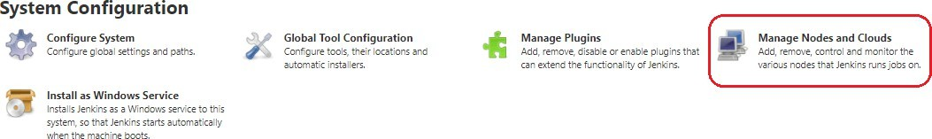

On the next screen, we enter the “Node Name” (slaveNode1), select “Permanent Agent”, then click “OK”:
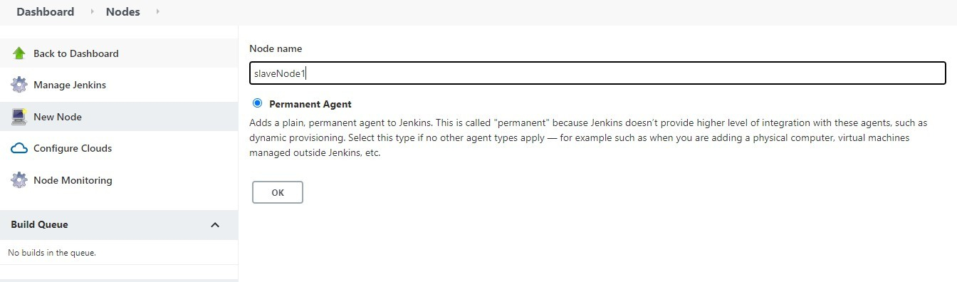
After clicking “OK”, we'll be taken to a screen with a newform where we need to fill out the slave node's information. We're consideringthe slave node to be running on Linux operating systems, hence the launch method is set to “Launch agents via ssh”.
In the same way, we'll add relevant details, such as the name, description, and a number of executors.
We'll save our work by pressing the “Save” button. The “Labels” with the name “slaveNode1” will help us to set up jobs on this slave node:

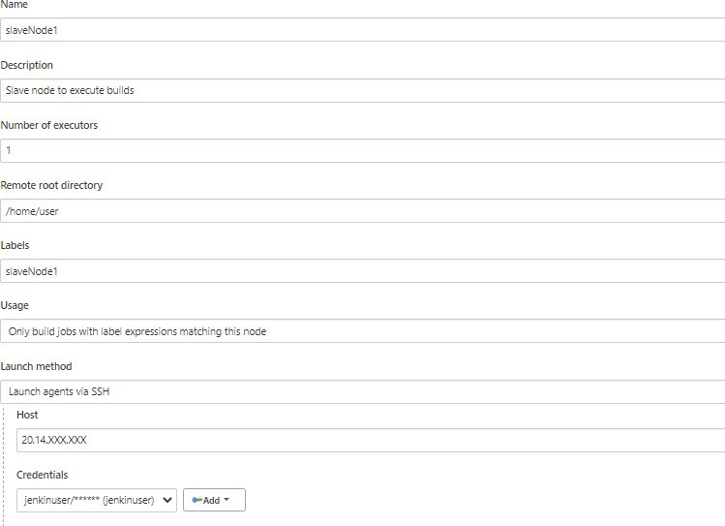

4.BuildingtheProjectonSlaveNodes

Nowthat our master and slave nodes are ready, we'lldiscuss the steps forbuilding the project on the slave node.
Forthis, westartbyclicking“NewItem”inthetopleftcorner ofthedashboard.
Next, we need to enter the name of our projectin the “Enter an item name” field and select the“Pipeline project”, and then click the “OK” button.
On the next screen, we'll enter a “Description” (optional) and navigate to the “Pipeline” section. Make sure the “Definition” field has the Pipeline script option selected.
After this,wecopyandpastethefollowingdeclarativePipelinescriptintoa“script”field:
node('slaveNode1'){ stage('Build') {
sh'''echo buildsteps'''
}
stage('Test'){
sh'''echoteststeps'''
}
}
Copy Next,weclickonthe“Save”button.ThiswillredirecttothePipelineviewpage.

On the left pane, we click the “Build Now” button to execute our Pipeline. After Pipeline execution is completed, we'll see the Pipeline view:
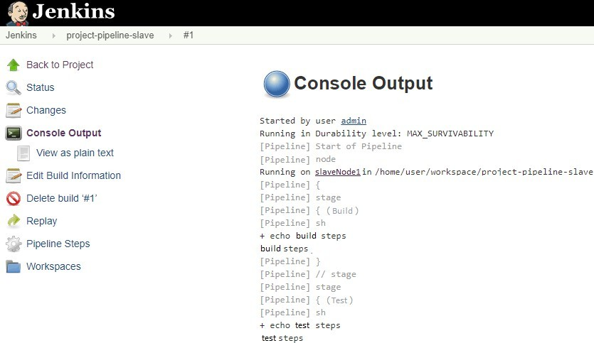
We can verify the history of the executed build under the Build History by clickingthe buildnumber. As shown above, when we clickon the build number and select “Console Output”, wecan seethat thepipelineranon our slaveNode1 machine.
Softwareonthehost
To run software on the host in Jenkins, you need to have the necessary dependencies and tools installed on the host machine. The exact software you'll need will depend on the specific requirements of your project and build process. Some common tools and software used inJenkins include:
Java:JenkinsiswritteninJavaandrequiresJavatobeinstalledonthehostmachine.
Git:Ifyourproject usesGit astheversioncontrolsystem, you'llneedto haveGit installedonthe host machine.
BuildTools:Depending on the programminglanguage and build process of yourproject, you may need to install build tools such as Maven, Gradle, or Ant.
TestingTools:Toruntestsaspartofyourbuildprocess,you'llneedtoinstallanynecessary testing tools, such as JUnit, TestNG, or Selenium.

Database Systems: If your project requires access to a database, you'll need to have the necessary database software installed on the host machine, such as MySQL, PostgreSQL, or Oracle.
ContinuousIntegrationPlugins:To extendthe functionalityofJenkins, you mayneedto install plugins that provide additional tools and features for continuous integration, such as the Jenkins GitHub plugin, Jenkins Pipeline plugin, or Jenkins Slack plugin.
To install these tools and software onthe host machine, you can use a package manager such as aptor yum, or youcandownloadand installthenecessarysoftware manually. Youcanalso usea containerization tool such as Docker to run Jenkins and the necessary software in isolated containers, which can simplify the installation process and make it easier to manage the dependencies and tools needed for your build process.

Trigger
Thesearethemost commonJenkinsbuildtriggers:

- Triggerbuildsremotely
- Buildafterotherprojectsarebuilt
- Buildperiodically
- GitHubhooktriggerforGITScmpolling
- PollSCM

- Triggerbuildsremotely:

If you want to trigger your project built from anywhere anytime then you should select Trigger builds remotely option from the build triggers.

You’llneed to provideanauthorizationtoken intheformofastring so thatonlythosewho know it would be able to remotely trigger this project’s builds. This provides the predefined URL to invoke this trigger remotely.
predefined URL to trigger build remotely: JENKINS_URL/job/JobName/build?token=TOKEN_NAME JENKINS_URL:the IPandPORTwhichtheJenkins server isrunning TOKEN_NAME:Youhaveprovidedwhileselectingthisbuildtrigger.
//Example:
http://e330c73d.ngrok.io/job/test/build?token=12345

WheneveryouwillhitthisURL fromanywhereyouprojectbuildwillstart.

- Buildafterotherprojectsare built

Ifyourprojectdependsonanotherprojectbuildthenyoushouldselect Buildafterotherprojects are built option from the build triggers.

Inthis, you must specifythe project(Job) names in the Projectsto watch field sectionand select one of the following options:

Afterthat,ItstartswatchingthespecifiedprojectsintheProjectstowatchsection.
1.
Trigger
only
if
the
build
is
Note:Abuildisstableifit wasbuiltsuccessfullyandnopublisherreportsitasunstable
2.
Trigger
even
if
the
build
is
u
Note:Abuildisunstableifitwasbuiltsuccessfullyandoneor morepublishersreportitunstable
3.Triggerevenifthebuildfails

Wheneverthebuildofthespecifiedprojectcompletes(eitherisstable,unstableorfailedaccording to your selected option) then this project build invokes.

- Build periodically:

Ifyouwanttoscheduleyourprojectbuildperiodicallythenyoushouldselectthe Build periodically
option from the build triggers. Youmustspecifytheperiodicaldurationoftheprojectbuildintheschedulerfieldsection
This field follows the syntax ofcron (with minor differences). Specifically, each line consists of 5 fields separated by TAB or whitespace:

MINUTEHOURDOMMONTHDOW

Minuteswithinthehour (0–59)
MINUTE

HOUR | Thehouroftheday(0–23)
DOM | Thedayofthemonth(1–31)
MONTH | Themonth(1–12)
DOW | Thedayoftheweek (0–7)where0 and7 areSunday.
Tospecifymultiplevaluesforonefield,thefollowingoperatorsareavailable.Intheorderof precedence,

- *specifiesallvalidvalues
- M-Nspecifies arangeof values
- M-N/Xor*/XstepsbyintervalsofXthroughthespecifiedrangeorwholevalidrange
- A,B,...,Zenumeratesmultiplevalues

Examples:

# every fifteen minutes |  | (perhaps | at |  | :07, :22, | :37, :52)
H/15 * |  | * |  |  | * | *
# every ten minutes in the | first | half of every hour |  | (three | times, perhaps at | :04, :14, :24)
H(0-29)/10 * |  | * |  |  | * | *
#onceevery twohoursat45minutespast |  | thehourstartingat9:45AM |  |  | andfinishingat3:45 | PMeveryweekday.
45 9-16/2 |  | * |  |  | * | 1-5
#onceinevery twohoursslotbetween9AM |  | and5PMeveryweekday(perhaps |  |  | at10:38AM,12:38PM, | 2:38PM,4:38PM)
H H(9-16)/2 |  | * |  |  | * | 1-5
# once a day on the 1st and 15th of every month except December HH1,151-11*
Aftersuccessfullyscheduledtheprojectbuildthentheschedulerwillinvokethebuild periodically according to your specified duration.

- GitHubwebhooktriggerforGITScm polling:

AwebhookisanHTTP callback, anHTTP POSTthatoccurswhensomething happensthrougha simple event-notification via HTTP POST.
GitHubwebhooksinJenkinsareusedtotriggerthebuildwheneveradevelopercommitssomething to the branch.

Let’sseehowtoaddbuild a webhook inGitHuband thenadd thiswebhookinJenkins.

- Gotoyourproject repository.
- Goto“settings”intherightcorner.
- Clickon“webhooks.”
- Click“Add webhooks.”
- WritethePayloadURLas
http://e330c73d.ngrok.io/github-webhook
//ThisURL isapublicURLwhere theJenkinsserveris running
Herehttps://e330c73d.ngrok.io/istheIPandportwheremyJenkins isrunning.

IfyouarerunningJenkinsonlocalhostthen writing https://localhost:8080/github-webhook/will not work because Webhooks can only work with the public IP.

Soifyouwantto make your localhost:8080exposepublicthenwecanusesometools. In this example, we used ngrok tool to expose my local address to the public.
To know more on how to add webhook in Jenkins pipeline, visit: https://blog.knoldus.com/opsinit-adding-a-github-webhook-in-jenkins-pipeline/
- PollSCM:

Poll SCM periodically polls the SCM to check whether changes were made (i.e. new commits) and builds the project if new commits were pushed since the last build.
You must schedule the polling duration in the scheduler field. Like we explained above in the Build periodically section. You can see the Build periodically section to know how to schedule.

After successfully scheduled, the scheduler polls the SCM according to your specified durationin scheduler field and builds the project if new commits were pushed since the last build.LET'SINITIATE A PARTNERSHIP

Jobchaining
Job chaining in Jenkins refers to the process of linking multiple build jobs together in asequence. When one job completes, the next job in the sequence is automatically triggered. This allows you to create a pipeline of builds that are dependent on each other, so you can automate the entire build process.
ThereareseveralwaystochainjobsinJenkins:

Build Trigger: You can use the build trigger in Jenkins to start one job after another. This is done by configuring the upstream job to trigger the downstream job when it completes.
Jenkinsfile: If you are using Jenkins Pipeline, you can write a Jenkinsfile to define the steps in your build pipeline. The Jenkinsfile can contain multiple stages, each of which represents a separate build job in the pipeline.
JobDSLplugin: TheJobDSLpluginallowsyouto programmaticallycreateand manage Jenkins jobs. You can use this plugin to create a series of jobs that are linked together and run in sequence.
Multi-Job plugin: The Multi-Job plugin allows you to create a single job that runs multiplebuild steps, each of which can be a separate build job. This plugin is useful if you have a build pipeline that requires multiple build jobs to be run in parallel.
Bychaining jobs in Jenkins, you can automate the entire build process and ensure that each step is completed before the next step is started. This can help to improve the efficiency andreliabilityofyour build process, and allow you to quicklyand easily make changes to your build pipeline.

Buildpipelines

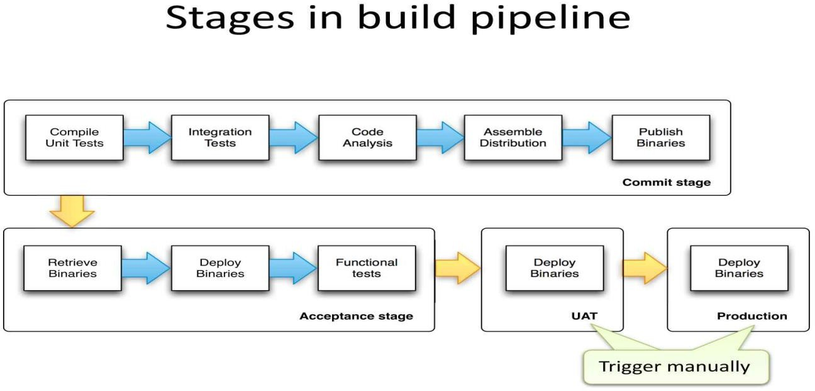

Abuildpipeline inDevOps isaset ofautomatedprocessesthat compile, build, andtest software, and prepare it for deployment. A build pipeline represents the end-to-end flow of code changes from development to production.
Thestepsinvolvedinatypicalbuildpipelineinclude:
CodeCommit:DeveloperscommitcodechangestoaversioncontrolsystemsuchasGit.
Build and Compile: The code is built and compiled, and any necessary dependencies are resolved.
UnitTesting:Automated unittestsareruntovalidatethe codechanges.
Integration Testing: Automated integration tests are run to validate that the code integrates correctly with other parts of the system.
Staging:Thecodeisdeployedtoastagingenvironmentforfurthertestingandvalidation. Release:Ifthecodepassesalltests,itisdeployed totheproductionenvironment.
Monitoring:Thedeployedcodeismonitoredforperformanceand stability.
A build pipeline can be managed using a continuous integration tool such as Jenkins, TravisCI, or CircleCI. These tools automate the build process, allowing you to quickly and easily make changes to the pipeline, and ensuring that the pipeline is consistent and reliable.
In DevOps, the build pipeline is a critical component of the continuous delivery process, and is used to ensurethat codechangesare tested,validated, and deployed to productionasquicklyand efficiently as possible. By automating the build pipeline, you can reduce the time and effort required to deploy code changes, and improve the speed and quality of your software delivery process.

Buildservers

When you're developing and deploying software, one of the first things to figure out is how to take your code and deploy your working application to a production environment where people can interact with your software.

Most development teams understand the importance of version control to coordinate code commits, and build servers to compile and package their software, but Continuous Integration (CI) is a big topic.
Why build servers are important Buildservershave3mainpurposes:

- Compilingcommittedcodefromyour repositorymanytimesaday
- Runningautomaticteststovalidatecode
- Creatingdeployablepackagesandhandingofftoadeploymenttool,likeOctopusDeploy

Without a build server you're slowed down by complicated, manual processes and the needless time constraints they introduce. For example, without a build server:

- Yourteamwilllikelyneedtocommitcodebeforeadailydeadlineorduringchange windows
- After that deadline passes, no one can commit again until someone manually creates and tests a build
- Ifthere are problems with the code,the deadlines and manualprocesses further delaythe fixes
Without a build server, the team battles unnecessary hurdles that automation removes. A build server will repeat these tasks for you throughout the day, and without those human-causeddelays.
But CI doesn’t just mean less time spent on manual tasks or the death of arbitrary deadlines, either. By automatically taking these steps many times a day, you fix problems sooner and your results become more predictable. Build servers ultimately help you deploythrough your pipeline with more confidence.

Buildingserversin DevOpsinvolvesseveralsteps:
Requirements gathering: Determine the requirements for the server, such as hardware specifications, operating system, and software components needed.
Serverprovisioning: Choose a method for provisioning the server, suchas physicalinstallation, virtualization, or cloud computing.
OperatingSysteminstallation:Installthechosenoperating systemontheserver.
Software configuration: Install and configure the necessary software components, such as web servers, databases, and middleware.
Network configuration: Set up network connectivity, such as IP addresses, hostnames, and firewall rules.
Security configuration: Configure security measures, such as user authentication, access control, and encryption.
Monitoring and maintenance: Implement monitoring and maintenance processes, such as logging, backup, and disaster recovery.

Deployment: Deploy the application to the server and test it to ensure it is functioning as expected.
Throughout the process, it is important to automate as much as possible using tools such as Ansible, Chef, or Puppet to ensure consistencyand efficiency in building servers.

Infrastructureascode

Infrastructure as code (IaC)uses DevOps methodologyand versioning with a descriptive model to define and deploy infrastructure, such as networks, virtual machines, load balancers, and connection topologies. Just as the same source code always generates the same binary, an IaC model generates the same environment every time it deploys.

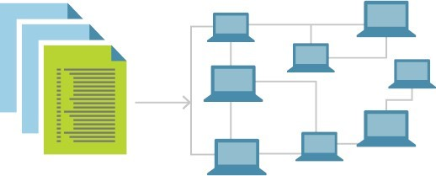

IaC is a keyDevOps practice and a component ofcontinuous delivery. With IaC, DevOps teams can work together with a unified set of practices and tools to deliver applications and their supporting infrastructure rapidly and reliably at scale.

IaC evolved to solve the problem ofenvironment driftin release pipelines. Without IaC, teams must maintain deployment environment settings individually. Over time, each environment becomes a "snowflake," a unique configuration that can't be reproduced automatically. Inconsistency among environments can cause deployment issues. Infrastructure administration and maintenance involve manual processes that are error prone and hard to track.

IaC avoids manual configuration and enforces consistency by representing desired environment states via well-documented code in formats such as JSON. Infrastructure deployments with IaC are repeatableandpreventruntimeissuescausedbyconfigurationdriftormissingdependencies.

Release pipelines execute the environment descriptions and version configuration models to configure target environments. To make changes, the team edits the source, not the target.

Idempotence, the ability of a given operation to always produce the same result, is an important IaC principle. A deployment command always sets the target environment into the same configuration, regardless of the environment's starting state. Idempotency is achieved by either automaticallyconfiguring the existing target,orbydiscarding the existing target and recreating a fresh environment.

IAC can be achieved by using tools such as Terraform, CloudFormation, or Ansible to define infrastructurecomponentsinafilethat canbeversioned,tested,anddeployed inaconsistent and automated manner.
BenefitsofIACinclude: Speed:IACenablesquickandefficientprovisioninganddeploymentofinfrastructure.
Consistency: By using code to define and manage infrastructure, it is easier to ensure consistency across multiple environments.
Repeatability: IAC allows for easy replication of infrastructure components in different environments, such as development, testing, and production.
Scalability:IACmakes iteasiertoscaleinfrastructureasneededbysimplymodifyingthe code.
Version control: Infrastructure components can be versioned, allowing for rollback to previous versions if necessary.
Overall, IAC is a key component of modern DevOps practices, enabling organizations to manage their infrastructure in a more efficient, reliable, and scalable way.

Buildingbydependencyorder
Building by dependency order in DevOps is the process of ensuring that the components of a system are built and deployed in the correct sequence, based on their dependencies. This is necessary to ensure that the system functions as intended, and that components are deployed in the right order so that they can interact correctly with each other.
ThestepsinvolvedinbuildingbydependencyorderinDevOpsinclude:
Define dependencies: Identify all the components of the system and the dependencies between them. This can be represented in a diagram or as a list.
Determine the build order: Based on the dependencies, determine the correct order in which components should be built and deployed.

Automate the build process: Use tools such as Jenkins, TravisCI, or CircleCI to automate the build and deployment process. This allows for consistencyand repeatability inthe build process.
Monitor progress: Monitor the progress of the build and deployment process to ensure that components are deployed in the correct order and that the system is functioning as expected.
Test and validate: Test the system after deployment to ensure that all components are functioning as intended and that dependencies are resolved correctly.
Rollback: Ifnecessary, havearollbackplaninplacetorevertto apreviousversionofthesystem if the build or deployment process fails.
In conclusion, building by dependency order in DevOps is a critical step in ensuring the success ofa systemdeployment, as it ensures that components are deployed in the correct order and that dependencies are resolved correctly. This results in a more stable, reliable, and consistentsystem.

Buildphases
InDevOps,thereareseveralphasesinthebuildprocess,including: Planning:Definetheprojectrequirements,identifythedependencies,andcreateabuild plan. Codedevelopment:Writethecodeandimplementfeatures,fixingbugsalongtheway.
Continuous Integration (CI): Automatically build and test the code as it is committed to a version control system.
ContinuousDelivery(CD): Automaticallydeploycodechangestoatestingenvironment,where they can be tested and validated.
Deployment: Deploy the code changes to a production environment, after they have passed testing in a pre-production environment.
Monitoring:Continuously monitorthe systemtoensurethat it isfunctioning asexpected, andto detect and resolve any issues that may arise.
Maintenance: Continuously maintain and update the system, fixing bugs, adding new features, and ensuring its stability.
These phases help to ensure that the build process is efficient, reliable, and consistent, and that code changes are validated and deployed in a controlled manner. Automation is a key aspect of DevOps, and it helps to make these phases more efficient and less prone to human error.

Incontinuous integration(CI), this is where we build the application for the first time. The build stage is the first stretch of aCI/CD pipeline, and it automates steps like downloading dependencies, installing tools, and compiling.

Besides building code, build automation includes using tools to check that the code is safe and follows best practices. The build stage usually ends in the artifact generationstep, where we create a production-ready package. Once this is done, the testing stage can begin.
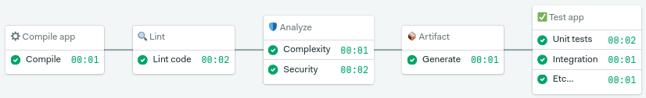
Thebuild stagestartsfromcodecommitandrunsfromthebeginning upto thetest stage

We’ll be covering testing in-depth in future articles (subscribe to the newsletter so you don’tmiss them). Today, we’ll focus on build automation.

Build automation verifies that the application, at a given code commit, can qualify for further testing. We can divide it into three parts:

- Compilation:thefirststepbuildstheapplication.
- Linting:checksthecodeforprogrammaticandstylisticerrors.
- Codeanalysis:usingautomated source-checkingtools,wecontrolthecode’squality.
- Artifactgeneration:thelaststeppackagestheapplicationforreleaseor deployment.

Alternativebuildservers
Thereareseveralalternativebuildservers inDevOps,including:
Jenkins - an open-source, Java-based automation server that supports various plugins and integrations.
TravisCI-acloud-based, open-sourceCI/CDplatformthatintegrateswithGithub.
CircleCI - a cloud-based, continuous integration and delivery platform that supports multiple languages and integrates with several platforms.
GitLab CI/CD - an integrated CI/CD solution within GitLab that allows for complete project and pipeline management.

Bitbucket Pipelines - a CI/CD solution within Bitbucket that allows for pipeline creation and management within the code repository.
AWS CodeBuild - a fully managed build service that compiles source code, runs tests, and produces software packages that are ready to deploy.
Azure Pipelines - a CI/CD solutionwithinMicrosoft Azurethat supportsmultiple platformsand programming languages.

Collatingqualitymeasures
In DevOps, collating quality measures is an important part of the continuous improvement process. The following are some common quality measures used in DevOps to evaluate the quality of software systems:
Continuous Integration (CI) metrics - metrics that trackthe success rateof automated builds and tests, such as build duration and test pass rate.
Continuous Deployment (CD) metrics - metrics that track the success rate of deployments, such as deployment frequency and time to deployment.
Code review metrics - metrics that track the effectiveness of code reviews, such as review completion time and code review feedback.
Performance metrics - measuresofsystemperformance inproduction, suchasresponse time and resource utilization.
User experience metrics - measures of how users interact with the system, such as click-through rate and error rate.
Securitymetrics-measuresofthesecurityofthesystem,suchasthenumberofsecurityvulnerabilities and the frequency of security updates.
Incidentresponsemetrics-metricsthattracktheeffectivenessofincidentresponse,suchas mean time to resolution (MTTR) and incident frequency.
Byregularlycollatingthesequalitymeasures, DevOpsteamscanidentifyareas forimprovement, track progress over time, and make informed decisions about the qualityof their systems.

Unit5
Testing Tools and automation
As we know, software testing is a process of analyzing an application's functionality as per the customer prerequisite.

Ifwewantto ensurethat our softwareis bug-free or stable, we must performthe varioustypesof software testing because testing is the only method that makes our application bug-free.

Varioustypesoftesting

The categorizationofsoftwaretesting is a part of diverse testing activities, such astest strategy, test deliverables, a defined test objective, etc. And software testing is the execution of the software to find defects.

ThepurposeofhavingatestingtypeistoconfirmtheAUT(ApplicationUnder Test).

To start testing, we should have arequirement, application-ready, necessary resources available. To maintain accountability, we should assign a respective module to different test engineers.

Thesoftwaretestingmainlydividedintotwoparts,whichareasfollows:

- Manual Testing
- AutomationTesting

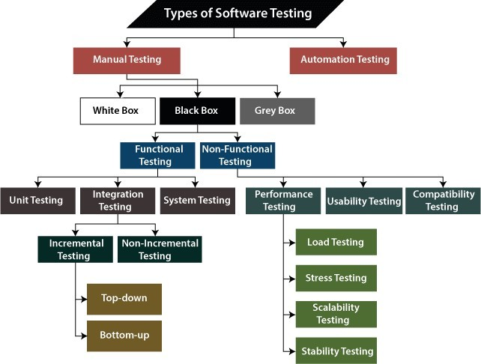

WhatisManualTesting?

Testing any software or an application according to the client's needs without using any automation tool is known as manual testing.
In other words, we can say that itis a procedure ofverification and validation. Manual testing is used to verify the behavior of an application or software in contradiction of requirements specification.

We do not require any precise knowledge of any testing tool to execute the manual test cases.We can easily prepare the test document while performing manual testing on any application.

To get in-detail information about manual testing, click on the following link: https://www.javatpoint.com/manual-testing.
Classification ofManualTesting

Insoftwaretesting, manualtesting can be further classified into three different types oftesting, which are as follows:

- WhiteBoxTesting
- BlackBoxTesting
- GreyBoxTesting

Forourbetterunderstandinglet'sseethemoneby one:

WhiteBoxTesting

In white-box testing, the developer will inspect every line of code before handing it over to the testing team or the concerned test engineers.

Subsequently, the code is noticeable for developers throughout testing; that's why this process is known as WBT (White Box Testing).

Inother words, wecansaythat thedeveloperwill executethecompletewhite-boxtesting forthe particular software and send the specific application to the testing team.

The purpose of implementing the white box testing is to emphasize the flow of inputs andoutputs over the software and enhance the security of an application.

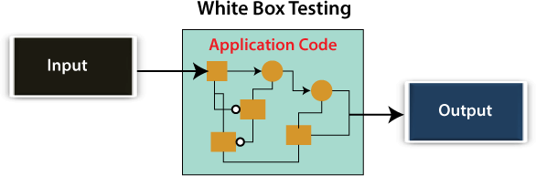

White box testing is also known as open box testing, glass box testing, structural testing,clear box testing, and transparent box testing.

BlackBoxTesting

Another type of manual testingis black-box testing. In this testing, the test engineer will analyze the software against requirements, identify the defects or bug, and sends it back to the development team.

Then, the developers will fix those defects, doone round ofWhite boxtesting, and send it to the testing team.

Here, fixing the bugs means the defect is resolved, and the particular feature is working according to the given requirement.

The main objective of implementing the black box testing is to specifythe business needs orthe customer's requirements.

In other words, we can say that black box testing is a process ofchecking the functionality ofan application as per the customer requirement. The source code is not visible in this testing; that's why it is known as black-box testing.
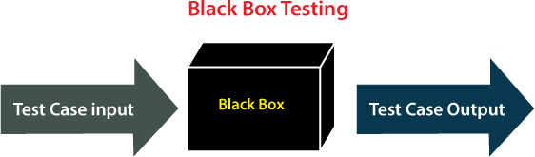

TypesofBlackBoxTesting

Blackboxtestingfurthercategorizesintotwoparts, whichareasdiscussed below:

- FunctionalTesting
- Non-function Testing

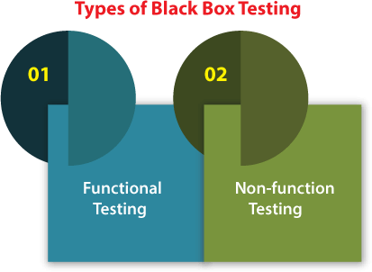

FunctionalTesting

Thetest engineerwillcheckallthecomponentssystematicallyagainst requirement specifications is known as functional testing. Functional testing is also known as Component testing.
In functional testing, all the components are tested by giving the value, defining the output, and validating the actual output with the expected value.

Functionaltesting isapart ofblack-boxtesting as itsemphasesonapplicationrequirement rather than actual code. The test engineer has to test only the program instead of the system.

Types of Functional Testing

Just like another type of testing is divided into several parts, functional testing is also classified into various categories.
The diverse types of Functional Testing contain the following:

- Unit Testing
- Integration Testing
- System Testing

Now, Let's understand them one by one:

- UnitTesting

Unit testing is the first level of functional testing in order to test any software. In this, the test engineer willtest the module ofan application independentlyor test allthe module functionality is called unit testing.

The primary objective of executing the unit testing is to confirm the unit components with their performance. Here, a unit is defined as a single testable function ofa software or an application. And it is verified throughout the specified application development phase.

- IntegrationTesting

Once we are successfully implementing the unit testing, we will go integration testing. It is the second level of functional testing, where we test the data flow between dependent modules or interface between two features is called integration testing.

The purpose of executing the integration testing is to test the statement's accuracy between each module.

TypesofIntegrationTesting

Integrationtesting isalso furtherdivided intothefollowingparts:

  - IncrementalTesting
  - Non-IncrementalTesting IncrementalIntegration Testing
Whenever there is a clear relationship between modules, we go for incremental integration testing. Suppose, we take two modules and analysis the data flow between them if they are working fine or not.

Ifthese modulesare working fine, thenwe canaddone more module and test again. And we can continue with the same process to get better results.

In other words, we can say that incrementally adding up the modules and test the data flow between the modules is known as Incremental integration testing.

Types of Incremental Integration Testing

Incrementalintegrationtestingcanfurtherclassifyintotwoparts, whichareasfollows:

- Top-downIncrementalIntegration Testing
- Bottom-upIncrementalIntegrationTesting

Let'sseeabriefintroductionofthese typesofintegrationtesting:

- Top-downIncrementalIntegrationTesting

In this approach, we will add the modules step by step or incrementally and test the data flow between them. We have to ensure that the modules we are adding are the child of the earlier ones.

- Bottom-upIncrementalIntegrationTesting

In the bottom-up approach, we will add the modules incrementally and check the data flow between modules. And also, ensure that the module we are adding is the parent of the earlier ones.

Non-IncrementalIntegration Testing/ BigBangMethod

Whenever the data flow is complexand verydifficult to classifya parent and a child, we will go for the non-incremental integration approach. The non-incremental method is also known as the Big Bang method.

SystemTesting

Whenever we are done with the unit and integration testing, we can proceed with the system testing.

Insystemtesting, thetest environment isparalleltotheproductionenvironment. It isalso known as
end-to-end testing.

In this type of testing, we will undergo each attribute of the software and test if the end feature works according to the business requirement. And analysis the software product as a complete system.

Non-functionTesting

The next part of black-box testing is non-functional testing. It provides detailed information on software product performance and used technologies.

Non-functional testing will help us minimize the risk of production and related costs of the software.

Non-functional testing is a combination of performance, load, stress, usability and, compatibility testing.

Types of Non-functional Testing

Non-functional testing categorized into different parts of testing, which we are going to discuss further:

- PerformanceTesting
- UsabilityTesting
- CompatibilityTesting

- PerformanceTesting
Inperformancetesting, thetest engineer willtesttheworkingofanapplicationbyapplyingsome load. In this type of non-functional testing,the testengineerwill onlyfocus on several aspects,such as
Response time, Load, scalability, and Stability of the software or an application.

Classification of Performance Testing

Performancetestingincludesthevarioustypesoftesting,whichareas follows:

  - Load Testing
  - Stress Testing
  - Scalability Testing
  - Stability Testing
  - Load Testing

While executing the performance testing, we will apply some load on the particular applicationto check the application's performance, known as load testing. Here, the load could be less than or equal to the desired load.
It will help us to detect the highest operating volume of the software and bottlenecks.

  - Stress Testing
It is used to analyze the user-friendliness and robustness of the software beyond the common functional limits.
Primarily, stress testing is used for critical software, but it can also be used for all types of software applications.

  - Scalability Testing

To analysis, the application's performance by enhancing or reducing the load in particular balances is known as scalability testing.
In scalabilitytesting, we can also check the system, processes, or database's abilityto meet an upward need. And in this, the Test Cases are designed and implemented efficiently.

  - Stability Testing

Stability testing is a procedure where we evaluate the application's performance by applying the load for a precise time.

It mainly checks the constancy problems of the application and the efficiency of a developed product. In this type of testing, we can rapidly find the system's defect even in a stressful situation.

Usability Testing

Another type of non-functional testing is usability testing. In usability testing, we will analyze the user-friendliness of an application and detect the bugs in the software's end-user interface.

Here,the term user-friendliness definesthefollowingaspectsofanapplication:

  - The application should be easy to understand, which means that all the features must be visible to end-users.
  - The application's look and feel should be good that means the application should be pleasant looking and make a feel to the end-user to use it.

Compatibility Testing

In compatibility testing, we will check the functionality of an application in specific hardware and software environments. Once the applicationis functionally stable then only, we go for compatibility testing.
Here, software means we can test the application on the different operating systems and other browsers, and hardware means we can test the application on different sizes.

GreyBox Testing
Another part of manual testing is Grey box testing. It is a collaboration of black box and white box testing.

Since, the grey box testing includes access to internal coding for designing test cases. Grey box testing is performed by a person who knows coding as well as testing.

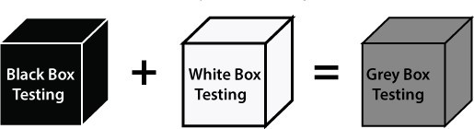

In other words, we can say that if a single-person team done bothwhite box and black-box testing, it is considered grey box testing.

AutomationTesting

The most significant part of Software testing is Automation testing. It uses specific tools to automate manual design test cases without any human interference.

Automation testing is the best way to enhance the efficiency, productivity, and coverage of Software testing.

Itisusedtore-runthetestscenarios, whichwereexecutedmanually, quickly, andrepeatedly.

In other words, we can say that whenever we are testing an application by using some tools is known as automation testing.

We will go for automation testing when various releases or several regression cycles goes on the applicationorsoftware. Wecannot writethetest scriptorperformtheautomationtestingwithout understanding the programming language.

Automation of testing Pros and cons

Some other types of Software Testing

In software testing, we also have some other types of testing that are not part of any above discussed testing, but those testing are required while testing any software or an application.

- Smoke Testing
- Sanity Testing
- Regression Testing
- User Acceptance Testing
- Exploratory Testing
- Adhoc Testing
- Security Testing
- Globalization Testing

Let'sunderstandthosetypesoftesting one by one:

In smoke testing, we will test an application's basic and critical features before doing one round of deep and rigorous testing.
Orbefore checking all possible positive and negative values is known as smoke testing. Analyzing the workflow of the application's core and main functions is the main objective of performing the smoke testing.

Sanity Testing

It isused to ensurethat allthe bugshave been fixed and no added issuescome into existence due to these changes. Sanity testing is unscripted, which means we cannot documented it. It checks the correctness of the newly added features and components.

Regression Testing

Regressiontestingisthemostcommonlyusedtypeofsoftwaretesting.Here,the term regression
implies that we have to re-test those parts of an unaffected application.

Regression testing is the most suitable testing for automation tools. As per the project type and accessibility of resources, regression testing can be similar to Retesting.
Whenever a bug is fixed bythe developers and then testing the other features ofthe applications that might be simulated because of the bug fixing is known as regression testing.

In other words, we can say that whenever there is a new release for some project, then we can

perform Regression Testing, and due to a new feature may affect the old features in the earlier releases.

UserAcceptanceTesting

The User acceptance testing (UAT) is done by the individual team known as domain expert/customer or the client. And knowing the application before accepting the final product is called as user acceptance testing.

In user acceptance testing, we analyze the business scenarios, and real-time scenarios on the distinct environment called the UAT environment. In this testing, we will test the application before UAI for customer approval.

ExploratoryTesting

Whenever the requirement is missing, early iteration is required, and the testing team has experienced testers when we have a critical application. New test engineer entered into the team then we go for the exploratory testing.

To execute the exploratory testing, we will first go through the application in all possible ways, make a test document, understand the flow of the application, and then test the application.

Adhoc Testing

Testingtheapplicationrandomlyassoonasthebuildisinthecheckedsequenceisknown as Adhoc testing.
It is also called Monkey testing and Gorilla testing. In Adhoc testing, we will check the application in contradiction of the client's requirements; that's why it is also known as negative testing.

When the end-user using the application casually, and he/she may detect a bug. Still, the specialized test engineer uses the software thoroughly, so he/she may not identify a similar detection.

SecurityTesting
It is an essential part of software testing, used to determine the weakness, risks, or threats in the software application.

The execution ofsecuritytesting will help us to avoid the nastyattack fromoutsiders and ensure our software applications' security.

Inother words, we cansaythat securitytesting is mainly used to define that the datawill be safe and endure the software's working process.

Globalization Testing

Another type of software testing is Globalization testing. Globalization testing is used to check the developed software for multiple languages or not. Here, the words globalization means enlightening the application or software for various languages.
Globalization testing is used to make sure that the application will support multiple languages and multiple features.

In present scenarios, we can see the enhancement in several technologies as the applications are prepared to be used globally.

Conclusion

In the tutorial, we have discussed various types of software testing. But there is still a list of more than 100+ categories of testing. However, each kind of testing is not used in all types of projects.

We have discussed the most commonly used types of Software Testing like black-box testing, white box testing, functional testing, non-functional testing, regression testing, Adhoc testing, etc.

Also, there are alternate classifications or processes used in diverse organizations, but the general concept is similar all over the place.
These testing types, processes, and execution approaches keep changing when the project, requirements, and scope change.

Automation of testing Pros and cons
Pros of Automated Testing:
AutomatedTestinghasthefollowingadvantages:

- Automated testing improves the coverage of testing as automated execution of test cases is faster than manual execution.
- Automatedtestingreducesthedependabilityoftestingontheavailabilityofthetest engineers.
- Automatedtestingprovides roundthe clockcoverage as automatedtests canbe run all time in 24*7 environment.
- Automatedtesting takesfarlessresourcesinexecutionascompared tomanualtesting.
- It helps to train the test engineers to increase their knowledge by producing a repository of different tests.
- Ithelpsintestingwhichisnotpossiblewithoutautomationsuchasreliabilitytesting, stress

testing, load and performance testing.
- It includes all other activities like selecting the right product build, generating the righttest data and analyzing the results.
- It acts as test data generator and produces maximumtest datato cover a large number of input and expected output for result comparison.
- Automatedtestinghas lesschancesoferrorhencemore reliable.
- As with automated testing test engineers have free time and can focus on other creativetasks.
ConsofAutomatedTesting:AutomatedTestinghasthefollowing disadvantages:
- Automatedtestingisverymuchexpensivethanthemanualtesting.
- It also becomes inconvenient andburdensomeastodecidewho wouldautomateandwho would train.
- Ithaslimitedtosomeorganisationsas manyorganisationsnotprefertest automation.
- Automatedtestingwouldalso requireadditionallytrainedandskilledpeople.
- Automatedtestingonlyremovesthe mechanicalexecutionoftestingprocess, but creation of test cases still required testing professionals.

Selenium

Introduction
Seleniumisoneofthe most widelyusedopensourceWebUI(UserInterface)automationtesting suite.It wasoriginallydeveloped byJasonHuggins in2004as aninternaltoolat Thought Works. Seleniumsupports automationacross different browsers, platforms and programming languages.

Selenium can be easily deployed on platforms such as Windows, Linux, Solaris and Macintosh. Moreover, it supports OS (Operating System) for mobile applications like iOS, windows mobile and android.

Selenium supports a variety of programminglanguages through the use of drivers specific to each Language.

LanguagessupportedbySeleniumincludeC#, Java, Perl, PHP,PythonandRuby.

Currently, Selenium Web driver is most popular with Java and C#. Selenium test scripts can be coded in any of the supported programming languages and can be run directly in most modern web browsers. Browsers supported by Selenium include Internet Explorer, Mozilla Firefox, Google Chrome and Safari.

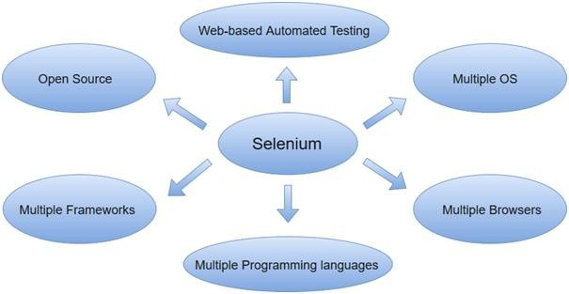

Selenium can be used to automate functional tests and can be integrated with automation test tools suchasMaven, Jenkins,& Dockerto achieve continuous testing. It canalso be integrated with tools such as TestNG, &JUnit for managing test cases and generating reports.

SeleniumFeatures

- SeleniumisanopensourceandportableWebtesting Framework.
- SeleniumIDEprovidesaplaybackandrecordfeatureforauthoringtestswithouttheneed to learn a test scripting language.
- It can be considered as the leading cloud-based testing platform which helps testers to record their actions and export themas a reusable script with a simple-to-understand and easy-to-use interface.
- Selenium supports various operating systems, browsers and programming languages. Following is the list:
  - ProgrammingLanguages:C#,Java,Python,PHP, Ruby,Perl,andJavaScript
  - OperatingSystems:Android, iOS,Windows,Linux,Mac,Solaris.
  - Browsers: Google Chrome, Mozilla Firefox, Internet Explorer, Edge, Opera, Safari, etc.
- It also supports paralleltest execution which reduces time and increases the efficiencyof tests.
- SeleniumcanbeintegratedwithframeworkslikeAntandMavenforsourcecode compilation.
- SeleniumcanalsobeintegratedwithtestingframeworkslikeTestNGforapplication testing and generating rseports.
- Seleniumrequiresfewer resourcesascomparedtoother automationtest tools.
- WebDriverAPIhasbeenindulgedinseleniumwhichisoneofthemostimportantmodifications done to selenium.
- Seleniumwebdriver doesnot require server installation, test scripts interact directlywith the browser.

- Seleniumcommands are categorized in terms ofdifferent classes which make it easier to understand and implement.

Java Script testing
JavaScript testing is a crucial part of the software development process that helps ensure the quality and reliability of code. The following are the key components of JavaScript testing:
Test frameworks: A test framework provides a structure for writing and organizing tests. Some popular JavaScript test frameworks include Jest, Mocha, and Jasmine.
Assertion libraries: An assertion library provides a set of functions that allow developers to write assertions about the expected behavior of the code. For example, an assertion might check that a certain function returns the expected result.
Test suites: Atest suite isacollectionofrelatedteststhat aregroupedtogether.Thepurposeofa test suite is to test a specific aspect of the code in isolation.
Test cases: A test case is a single test that verifies a specific aspect of the code. For example, a test case might check that a function behaves correctly when given a certain input.
Testrunners: Atestrunner isatoolthat runsthetestsandprovides feedbackontheresults. Test runners typically provide a report on which tests passed and which tests failed.
ContinuousIntegration(CI): CIisa software development practice where developers integrate code into a shared repository frequently. By using CI, developers can catch issues early andavoid integration problems.
The goalofJavaScript testing isto catchbugsand defectsearlyin the development cycle, before theybecome biggerproblemsand impact thequalityofthe software. Testingalso helpsto ensure that the code behaves as expected, even when changes are made in the future.
There are different types of tests that can be performed in JavaScript, including unit tests, integration tests, and end-to-end tests. The choice ofwhich teststo write depends on the specific requirements and goals of the project.

Testingbackendintegrationpoints
The term backend generally refers to server-side deployment. Here the process is entirely happening in the backend which is not shown to the user only the expectedresults will be shown to the user. In every web application, there will be a backend language to accomplish the task.
ForExample,whileuploadingthedetailsofthestudentsinthedatabase, thedatabasewill store all the details. When there is a need to display the details of the students, it will simply fetch all the details and display them. Here, it will show only the result, not the process and how it fetches the details.

What is Backend Testing?

Backend Testing is a testing method that checks the database or server-side of the web application. The main purpose ofbackend testingis to checkthe application layer andthe database layer. It will find an error or bug in the database or server-side.
For implementing backend testing, the backend test engineer should also have some knowledgeaboutthatparticularserver-sideordatabaselanguage.Itisalsoknown as Database Testing.
Importance of Backend Testing: Backend testing is a must because anything wrong or error happens at the server-side, it will not further proceed with that task or the outputwill get differed or sometimes it will also cause problems such as data loss, deadlock,etc.,

Types of Backend Testing

Thefollowingarethedifferenttypesofbackend testing:

- Structural Testing
- Functional Testing
- Non-Functional Testing
Let’sdiscusseachofthesetypesofbackendtesting.
- StructuralTesting
Structural testing is the process of validating all the elements that are present inside the datarepositoryandareprimarilyusedfordata storage. Itinvolvescheckingtheobjectsof front- end developments with the database mapping objects.
TypesofStructuralTesting:Thefollowingarethedifferenttypesofstructural testing:
- Schema Testing: In this Schema Testing, the tester will check for the correctly mapped objects. This is also known as mapping testing. It ensures whether the objects of the front-end and the objects ofthe back-end are correctly matched or mapped. It will mainly focus on schema objects such as a table, view, indexes, clusters, etc., In this testing, the tester will find the issues of mapped objects like table, view, etc.,
- Table and Column Testing: In this, it ensures that the table and column properties are correctly mapped.
- It ensures whether the table and the column names are correctly mapped on both thefront-end side and server-side.
- Itvalidatesthedatatypeofthecolumniscorrectlymentioned.
- Itensuresthecorrectnamingofthecolumn valuesofthedatabase.
- Itdetectstheunusedtablesandcolumns.
- It validates whether the users are able to give the correct input as per therequirement.

For example, if we mention the wrong datatype for the column on the server-side whichis different from the front-end then it will raise an error.
- KeyandIndexesTesting:Inthis,itvalidatesthekeyandindexesofthecolumns.
- Itensures whether the mentioned keyconstraintsare correctly provided. Forexample, Primary Key for the column is correctly mentioned as per the given requirement.
- ItensuresthecorrectreferencesofForeignKeywiththeparenttable.
- Itchecksthelengthandsizeoftheindexes.
- It ensures the creation of clustered and non-clustered indexes for the table as per therequirement.
- ItvalidatesthenamingconventionsoftheKeys.
- TriggerTesting: Itensuresthattheexecutedtriggersarefulfillingtherequired conditions of the DML transactions.
- Itvalidateswhetherthetriggersmakethedataupdatescorrectlywhenwehaveexecuted them.
- Itchecksthecodingconventionsarefollowedcorrectlyduringthecodingphaseofthe triggers.
- Itensuresthatthetriggerfunctionalitiesof update,delete,andinsert.

- StoredProceduresTesting: Inthis,thetesterchecksforthecorrectnessofthestored procedure results.
- It checks whether the stored procedure contains the valid conditions for looping andconditional statements as per the requirement.
- Itvalidatestheexceptionanderrorhandlingin thestoredprocedure.
- Itdetectstheunusedstoredprocedure.
- Itvalidatesthecursoroperations.
- ItvalidateswhethertheTRIMoperationsarecorrectlyappliedornot.
- Itensuresthattherequiredtriggersareimplicitlyinvokedbyexecutingthestored procedures.
- DatabaseServer ValidationTesting:It validatesthedatabase configurationdetailsas per the requirements.
- It validatesthatthetransactionsofthedataaremadeaspertherequirements.
- Itvalidatestheuser’sauthenticationandauthorization. ForExample,Ifwronguserauthenticationis given,itwillraiseanerror.

- FunctionalTesting

Functional Testing is the process of validating that the transactions and operations made by the end-users meet the requirements.
TypesofFunctionalTesting:Thefollowingarethedifferenttypesoffunctionaltesting:

BlackBoxTesting:

  - Black Box Testing is the process of checking the functionalities of the integration of the database.
  - ThistestingiscarriedoutattheearlystageofdevelopmentandhenceItisvery helpful to reduce errors.
  - It consists of various techniques such as boundary analysis,equivalent partitioning,and cause-effect graphing.
  - Thesetechniquesarehelpfulincheckingthefunctionalityofthedatabase.
  - ThebestexampleistheUser loginpage.Iftheenteredusernameandpasswordare correct, It will allow the user and redirect to the next page.

WhiteBoxTesting:
  - WhiteBoxTestingistheprocessofvalidatingtheinternalstructureofthedatabase.
  - Here,thespecifieddetailsarehiddenfromtheuser.
  - The database triggers,functions,views,queries,and cursors will be checked in this testing.
  - Itvalidatesthedatabaseschema,databasetable,etc.,
  - Herethecodingerrorsinthetriggerscanbeeasilyfound.
  - Errors in the queries can also be handled in this white box testing and hence internal errors are easily eliminated.

Non-FunctionalTesting
Non-functional testing is the process of performing load testing, stress testing, and checking minimum system requirements are required to meet the requirements. It will also detect risks, and errors and optimize the performance of the database.

LoadTesting:
  - Loadtestinginvolvestestingtheperformance andscalabilityofthedatabase.
  - It determines how the software behaves when it is been used by many users simultaneously.
  - Itfocusesongoodloadmanagement.
  - Forexample, ifthewebapplicationisaccessedbymultipleusersatthesametimeand it does not create any traffic problems then the load testingis successfully completed.

StressTesting:
  - Stress Testing is alsoknown as endurance testing.Stress testing is a testing processthat is performed to identify the breakpoint of the system.
  - Inthistesting,anapplicationisloadedtillthestagethesystemfails.
  - Thispointisknownasabreakpointofthedatabasesystem.
  - It evaluates and analyzes the software after the breakage of system failure. In case of error detection, It will display the error messages.
  - Forexample,ifusersenterthewronglogininformationthenitwillthrowanerror message.

BackendTestingProcess
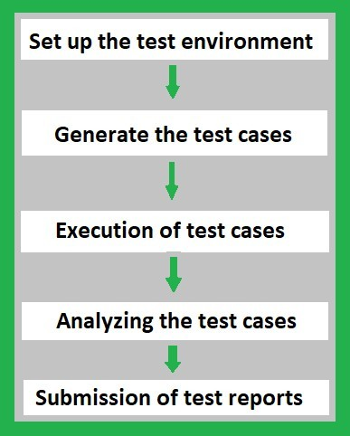
- Set up the Test Environment: When the coding process is done for the application, set up the test environment by choosing a proper testing tool for back-end testing. It includes choosing the right team to test the entire back-end environment with a proper schedule. Record all the testingprocesses in the documents or update themin software to keep track of all the processes.
- Generate the TestCases: Once thetoolandtheteamare ready for thetestingprocess, generate the test cases as per the business requirements. The automation tool itself will analyze the code and generate all possible test cases for developed code. If the process is manual then the tester will have to write the possible test cases in the testing tool to ensure the correctness of the code.
- Execution of Test Cases: Once the test cases are generated, the tester or Quality Analyst needs to execute those test cases in the developed code. If the tool is automated,it will generate and execute the test cases by itself. Otherwise, the tester needs to write and execute those test cases. It will highlight whether the execution of test cases is executed successfully or not.
- Analyzing the Test Cases: After the execution of test cases, it highlights the result of allthetestcaseswhetherithasbeenexecutedsuccessfullyornot. Ifanerroroccursinthe test cases, it will highlight where the particular error is formed or raised, and in some cases,theautomationtoolwillgivehintsregardingtheissuestosolvetheerror.
- The tester or Quality Analyst should analyze the code again and fix the issues if an

error occurred.
- Submission of Test Reports: This is the last stage in the testing process. Here, all the details such as who is responsible for testing, the tool used in the testingprocess, number of test casesgenerated, number of test cases executed successfully or not,time is taken to executeeachtestcase,numberoftimestestcasesfailed,numberoftimeserrorsoccurred. These details are either documented or updated in the software. The report will be submitted to the respective team.

BackendTestingValidation

Thefollowingaresomeofthefactorsforbackendtestingvalidation:
  - PerformanceCheck: Itvalidatestheperformanceofeachindividualtestandthe system behavior.
  - Sequence Testing:Backend testing validates that thetests are distributed according to the priority.
  - Database Server Validations: In this, ensures that the data fed through for the testsis correct or not.
  - FunctionsTesting: Inthis,thetestvalidatestheconsistencyintransactionsofthe database.
  - Key andIndexes: In this, the test ensures that the accurate constraint and the rules of constraints and indexes are followed properly.
  - DataIntegrityTesting: Itisatechniqueinwhichdataisverifiedinthedatabase whether it is accurate and functions as per requirements.
  - Database Tables: It ensures that the created table and the queries for the output areproviding the expected result.
  - Database Triggers:Backend Testing validates the correctness of the functionality of triggers.
  - StoredProcedures: Backendtestingvalidatesthefunctions,returnstatements, calling the other events, etc., are correctly mentioned as per the requirements,
  - Schema:Backend testing validates that the data is organized in a correct way as perthe business requirement and confirms the outcome.

ToolsForBackendTesting

Thefollowingaresomeofthetoolsforbackendtesting:

LoadRunner:
  - Itisastresstestingtool.
  - Itisanautomatedperformanceandtestingautomationtoolforanalyzingsystem behavior

and the performance of the system while generating the actual load.

Empirix-TESTSuite:
  - ItisacquiredbyOraclefromEmpirix.Itisaloadtestingtool.
  - It validates the scalability along with the functionality of the application under heavy test.
  - AcquisitionwiththeEmpirix-Testsuitemaybeproveneffectivetodelivertheapplication with improved quality.

StoredProcedureTestingTools–LINQ:
  - Itisapowerfultoolthatallowstheusertoshowtheprojects.
  - IttracksalltheORMcallsanddatabasequeriesfromthe ORM.
  - Itenablestoseetheperformanceofthedataaccesscodeandeasilydetermine performance.

UnitTestingTools–SQLUnit,DBFit,NDbUnit:
  - SQL UNIT:SQLUnit is a Unit Testing Framework for Regression and Unit Testing of database stored procedures.
  - DBFit:ItisapartofFitNesseand managesstoredproceduresandcustomprocedures. Accomplishes database testing either through Java or .NET and runs from the command line.
  - NDbUnit:It performs the database unit test for the system either before or after execution or compiled the other parts of the system.

DataFactoryTools:
  - Thesetoolsworkasdatamanagersanddatageneratorsforbackenddatabasetesting.
  - Itisusedtovalidatethequerieswithahugesetof data.
  - Itallowsperformingbothstressand loadtesting.

SQLMap:
  - Itisanopen-sourcetool.
  - ItisusedforperformingPenetrationTestingtoautomatetheprocessofdetection.
  - Powerfuldetectionoferrorswillleadtoefficienttestingandresultintheexpected behavior of the requirements.

phpMyadmin:
  - ThisisthesoftwaretoolanditiswritteninPHP.
  - It is developed to handle the databases and we can execute test queries to ensure thecorrectness of the result as a whole and even for a separate table.

AutomaticEfficientTestGenerator(AETG):
  - Itmechanicallygeneratesthepossibletestsfromuser-definedrequirements.
  - It is based on algorithms that use ideas from statistical experimental design theory to reduce the number of tests needed fora specific level of test coverage of the input test space.

HammerDB:

  - Itisanopen-sourcetoolforloadtesting.
  - Itvalidatestheactivityreplayfunctionalityfortheoracledatabase.
  - ItisbasedonindustrystandardslikeTPC-CandTPC-HBenchmarks.

SQLTest:
  - SQLTestusesanopen-sourcetSQLtframework,views,storedprocedures,andfunctions.
  - This tool stores database object in a separate schema and if changes occur there is no need for clearing the process.
  - ItallowsrunningtheunittestcasesfortheSQLserverdatabase.

AdvantagesofBackendTesting

Thefollowingaresomeofthebenefitsofbackendtesting:
  - Errorsareeasilydetectableattheearlierstage.
  - Itavoidsdeadlockcreationontheserver-side.
  - Webloadmanagementiseasilyachieved.
  - Thefunctionalityofthedatabaseismaintainedproperly.
  - Itreducesdataloss.
  - Enhancesthefunctioningofthesystem.
  - Itensuresthesecurityandprotectionofthesystem.
  - Whiledoing thebackendtesting,theerrorsintheUI partscanalsobedetectedand replaced.
  - Coverageofallpossibletestcases.

DisadvantagesofBackendTesting

Thefollowingaresomeofthedisadvantagesofbackendtesting:
  - Gooddomainknowledgeisrequired.
  - Providingtestcasesfortestingrequiresspecial attention.

  - InvestmentinOrganizationalcostsishigher.
  - Ittakesmoretimetotest.
  - IfmoretestingbecomesfailsthenItwillleadtoacrashontheserver-sideinsome cases.
  - Errors or Unexpected results from one test case scenario will affect the other system results also.

Test-drivendevelopment
Test Driven Development (TDD) is software development approach in which test cases

are developed to specify and validate what the code will do. In simple terms, testcases for each functionality are created and tested first and if the test fails then thenew code is written in order to pass the test and making code simple and bug-free.
Test-Driven Development starts with designing and developing tests for every small functionality of an application. TDD framework instructs developers to write new code only if an automated test has failed. This avoids duplication of code. The TDD full form is Test-driven development.
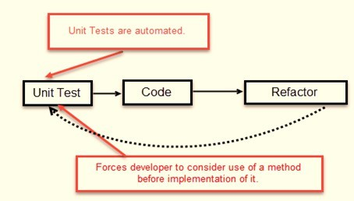

The simple concept of TDD is to write and correct the failed tests before writing new code (before development). This helps to avoid duplication of code as we write a small amount ofcode at a time in order to pass tests. (Tests are nothing butrequirementconditions thatwe need to test to fulfill them).

Test-Driven development is a process of developing and running automated test before actual development ofthe application. Hence, TDD sometimes also called as Test First Development.

HowtoperformTDDTest
FollowingstepsdefinehowtoperformTDDtest,

- Addatest.
- Runalltestsand seeifanynewtest fails.
- Writesomecode.
- RuntestsandRefactorcode.
- Repeat

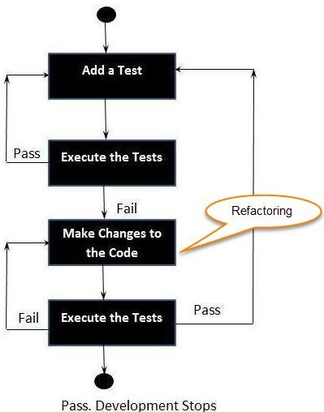

TDDVs. TraditionalTesting
BelowisthemaindifferencebetweenTestdrivendevelopmentandtraditionaltesting:

TDD approach is primarily a specification technique. It ensures that your source code is thoroughly tested at confirmatory level.

  - With traditional testing, a successful test finds one or more defects. It is sameas TDD. When a test fails, you have made progress because you knowthat you need to resolve the problem.
  - TDD ensures that your system actually meets requirements defined for it. It helps to build your confidence about your system.
  - In TDD more focus is on production code that verifies whether testing will workproperly.Intraditionaltesting, morefocus isontest casedesign. Whether the test will show the proper/improper execution of the application in order to fulfill requirements.
  - In TDD, you achieve 100% coverage test. Every single line of code is tested, unlike traditional testing.

  - The combination of both traditionaltestingand TDDleads to the importance of testing the system rather than perfection of the system.
  - In Agile Modeling (AM), you should “test with a purpose”. You should know why you are testing something and what level its need to be tested.

WhatisacceptanceTDDandDeveloperTDD
There aretwo levelsofTDD

- Acceptance TDD (ATDD): With ATDD you write a single acceptance test. This test fulfills the requirement of the specification or satisfies the behavior of the system. After that write just enough production/functionality code to fulfill that acceptance test. Acceptancetestfocuseson the overallbehaviorof thesystem.ATDDalsowasknown as Behavioral Driven Development (BDD).
- Developer TDD: With Developer TDD you write single developer test i.e. unit test and then just enough production code to fulfill that test. The unit test focuses on every small functionality of the system. Developer TDD is simply called as TDD.The main goal of ATDD and TDD is to specify detailed, executable requirements for your solution on ajustin time (JIT) basis. JIT means taking only those requirements in consideration that are needed in the system. So increase efficiency.
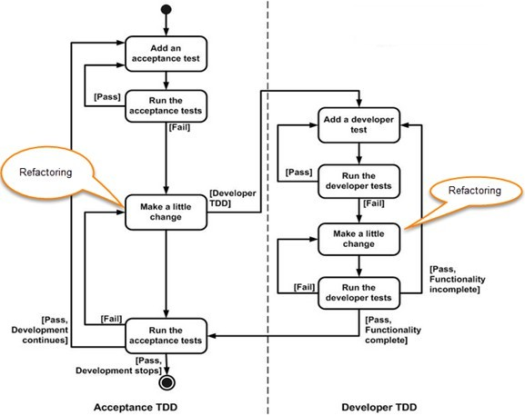

REPL-drivendevelopment
REPL-driven development (Read-Eval-Print Loop) is an interactive programming approach that allows developers to execute code snippets and see their results immediately. This enables developerstotesttheircodequicklyand iteratively, andhelpsthemto understandthebehaviorof their code as they work.
In a REPL environment, developers can type in code snippets, and the environment will immediatelyevaluate the code and return the results. This allows developers to test small bits of code and quickly see the results, without having to create a full-fledged application.
REPL-driven development is commonly used in dynamic programming languages such as Python, JavaScript, and Ruby. Some popular REPL environments include the Python REPL, Node.js REPL, and IRB (Interactive Ruby).
BenefitsofREPL-drivendevelopmentinclude:

Increased efficiency: The immediate feedback provided by a REPL environment allows developers to test and modify their code quickly, without having to run a full-fledgedapplication.
Improved understanding: By being able to see the results of code snippets immediately, developers can better understand how the code works and identify any issues early on.
Increased collaboration: REPL-driven development makes it easy for developers to share code snippets and collaborate on projects, as they can demonstrate the behavior of the code quickly and easily.
Overall, REPL-driven development is a useful tool for developers looking to improve their workflow and increase their understanding of their code. By providing an interactive environment fortestingandexploringcode,REPL-drivendevelopment canhelpdeveloperstobe more productive and efficient.

Deploymentofthesystem:
In DevOps, deployment systems are responsible for automating the release of software updates and applications from development to production. Some popular deployment systems include:
Jenkins: anopen-source automationserver that provides plugins to support building, deploying, and automating any project.
Ansible: anopen-source platformthat providesa simple wayto automate software provisioning, configuration management, and application deployment.
Docker:aplatformthatenablesdeveloperstocreate,deploy, andrunapplicationsincontainers.
Kubernetes: an open-source system for automating deployment, scaling, and management of containerized applications.
AWS Code Deploy: a fully managed deployment service that automates software deployments

to a variety of compute services such as Amazon EC2, AWS Fargate, and on-premises servers.
Azure DevOps: a Microsoft product that provides an end-to-end DevOps solution for developing, delivering, and deploying applications on multiple platforms.

Virtualizationstacks
In DevOps, virtualization refers to the creation of virtual machines, containers, or environments that allow multiple operating systems to run on a single physical machine. The following are some of the commonly used virtualization stacks in DevOps:
Docker: An open-source platform for automating the deployment, scaling, and management of containerized applications.

Kubernetes: Anopen-sourceplatformfor automatingthedeployment, scaling, and management of containerized applications, commonly used in conjunction with Docker.
VirtualBox: An open-source virtualization software that allows multiple operating systems to run on a single physical machine.
VMware: A commercial virtualization software that provides a comprehensive suite oftools for virtualization, cloud computing, and network and security management.
Hyper-V: Microsoft's hypervisor technology that enables virtualization on Windows-based systems.
These virtualization stacks play a crucial role in DevOps by allowing developers to build, test, and deploy applications in isolated, consistent environments, while reducing the costs and complexities associated with physical infrastructure.

codeexecutionattheclient
In DevOps, code execution at the client refers to theprocess of executing code or scripts on client devices or machines. This can be accomplished in several ways, including:
Client-side scripting languages: JavaScript, HTML, and CSS are commonly used client-side scripting languages that run in a web browser and allow developers to create dynamic,interactive web pages.
Remote execution tools: Tools such as SSH, Telnet, or Remote Desktop Protocol (RDP) allow developers to remotely execute commands and scripts on client devices.
Configuration management tools: Tools such as Ansible, Puppet, or Chef use agent-based or agentless architectures to manage and configure client devices, allowing developers to execute code and scripts remotely.
Mobile apps: Mobile applications can also run code on client devices, allowing developers to create dynamic, interactive experiences for users.

These methods are used in DevOps to automate various tasks, such as application deployment, software updates, or system configuration, on client devices. By executing code on the client side, DevOps teams can improve the speed, reliability, and security of their software delivery process.

Puppetmasterandagents:

PuppetArchitecture
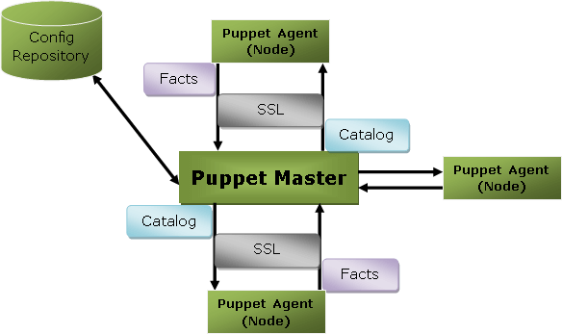
Puppetusesmaster-slaveorclient-serverarchitecture.Puppetclient andserver interconnectedby SSL, which is a secure socket layer. It is a model-driven system.

Here, the client is referred to as a Puppet agent/slave/node, and the server is referred to as a Puppet master.

Let'ssee the componentsofPuppetarchitecture:

PuppetMaster

Puppet master handles all the configuration related process in the form of puppet codes. It is a Linux based system in which puppet master software is installed. The puppet master must be in Linux. It uses the puppet agent to apply the configuration to nodes.
ThisistheplacewhereSSLcertificatesarecheckedandmarked.

PuppetSlaveorAgent

Puppet agents are the real working systems and used by the Client. It is installed on the client machine and maintained and managed by the puppet master. They have a puppet agent service running inside them.

The agent machine canbe configured onanyoperating systemsuchas Windows, Linux, Solaris, or Mac OS.

ConfigRepository

Config repository is the storage area where all the servers and nodes related configurations are stored, and we can pull these configurations as per requirements.
Facts

Factsarethekey-valuedatapair. It contains informationaboutthenodeorthemastermachine. It represents a puppet client states such asoperating system, network interface, IP address, uptime, and whether the client machine is virtual or not.
These facts are used for determining the present state of any agent. Changes on any target machine are made based on facts. Puppet's facts are predefined and customized.

Catalog

Theentireconfigurationand manifest filesthat arewritteninPuppet arechanged into acompiled format. This compiled format is known as a catalog, and then we can apply this catalog to the target machine.
Theabove imageperformsthefollowingfunctions:

- Firstofall,anagentnodesendsfactstothemasteror serverandrequestsforacatalog.
- The master or server compiles and returns the catalog of a node with the help of someinformation accessed by the master.
- Then the agent applies the catalog to the node by checking every resource mentioned in the catalog. If it identifies resources that are not in their desired state, then makes the necessary adjustments to fix them. Or, it determines in no-op mode, the adjustments would be required to reconcile the catalog.
- Andfinally, theagent sendsareport backtothemaster.

PuppetMaster-SlaveCommunication

Puppet master-slave communicates via a secure encrypted channel through the SSL (Secure Socket Layer). Let'sseethe below diagramto understandthe communicationbetweenthe master and slave with this channel:

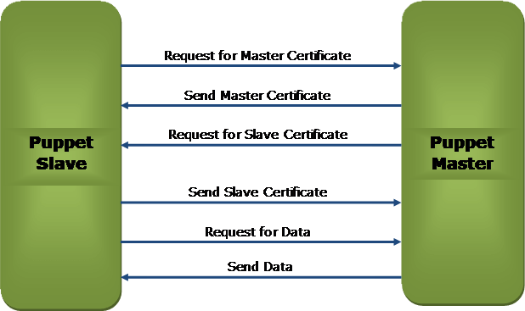

Theabovediagramdepictsthe following:

- PuppetslaverequestsforPuppetMasterCertificate.
- Puppetmaster sendstheMasterCertificatetothepuppetslaveinresponsetotheclient request.
- PuppetmasterrequeststothePuppetslavefortheslavecertificate.
- Puppetslavesends therequestedslavecertificatetothepuppetmaster.
- Puppetslavesendsa requestfor data tothepuppetmaster.
- Finally,themastersendsthedata tothepuppetslaveasper therequest.

PuppetBlocks
Puppet providesthe flexibilitytointegrateReportswiththird-partytoolsusing PuppetAPIs.

FourtypesofPuppetbuildingblocksare

- Resources
- Classes
- Manifest
- Modules

PuppetResources:
PuppetResourcesarethebuildingblocksofPuppet.

Resourcesarethe inbuilt functionsthatrunatthebackendto performtherequiredoperations in puppet.
PuppetClasses:
Acombinationofdifferentresourcescanbegroupedtogetherintoasingleunitcalledclass.

PuppetManifest:
V Manifest is a directory containing puppet DSL files. Those files have a .pp extension. The .pp

extension stands for puppet program. The puppet code consists of definitions or declarations of Puppet Classes.

PuppetModules:
Modules are a collection of files and directories such as Manifests, Class definitions. They arethe re-usable and sharable units in Puppet.

For example, the MySQL module to install and configure MySQL or the Jenkins module to manage Jenkins, etc..
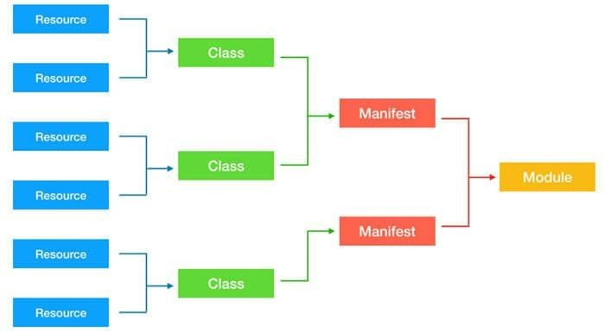

Ansible:
Ansible is simple open source IT engine which automates application deployment, intra service orchestration, cloud provisioning and many other IT tools.
Ansibleiseasytodeploybecauseitdoesnotuseanyagentsor customsecurityinfrastructure.

Ansibleusesplaybooktodescribeautomationjobs,andplaybookusesverysimplelanguage
i.e. YAML(It’s a human-readable data serialization language & is commonly used for configuration files, but could be used in many applications where data is being stored)which is very easy for humans to understand, read and write. Hence the advantage is that even the IT infrastructure support guyscanread and understandthe playbook and debug ifneeded (YAML – It is in human readable form).
Ansible is designed for multi-tier deployment. Ansible does not manage one system at time, it modelsIT infrastructure bydescribing allofyour systemsare interrelated. Ansible iscompletely agentless which means Ansible works by connecting your nodes through ssh(by default). But if

you want other method for connection like Kerberos, Ansible gives that option to you.
After connecting to your nodes, Ansible pushes small programs called as “Ansible Modules”. Ansible runs that modules on your nodes and removes them when finished. Ansible manages your inventory in simple text files (These are the hosts file). Ansible uses the hosts file whereone can group the hosts and can control the actions on a specific group in the playbooks.
SampleHosts File
Thisisthecontentofhostsfile− #File name: hosts
#Description:Inventoryfileforyourapplication.Definesmachinetypeabc node to deploy specific artifacts
#Definesmachinetypedefnodetoupload metadata.

[abc-node] #server1ansible_host=<targetmachineforDUdeployment>ansible_user=<Ansible user> ansible_connection = ssh server1ansible_host=<yourhostname>ansible_user=<yourunixuser> ansible_connection = ssh

[def-node]
#server2ansible_host=<targetmachineforartifactupload> ansible_user =
<Ansible user> ansible_connection = ssh server2ansible_host=<host>ansible_user=<user>ansible_connection=ssh

What isConfigurationManagement

Configuration management in terms of Ansible means that it maintains configuration of the product performance by keeping a record and updating detailed information which describes an enterprise’s hardware and software.
Such information typically includes the exact versions and updates that have been applied to installedsoftwarepackagesandthelocationsandnetworkaddressesofhardwaredevices.For
e.g. Ifyouwantto installthe new versionof WebLogic/WebSphere server onallofthe machines present in your enterprise, it is not feasible for you to manually go and update each and every machine.
YoucaninstallWebLogic/WebSphere inonego onallofyour machineswithAnsibleplaybooks and inventory written in the most simple way. All you have to do is list out the IP addresses of your nodes in the inventory and write a playbook to install WebLogic/WebSphere. Run the playbook from your control machine & it will be installed on all your nodes.

AnsibleWorkflow

Ansible works by connecting to your nodes and pushing out a small program called Ansible modulesto them. Then Ansible executed these modules and removed them after finished. The libraryofmodulescanresideonanymachine,andthereareno daemons, servers, or databases required.
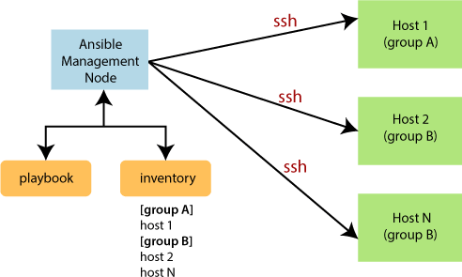

In the above image, the Management Node is the controlling node that controls the entire executionoftheplaybook.TheinventoryfileprovidesthelistofhostswheretheAnsible
modules need to be run. The Management Node makes anSSHconnection and executes the small modules on the host's machine and install the software.

Ansible removes the modules once those are installed so expertly. It connects to the hostmachine executes the instructions, and if it is successfully installed, then remove that code in which one was copied on the host machine.

TermsusedinAnsible

Terms Explanation
Ansible Server | ItisamachinewhereAnsibleisinstalledandfromwhichalltasksand playbooks will be executed.
Modules | The module is a command orsetofsimilar commands which is executedonthe client-side.
Task | Ataskisasectionwhichconsistsofa single proceduretobe completed.

Role | Itisawayoforganizingtasksandrelatedfilestobelater calledinaplaybook.
Fact | The information fetched from the client system from the global variables with the gather facts operation.
Inventory | AfilecontainingthedataregardingtheAnsibleclient-server.
Play | It isthe executionofthe playbook.
Handler | Thetaskiscalledonlyifanotifierispresent.
Notifier | Thesectionattributedtoatask whichcallsahandleriftheoutput ischanged.
Tag | It is a name set to a taskthat can be used later onto issue just that specific task or group of jobs.

AnsibleArchitecture

The Ansible orchestration engine interacts with a user who is writing the Ansible playbook to execute the Ansible orchestration and interact along with the services of private or public cloud and configuration management database. You can show in the below diagram, such as:
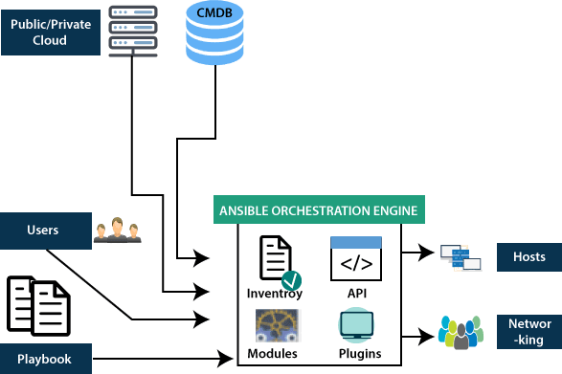
Inventory

Inventory is lists of nodes or hosts having their IP addresses, databases, servers, etc. which are need to be managed.

API's

TheAnsibleAPI'sworksasthetransportforthepublicor privatecloud services.

Modules

Ansible connectedthe nodesand spread outthe Ansible modulesprograms. Ansible executesthe modules and removed after finished. These modules can reside on any machine; no database or servers are required here. You can work with the chose text editor or a terminal or versioncontrol system to keep track of the changes in the content.

Plugins

Plugins is a piece of code that expends the core functionality of Ansible. There are many useful plugins, and you also can write your own.
Playbooks

Playbooks consist of your written code, and they are written in YAML format, which describes the tasks and executes through the Ansible. Also, you can launch the tasks synchronously and asynchronously with playbooks.
Hosts

Inthe Ansible architecture,hostsarethe nodesystems, whichare automated byAnsible, and any machine such as RedHat, Linux, Windows, etc.

Networking

Ansible is used to automate different networks, and it uses the simple, secure, and powerful agentless automation framework for IT operations and development. It uses a type ofdata model which separated from the Ansible automation engine that spans the different hardware quite easily.

Cloud

A cloud is a network of remote servers on which you can store, manage, and process the data. These serversarehosted onthe internet and storing thedataremotelyrather thanthe localserver. It just launches the resources and instances on the cloud, connect them to the servers, and you have good knowledge of operating your tasks remotely.

CMDB

CMDBisa typeofrepositorywhichactsas a datawarehouseforthe ITinstallations.

PuppetComponents

Followingarethekeycomponents ofPuppet:

- Manifests
- Module
- Resource
- Factor
- M-collective
- Catalogs
- Class
- Nodes Let'sunderstandthesecomponents indetail:
Manifests

Puppet Mastercontainsthe PuppetSlave'sconfigurationdetails, and these are writteninPuppet's native language.

Manifest is nothing but the files specifying the configuration details for Puppet slave. The extension for manifest files is .pp, which means Puppet Policy. These files consist of puppet scripts describing the configuration for the slave.

Module

The puppet module is a set of manifests and data. Here data is file, facts, or templates. The module follows a specific directory structure. These modules allow the puppet program to split into multiple manifests. Modules are simply self-contained bundles of data or code.
Let'sunderstandthemodulebythefollowingimage:
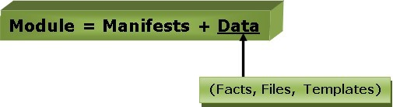

Resource

Resources are a basic unit ofsystemconfiguration modeling. These are the predefined functions that run at the backend to perform the necessary operations in the puppet.
Each puppet resource defines certain elements of the system, such as some particular service or package.
Factor

The factorcollectsfactsorimportant informationabout the puppet slave. Factsare the key-value data pair. It contains information about the node or the master machine. It represents a puppet client states such as operating system, network interface, IP address, uptime, and whether the client machine is virtual or not.

These facts are used for determining the present state of any agent. Changes on any target machine are made based on facts. Puppet's facts are predefined and customized.
M-Collective

M-collective is a framework that enables parallel execution of several jobs on multiple Slaves. This framework performs several functions, such as:
- This is used to interact withclustersofpuppet slaves;they can be insmallgroupsor very large deployments.
- To transmit demands, use a broadcast model. All Slaves receive all requests at the same time, requests have filters attached, and only Slaves matching the filter can act on requests.
- Thisisused tocallremoteslaveswiththehelp ofsimplecommand-linetools.
- Thisisusedtowritecustomreportsaboutyour infrastructure.

Catalogs

Theentireconfigurationand manifest filesthat arewritteninPuppet arechanged into acompiled format. This compiled format is known as a catalog, and then we can apply this catalog to the target machine.

Alltherequired statesofslaveresourcesaredescribedinthecatalog.

Class

Like other programming languages, the puppet also supports a class to organize the code in a better way. Puppet class is a collection of various resources that are grouped into a single unit.

V Nodes

The nodes are the location where the puppet slaves are installed used to manage all the clients and servers.

Deploymenttools

Chef
Chef is an open source technology developed by Opscode. Adam Jacob, co-founder of Opscode is known as the founder of Chef. This technology uses Ruby encoding to develop basic building blocks like recipe and cookbooks. Chef is used in infrastructure automation and helps inreducing manual and repetitive tasks for infrastructure management.
Chef have got its own convention for different building blocks, which are required to manageand automate infrastructure.
WhyChef?
Chefisaconfigurationmanagementtechnologyusedto automatetheinfrastructureprovisioning. It is developed on the basis of Ruby DSL language. It is used to streamline the task of configurationand managingthecompany’s server. It hasthecapabilityto get integratedwithany of the cloud technology.
In DevOps, we use Chef to deploy and manage servers and applications in-house and on the cloud.
Featuresof Chef
Followingarethe mostprominentfeaturesofChef−
- ChefusespopularRubylanguagetocreateadomain-specificlanguage.
- Chefdoes not make assumptions onthe current statusofa node. It uses its mechanisms to get the current status of machine.
- Chefisidealfordeployingandmanagingthecloudserver,storage,and software.

AdvantagesofChef
Chefoffersthefollowingadvantages−
- Lower barrier for entry − As Chef uses native Ruby language for configuration, a standard configuration language it can be easily picked up by anyone having some development experience.
- Excellent integration with cloud − Using the knife utility, it can be easily integratedwith any of the cloud technologies. It is the best tool for an organization that wishes to distribute its infrastructure on multi-cloud environment.

DisadvantagesofChef
Someofthemajor drawbacksofChefareasfollows−

- One of the huge disadvantages of Chef is the way cookbooks are controlled. It needs constant babying so that people who are working should not mess up with others cookbooks.
- OnlyChefsoloisavailable.
- Inthecurrentsituation,itisonlyagoodfitforAWScloud.
- Itisnot veryeasytolearn ifthepersonisnot familiar withRuby.
- Documentationisstilllacking.
Key Building Blocks of ChefRecipe
It can be defined as a collection of attributes which are used to manage the infrastructure. These attributes which are present in the recipe are used to change the existing state or setting a particular infrastructure node. They are loaded during Chef client run and comparted with the existing attribute of the node (machine). It then gets to the status which is defined in the node resource of the recipe. It is the main workhorse of the cookbook.
Cookbook
A cookbook is a collection of recipes. They are the basic building blocks which get uploaded to Chef server. When Chef run takes place, it ensures that the recipes present inside it gets a given infrastructure to the desired state as listed in the recipe.
Resource
It is the basic component of a recipe used to manage the infrastructure with different kind of states. There can be multiple resources in a recipe, which will help in configuring and managing the infrastructure. For example −
- package− Managesthe packagesona node
- service−Managestheservicesona node
- user− Managesthe usersonthenode
- group−Managesgroups
- template−Managesthefileswithembedded Rubytemplate
- cookbook_file −Transfersthefilesfromthefilessubdirectoryinthecookbooktoa location on the node
- file − Managesthecontentsofafile onthenode
- directory −Managesthedirectoriesonthenode
- execute−Executesacommand onthenode
- cron−Editsanexistingcronfile onthe node

Chef-Architecture
- Chef works on a three-tier client server model wherein the working units such as cookbooks are developed on the Chef workstation. From the command line utilities such as knife, they are uploaded to the Chef server and all the nodes which are present in the architecture are registered with the Chef server.

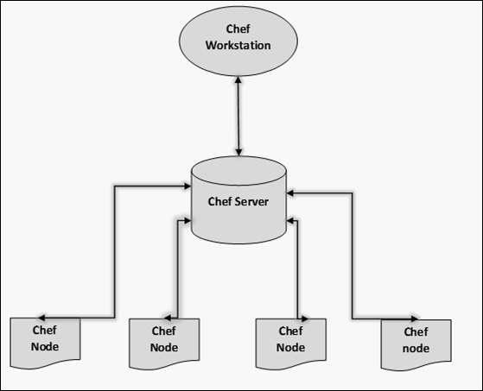

- In order to get the working Chef infrastructure in place, we need to set up multiple things in sequence.
- Intheabovesetup, wehavethefollowingcomponents.
- Chef Workstation
- This is the location where all the configurations are developed. Chef workstation is installed on the local machine. Detailed configuration structure is discussed in the later chapters of this tutorial.
- ChefServer
- This works as a centralized working unit of Chef setup, where all the configuration files are uploaded post development. There are different kinds of Chef server, some are hosted Chef server whereas some are built-in premise.
- ChefNodes
- They are the actual machines which are going to be managed by the Chef server. All the nodes can have different kinds of setup as per requirement. Chef client is the key component of all the nodes, which helps in setting up the communication between the Chef server and Chef node. The other components of Chef node is Ohai, which helps in getting the current state of any node at a given point of time.

SaltStack

Salt Stack is an open-source configuration management software and remote execution engine. Salt is a command-line tool. While written in Python, SaltStack configuration management is languageagnosticand simple. Salt platformusesthepushmodelforexecutingcommands viathe SSH

protocol. The default configurationsystemis YAMLandJinjatemplates. Salt isprimarily competing with Puppet, Chef and Ansible.
Salt provides many features when compared to other competing tools. Some of these important features are listed below.
- Fault tolerance − Salt minions can connect to multiple masters at one time byconfiguring the master configuration parameter as a YAML list of all the available masters. Any master can direct commands to the Salt infrastructure.
- Flexible − The entire management approach of Salt is very flexible. It can be implemented to follow the most popular systems management models such as Agent and Server, Agent-only, Server-only or all of the above in the same environment.
- Scalable Configuration Management − SaltStack is designed to handle ten thousand minions per master.
- Parallel Execution model− Salt can enable commands to execute remote systems in a parallel manner.
- Python API− Salt provides a simple programming interface and it was designed to be modular and easily extensible, to make it easyto mold to diverse applications.
- Easy to Setup− Salt is easyto setup and provides a single remote execution architecture that can manage the diverse requirements of any number of servers.
- Language Agnostic − Salt state configuration files, templating engine or file type supports any type of language.

Benefitsof SaltStack
Beingsimpleaswellasafeature-richsystem,Saltprovidesmanybenefitsandtheycanbe summarized as below −
- Robust − Saltis powerful and robustconfiguration managementframework and works around tens of thousands of systems.
- Authentication−SaltmanagessimpleSSHkeypairs forauthentication.
- Secure−Saltmanagessecuredatausinganencryptedprotocol.
- Fast−Saltis very fast, lightweightcommunication bus toprovidethefoundation fora remote execution engine.
- VirtualMachineAutomation −TheSaltVirtCloudControllercapabilityisusedfor automation.
- Infrastructure as data, not code− Salt provides a simple deployment, model driven configuration management and command execution framework.

IntroductiontoZeroMQ
Salt isbasedonthe ZeroMQ library anditisanembeddablenetworkinglibrary.Itis lightweight and a

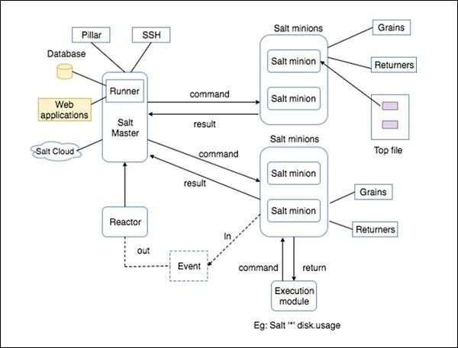
fast messaging library. The basic implementation is in C/C++and native implementations for several languages including Java and .Net is available.
ZeroMQ isa broker-lesspeer-peer messageprocessing. ZeroMQallows youto designacomplex communication system easily.
ZeroMQcomeswiththefollowingfivebasicpatterns−
- Synchronous Request/Response− Used for sending a request and receiving subsequent replies for each one sent.
- Asynchronous Request/Response − Requestor initiates the conversation by sending a Request message and waits for a Response message. Provider waits for the incoming Request messages and replies with the Response messages.
- Publish/Subscribe− Used for distributing data from a single process (e.g. publisher) to multiple recipients (e.g. subscribers).
- Push/Pull−Usedfordistributingdatatoconnected nodes.
- ExclusivePair−Usedforconnectingtwopeerstogether, forminga pair.

ZeroMQ isa highlyflexible networking toolfor exchanging messagesamong clusters, cloud and other multi system environments. ZeroMQ is the default transport library presented in SaltStack.

SaltStack– Architecture

The architecture of SaltStack is designed to work with any number of servers, from localnetwork systems to other deployments across different data centers. Architecture is a simple server/client model with the needed functionality built into a single set of daemons.
Take a look at the following illustration. It shows the different components of SaltStack architecture.

- SaltMaster− SaltMaster is the master daemon. A SaltMaster is used to send commands and configurations to the Salt slaves. A single master can manage multiple masters.
- SaltMinions− SaltMinion is the slave daemon. A Salt minion receives commands and configuration from the SaltMaster.
- Execution − Modules and Adhoc commands executed from the command line againstone or more minions. It performs Real-time Monitoring.
- Formulas− Formulas are pre-written Salt States. They are as open-ended as Salt States themselves and can be used for tasks such as installing a package, configuring andstarting a service, setting up users or permissions and many other common tasks.
- Grains− Grains is an interface that provides information specific to a minion. The information available through the grains interface is static. Grains get loaded when the Salt minion starts. This means that the information in grains is unchanging. Therefore, grains information could be about the running kernel or the operating system. It is case insensitive.
- Pillar− Apillar isaninterfacethat generatesandstoreshighlysensitivedataspecificto a particular minion, suchascryptographic keysand passwords. It storesdataina key/value pair and the data is managed in a similar wayas the Salt State Tree.
- TopFile−MatchesSaltstatesandpillardatatoSaltminions.
- Runners− It is a module located inside the SaltMaster and performs tasks such as job status, connection status, read data fromexternal APIs, queryconnected salt minions and more.
- Returners−ReturnsdatafromSaltminionstoanothersystem.
- Reactor− It is responsible for triggering reactions when events occur in your SaltStack environment.
- SaltCloud−SaltCloudprovidesapowerfulinterfacetointeractwithcloud hosts.
- SaltSSH−RunSaltcommandsoverSSHonsystemswithoutusingSaltminion.

Docker
Dockerisacontainermanagementservice.ThekeywordsofDockerare develop, ship and run anywhere. The whole idea of Docker is for developers to easily develop applications, ship them into containers which can then be deployed anywhere.
The initialrelease ofDocker was in March 2013 and since then, it has become the buzzword for modern world development, especially in the face of Agile-based projects.
FeaturesofDocker
- Docker has the ability to reduce the size of development by providing a smaller footprint of the operating system via containers.
- With containers, it becomes easier for teams across different units, such as development, QA and Operations to work seamlessly across applications.
- You can deploy Docker containers anywhere, on any physical and virtual machines andeven on the cloud.

- SinceDockercontainersareprettylightweight,theyareveryeasilyscalable. Components of Docker
Dockerhasthefollowingcomponents
- DockerforMac −ItallowsonetorunDocker containersontheMacOS.
- DockerforLinux−It allowsoneto runDockercontainersontheLinuxOS.
- DockerforWindows−Itallowsoneto runDocker containersontheWindowsOS.
- DockerEngine−Itisusedfor buildingDockerimagesandcreatingDocker containers.
- DockerHub−Thisistheregistrywhich isused tohost variousDockerimages.
- DockerCompose−This isusedtodefineapplicationsusingmultipleDocker containers.

Dockerarchitecture
- Docker uses a client-server architecture. The Docker clienttalks to the Dockerdaemon, which does the heavy lifting of building, running, and distributing your Docker containers. The Docker client and daemoncanrun on the same system, or you can connect a Docker client to a remote Docker daemon. The Docker client and daemon communicate using a REST API, over UNIX sockets or a network interface. Another Dockerclient is Docker Compose, that lets you workwithapplications consisting ofa set of containers.

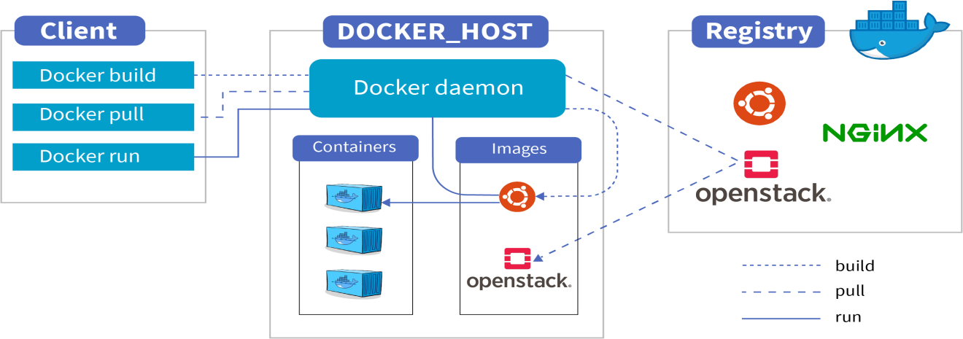

TheDockerdaemon
TheDockerdaemon(dockerd)listens forDockerAPIrequestsand managesDockerobjectssuch as images, containers, networks, and volumes. A daemon can also communicate with other daemons to manage Docker services.

TheDockerclient
The Docker client (docker) is the primary way that many Docker users interact with Docker.

When you use commands such as dockerrun, the clientsends these commands to dockerd, which carries them out. The docker command uses the Docker API. The Docker client can communicate with more than one daemon.

DockerDesktop
Docker Desktop is an easy-to-install application for your Mac, Windows or Linux environment that enables you to build and share containerized applications and microservices. DockerDesktop includes the Docker daemon (dockerd), the Docker client (docker), Docker Compose, Docker Content Trust, Kubernetes, and Credential Helper. For more information, see DockerDesktop.

Docker registries
A Docker registrystores Docker images. Docker Hub is a public registry that anyone can use, and Docker is configured to look for images on Docker Hub by default. You can even run your own private registry.
Whenyouusethe dockerpullor dockerruncommands,therequiredimagesarepulledfrom your configured registry. When you usethe dockerpushcommand, yourimage ispushed to your configured registry.

Dockerobjects
When you use Docker, you are creating and using images, containers, networks, volumes, plugins, and other objects. This section is a brief overview of some of those objects.
Images
Animage is a read-only template with instructions for creating a Docker container. Often, an image isbased on another image, with some additional customization. For example, you may build an image which is based onthe ubuntuimage, but installs the Apache web server and your application, as well as the configuration details needed to make your application run.
You might create your own images or you might onlyuse those created byothers and published ina registry. To build yourown image, you create a Dockerfilewitha simple syntax for defining the steps neededto createthe image and run it. Each instruction ina Dockerfile creates alayer in the image. When you change the Dockerfile and rebuild the image, onlythose layerswhich have changed are rebuilt. This is part of what makes images so lightweight, small, and fast, when compared to other virtualization technologies.
Containers
A container is a runnable instance of an image. You can create, start, stop, move, or delete a container using the Docker API or CLI. You can connect a container to one or more networks, attach storage to it, or even create a new image based on its current state.

Bydefault, acontainer isrelativelywell isolated fromother containersand its host machine. You cancontrolhow isolated a container’s network, storage,orother underlying subsystems are from other containers or from the host machine.
A container is defined by its image as well as any configuration options you provide to it when you createor start it. When a container is removed, anychanges to its statethat are not stored in persistent storage disappear.
Exampledockerruncommand
The following command runsanubuntucontainer, attaches interactivelyto your localcommand- line session, and runs /bin/bash.
$dockerrun-i-tubuntu/bin/bash
When you runthiscommand, the following happens(assuming you are using the default registry configuration):
- Ifyoudonothavethe ubuntu imagelocally,Dockerpullsitfromyourconfiguredregistry, as though you had run docker pull ubuntu manually.
- Docker createsa new container, asthough you had runa docker container create command manually.
- Docker allocates a read-write filesystem to the container, as its final layer. This allows a running container to create or modify files and directories in its local filesystem.
- Docker creates a network interface to connect the container to the default network, since you did not specifyany networking options. This includes assigning an IP address to the container. By default, containers can connect to external networks using the host machine’s network connection.
- Docker starts the container and executes /bin/bash. Because the container is running interactively and attached to your terminal (due to the -iand-t flags), you can provide input using your keyboard while the output is logged to your terminal.
- When you typeexit to terminate the/bin/bashcommand, the container stops but is not removed. You can start it again or remove it.

Theunderlying technology
Docker iswritteninthe Go programming language andtakesadvantageofseveralfeaturesofthe Linux kernelto deliver its functionality. Docker uses a technologycalled namespacesto provide theisolatedworkspacecalledthe container.Whenyourunacontainer,Dockercreatesaset of namespaces for that container.
These namespaces provide a layer of isolation. Each aspect of a container runs in a separate namespace and its access is limited to that namespace.

UNIT WISE IMP Questions

Unit 1

PART A
- Explain briefly about SDLC?
- What is waterfall model?
- What is agile model?
- Why DevOps?
- What is DevOps?
- What is ITIL?
- What is continuous development?
- What is continuous integration?
- What is continuous testing?
- What is continuous delivery?
- What is continuous deployment?
- What is Scrum?
- What is Kanban?

PART B
- What is the difference between Agile and DevOps?
- What are the differences between Agile and Waterfall model?
- Explain DevOps process flow in detail?
- What is continuous delivery and how it works?
- Explain components of delivery pipeline?

Unit 2

PART A
- What are different software development lifecycle models?
- What is data tier in DevOps?
- What is monolithic architecture?
- What are benefits of monolithic architecture?

PART B
- Explain DevOps lifecycle in detail?
- What are DevOps components?
- Explain about DevOps architecture in detail?
- What are microservices and how does microservices architecture work?
- Explain architecture rules of thumb?
- Explain database migration?
- What are the advantages of migration tools?

Unit 3

PART A
- What is the need for source code control in DevOps?
- What are the roles and codes in DevOps?
- What are the benefits of source code management in DevOps?
- What is shared authentication in DevOps?
- What is pull request model in DevOps?

PART B
- What is version control? Explain types of version control systems and benefits of version control systems.
- What is Gerrit and explain the architecture of Gerrit?
- What is Docker intermission and what are the differences between Docker and machine?
- Explain Gerrit and its architecture?

Unit 4

PART A
- What is Git plugin?
- What is managing build dependencies in DevOps?
- What is build pipelines?
- What is job chaining?
- Explain collating quality measures?
- What are alternative build servers?

PART B
- What is Jenkins and explain its workflow?
- Explain Jenkins master-slave architecture and Jenkins applications?
- What are build slaves in DevOps?
- What is infrastructure as a code in DevOps?
- What are different build phases in DevOps?

Unit 5

PART A
- What is JavaScript testing?
- What are the different tools used for backend testing?
- Explain TDD vs Traditional Testing?
- What is Acceptance TDD and Developer TDD?
- What is REPL driven development?
- What is deployment of the system?
- What is virtualization of the stack?

PART B
- What is testing and explain different types of testing?
- Pros and cons of testing?
- What is Selenium and explain Selenium features?
- What are backend integration points and explain backend testing validation?
- What are advantages and disadvantages of backend testing?
- What is TTD and how it is performed?

OBJECTIVE TYPE UNIT WISE QUESTIONS

Unit 1
- What is the main philosophy of Agile development? a. To deliver working software frequently b. To prioritize customer satisfaction c. To respond to change over following a plan d. All of the above Answer: d. All of the above
- What is the most commonly used Agile methodology? a. Scrum b. Kanban c. Waterfall d. XP (Extreme Programming) Answer: a. Scrum
- In Scrum, what is the role of the Scrum Master? a. To lead the development team b. To manage the project schedule c. To facilitate the Scrum process d. To direct the work of the development team Answer: c. To facilitate the Scrum process
- In Scrum, what is the purpose of the daily stand-up meeting? a. To review progress b. To plan the next sprint c. To inspect the previous sprint d. To coordinate work between team members Answer: a. To review progress
- What is the main purpose of sprint retrospectives in Scrum? a. To evaluate the sprint and identify areas for improvement b. To plan the next sprint c. To review progress d. To coordinate work between team members Answer: a. To evaluate the sprint and identify areas for improvement
- What is pair programming in XP (Extreme Programming)? a. Two programmers working on the same task b. Two programmers working on different tasks c. One programmer working alone d. None of the above Answer: a. Two programmers working on the same task
- What is ITIL (Information Technology Infrastructure Library)? a. A set of best practices for IT service management b. A framework for managing and delivering IT services c. A methodology for continuous delivery and integration d. All of the above Answer: a. A set of best practices for IT service management
- What is the main goal of ITIL? a. To improve the quality of IT services b. To reduce the cost of IT services c. To improve the efficiency of IT service delivery d. All of the above Answer: d. All of the above
- What is the relationship between ITIL and DevOps? a. ITIL and DevOps are completely separate and have no relationship b. ITIL is a methodology that can be used to support DevOps c. DevOps is a methodology that can be used to support ITIL d. Both ITIL and DevOps are completely integrated and cannot be used separately Answer: b. ITIL is a methodology that can be used to support DevOps
- Which ITIL process is concerned with the delivery of IT services to customers? a. Incident Management b. Service Delivery c. Service Level Management d. Capacity Management Answer: b. Service Delivery
- What is the purpose of the Change Management process in ITIL? a. To ensure that changes to IT services are properly planned and tested b. To minimize the disruption caused by changes to IT services c. To ensure that changes are implemented in a controlled and coordinated manner d. All of the above Answer: d. All of the above
- Which ITIL process is concerned with the management of IT service continuity? a. Incident Management b. Service Delivery c. Service Level Management d. Continuity Management Answer: d. Continuity Management
- What is the main purpose of using Kanban in DevOps? a. To increase efficiency in the development process b. To manage the entire software development lifecycle c. To increase speed and agility in delivering software d. To visualize the flow of work Answer: d
- What is the main difference between Scrum and Kanban? a. Scrum has time-boxed iterations, while Kanban does not b. Kanban focuses on delivering software quickly, while Scrum focuses on teamwork c. Scrum has defined roles and ceremonies, while Kanban does not d. Kanban is mainly used for maintenance and operations, while Scrum is mainly used for new development Answer: a
- How is work prioritized in a Kanban system? a. Based on the order in which it was received b. Based on the availability of team members c. Based on the priority set by the customer d. Based on the importance of the work Answer: c
- In a Kanban system, what is the purpose of a "pull" system? a. To assign tasks to team members b. To ensure work is only started when there is capacity available c. To control the flow of work d. To prioritize tasks Answer: b
- What is the main purpose of a delivery pipeline in DevOps? a. To automate the software delivery process b. To manage the entire software development lifecycle c. To increase speed and agility in delivering software d. To visualize the flow of work Answer: a
- What are the main stages in a typical delivery pipeline? a. Development, testing, deployment b. Requirements gathering, design, coding c. Planning, execution, monitoring d. Continuous integration, continuous delivery, continuous deployment Answer: d
- What is the purpose of continuous integration in a delivery pipeline? a. To automate the testing process b. To integrate code changes from multiple developers c. To deploy software to production d. To manage the entire software development lifecycle Answer: b
- What is the purpose of continuous delivery in a delivery pipeline? a. To automate the testing process b. To integrate code changes from multiple developers c. To deploy software to production with a single click d. To manage the entire software development lifecycle Answer: c
- What is the purpose of continuous deployment in a delivery pipeline? a. To automate the testing process b. To integrate code changes from multiple developers c. To deploy software to production with a single click d. To automatically deploy software to production whenever changes are made Answer: d

Unit 2
- What are the main stages of the DevOps lifecycle? a) Development, testing, deployment b) Plan, code, deploy c) Continuous integration, continuous delivery, continuous deployment d) Plan, build, test, release, deploy, operate, monitor Answer: d
- What is the purpose of the "plan" stage in the DevOps lifecycle? a) To plan the development and deployment process b) To build the software c) To test the software d) To release the software Answer: a
- What is the purpose of the "build" stage in the DevOps lifecycle? a) To plan the development and deployment process b) To build the software c) To test the software d) To release the software Answer: b
- What is the purpose of the "test" stage in the DevOps lifecycle? a) To plan the development and deployment process b) To build the software c) To test the software d) To release the software Answer: c
- What is the purpose of the "release" stage in the DevOps lifecycle? a) To plan the development and deployment process b) To build the software c) To test the software d) To release the software Answer: d
- What is the purpose of the "deploy" stage in the DevOps lifecycle? a) To deploy the software to production b) To build the software c) To test the software d) To release the software Answer: a
- What is the purpose of the "operate" stage in the DevOps lifecycle? a) To operate and maintain the software b) To build the software c) To test the software d) To release the software Answer: a
- What is the purpose of the "monitor" stage in the DevOps lifecycle? a) To monitor the performance and stability of the software b) To build the software c) To test the software d) To release the software Answer: a
- What is a monolithic architecture in DevOps? a) An architecture in which all components are tightly coupled and cannot be separated b) An architecture in which components are loosely coupled and can be separated c) An architecture in which components are dependent on each other d) An architecture in which components are independent of each other Answer: a
- What are the main benefits of a monolithic architecture in DevOps? a) Scalability and flexibility b) Ease of deployment c) Simplicity and ease of maintenance d) Isolation of components Answer: c
- What are the main drawbacks of a monolithic architecture in DevOps? a) Scalability and flexibility b) Ease of deployment c) Simplicity and ease of maintenance d) Isolation of components Answer: a
- How does a monolithic architecture impact deployment in DevOps? a) Deployment is difficult because all components are tightly coupled b) Deployment is easy because all components are loosely coupled c) Deployment is not impacted by the architecture d) Deployment is made more complex because of the inter-dependencies of components Answer: a
- How does a monolithic architecture impact scalability in DevOps? a) Scalability is difficult because all components are tightly coupled b) Scalability is easy because all components are loosely coupled c) Scalability is not impacted by the architecture d) Scalability is made more complex because of the inter-dependencies of components Answer: a
- What is the main purpose of database migrations in DevOps? a) To move data from one database to another b) To change the schema of a database c) To store data in a database d) To retrieve data from a database Answer: b
- What are the main challenges of handling database migrations in DevOps? a) Data loss and downtime b) Incompatibility with different database systems c) Lack of automation d) All of the above Answer: d
- How can database migrations be automated in DevOps? a) By using manual scripts b) By using database migration tools c) By using continuous integration and continuous deployment (CI/CD) pipelines d) By using database backup tools Answer: c
- What is the purpose of using database migration tools in DevOps? a) To automate the process of database migrations b) To store data in a database c) To retrieve data from a database d) To move data from one database to another Answer: a
- How can database downtime be minimized during migrations in DevOps? a) By using manual scripts b) By using database migration tools c) By using CI/CD pipelines d) By using database backup tools Answer: b
- What is a microservice architecture in DevOps? a) An architecture in which a large application is divided into small, independent services b) An architecture in which a large application is tightly coupled and cannot be separated c) An architecture in which a large application is loosely coupled and can be separated d) An architecture in which a large application is dependent on a single service Answer: a
- What are the main benefits of using microservices in DevOps? a) Scalability and flexibility b) Ease of deployment c) Simplicity and ease of maintenance d) All of the above Answer: d
- What are the main drawbacks of using microservices in DevOps? a) Complexity of managing multiple services b) Inter-service communication overhead c) Lack of scalability d) All of the above Answer: a
- How does using microservices impact deployment in DevOps? a) Deployment is more complex because multiple services must be deployed b) Deployment is simpler because services can be deployed independently c) Deployment is not impacted by the architecture d) Deployment is made easier because of the inter-dependencies of services Answer: b

Unit 3
- What is the purpose of source code management in DevOps? a) To manage and track changes to source code b) To store source code c) To compile source code d) To distribute source code Answer: a
- What are the main benefits of using source code management in DevOps? a) Improved collaboration and coordination between developers b) Increased visibility into code changes c) Better organization of source code d) All of the above Answer: d
- What are the main tools used for source code management in DevOps? a) Git b) Subversion c) Mercurial d) All of the above Answer: a
- How does using source code management impact deployment in DevOps? a) Deployment is not impacted by source code management b) Deployment is made more complex because of the need to manage code changes c) Deployment is simplified because code changes are tracked and can be easily rolled back d) Deployment is made easier because code changes are automatically compiled Answer: c
- How does using source code management impact collaboration between developers in DevOps? a) Collaboration is not impacted by source code management b) Collaboration is made more complex because of the need to manage code changes c) Collaboration is simplified because code changes are tracked and can be easily reviewed d) Collaboration is made easier because code changes are automatically compiled Answer: c
- What is a migration in DevOps? a) A process of moving data from one location to another b) A process of changing infrastructure c) A process of updating software d) A process of changing development processes Answer: a
- What are the main benefits of using migrations in DevOps? a) Improved stability of systems b) Increased efficiency of systems c) Better ability to scale systems d) All of the above Answer: d
- What are the main challenges associated with migrations in DevOps? a) Data loss b) Downtime c) Increased complexity of systems d) All of the above Answer: d
- How do migrations impact deployment in DevOps? a) Deployment is not impacted by migrations b) Deployment is made more complex because of the need to manage data migrations c) Deployment is simplified because migrations are automated d) Deployment is made easier because migrations are automatically performed Answer: b
- How do migrations impact collaboration between teams in DevOps? a) Collaboration is not impacted by migrations b) Collaboration is made more complex because of the need to coordinate migrations c) Collaboration is simplified because migrations are tracked and can be easily reviewed d) Collaboration is made easier because migrations are automatically performed Answer: b
- What is shared authentication in DevOps? a) A system for sharing authentication credentials between different systems b) A system for storing authentication credentials c) A system for managing authentication credentials d) A system for distributing authentication credentials Answer: a
- What are the main benefits of using shared authentication in DevOps? a) Improved security b) Increased efficiency c) Better ability to manage authentication credentials d) All of the above Answer: d
- What are the main challenges associated with shared authentication in DevOps? a) Lack of control over authentication credentials b) Increased risk of unauthorized access c) Increased complexity of systems d) All of the above Answer: d
- How does shared authentication impact deployment in DevOps? a) Deployment is not impacted by shared authentication b) Deployment is made more complex because of the need to manage shared authentication credentials c) Deployment is simplified because authentication is centralized d) Deployment is made easier because authentication is automatically performed Answer: b
- How does shared authentication impact collaboration between teams in DevOps? a) Collaboration is not impacted by shared authentication b) Collaboration is made more complex because of the need to coordinate shared authentication credentials c) Collaboration is simplified because authentication is centralized d) Collaboration is made easier because authentication is automatically performed
- What is Git? a) A version control system b) A file backup system c) A project management tool d) A software distribution platform Answer: a
- What are the main benefits of using Git in software development? a) Improved collaboration b) Increased efficiency c) Better ability to manage code changes d) All of the above Answer: d
- What is the default branch in a Git repository? a) master b) develop c) trunk d) main Answer: a
- How does Git handle conflicts between multiple code changes? a) Git automatically merges changes b) Git prompts the user to manually resolve conflicts c) Git discards conflicting changes d) Git stores conflicting changes as separate branches Answer: b
- What is the purpose of a Git stash? a) To save changes temporarily without committing them b) To discard changes c) To revert code changes d) To store changes as a new branch Answer: a
- What is GitHub? a) A version control system b) A code hosting platform c) A project management tool d) A software distribution platform Answer: b
- What are the main benefits of using GitHub in software development? a) Improved collaboration b) Increased visibility of code changes c) Better ability to manage code changes d) All of the above Answer: d
- What is a GitHub repository? a) A collection of code and related files b) A place to store code backups c) A project management tool d) A software distribution platform Answer: a
- What is a pull request in GitHub? a) A request for code changes to be merged into a repository b) A request for code to be stored in a repository c) A request for a repository to be deleted d) A request for code to be reviewed Answer: a
- What is a GitHub issue? a) A place to report bugs or request features b) A place to store code backups c) A project management tool d) A software distribution platform Answer: a
- What is Docker? a) A virtual machine software b) A containerization platform c) A configuration management tool d) A software distribution platform Answer: b
- What are the main benefits of using Docker in software development? a) Improved application portability b) Increased efficiency in deploying applications c) Better ability to manage dependencies d) All of the above Answer: d
- What is a Docker image? a) A pre-configured environment for running applications b) A set of instructions for building containers c) A place to store configuration data d) A way to manage container resources Answer: a
- What is a Docker container? a) A pre-configured environment for running applications b) A set of instructions for building containers c) A place to store configuration data d) A running instance of a Docker image Answer: d
- What is the purpose of a Dockerfile? a) To store configuration data for a Docker container b) To specify the steps to build a Docker image c) To run a Docker container d) To manage container resources Answer: b
- What is Gerrit? a) A version control system b) A code hosting platform c) A code review tool d) A software distribution platform Answer: c
- What are the main benefits of using Gerrit in software development? a) Improved collaboration b) Increased visibility of code changes c) Better ability to manage code changes d) All of the above Answer: d
- What is a Gerrit change? a) A set of code changes in a repository b) A request for code changes to be merged c) A request for code review d) A place to store code backups Answer: a
- What is a Gerrit patchset? a) A new version of a change in Gerrit b) A request for code changes to be merged c) A request for code review d) A place to store code backups Answer: a
- What is a Gerrit review? a) An evaluation of code changes in Gerrit b) A request for code changes to be merged c) A request for code review d) A place to store code backups Answer: a

Unit 4
- What is Jenkins? a) A virtual machine software b) A continuous integration and continuous delivery (CI/CD) tool c) A configuration management tool d) A software distribution platform Answer: b
- What are the main benefits of using Jenkins in software development? a) Improved collaboration b) Increased efficiency in software delivery c) Better ability to manage build and deployment processes d) All of the above Answer: d
- What is a Jenkins job? a) A set of instructions for building and deploying software b) A place to store code backups c) A project management tool d) A software distribution platform Answer: a
- What is a Jenkins build? a) The process of building and compiling software b) A place to store build artifacts c) A request for code review d) A running instance of a Docker image Answer: a
- What is a Jenkins pipeline? a) A set of instructions for building and deploying software b) A continuous delivery pipeline c) A place to store configuration data d) A way to manage container resources Answer: b
- What is a Jenkins plugin? a) A software component that adds functionality to Jenkins b) A version control system c) A code review tool d) A software distribution platform Answer: a
- What are the main benefits of using Jenkins plugins in software development? a) Improved efficiency in software delivery b) Increased flexibility in customizing Jenkins c) Better ability to integrate with other tools and systems d) All of the above Answer: d
- What is the purpose of the Jenkins Git plugin? a) To integrate Git version control with Jenkins b) To manage Jenkins jobs c) To automate code review processes d) To distribute software packages Answer: a
- What is the purpose of the Jenkins Pipeline plugin? a) To define and manage Jenkins pipelines b) To automate code review processes c) To distribute software packages d) To manage Docker images Answer: a
- What is the purpose of the Jenkins Deployment Pipeline plugin? a) To automate deployment processes in Jenkins b) To manage Jenkins jobs c) To integrate version control with Jenkins d) To distribute software packages Answer: a
- What is a trigger in DevOps? a) An event or condition that initiates a process or action b) A version control system c) A code review tool d) A software distribution platform Answer: a
- What are the main types of triggers in DevOps? a) Scheduled triggers b) Event-based triggers c) Manual triggers d) All of the above Answer: d
- What is the purpose of scheduled triggers in DevOps? a) To initiate processes or actions at pre-determined times b) To respond to events or conditions c) To manually initiate processes or actions d) To distribute software packages Answer: a
- What is the purpose of event-based triggers in DevOps? a) To respond to events or conditions b) To initiate processes or actions at pre-determined times c) To manually initiate processes or actions d) To distribute software packages Answer: a
- What is the purpose of manual triggers in DevOps? a) To manually initiate processes or actions b) To respond to events or conditions c) To initiate processes or actions at pre-determined times d) To distribute software packages Answer: a
- What is the purpose of build pipelines in DevOps? a) To automate the process of building software b) To manage version control c) To automate code review processes d) To distribute software packages Answer: a
- What is the difference between build pipelines and orchestration in DevOps? a) Build pipelines are a series of automated steps for building software, while orchestration involves coordinating and automating the various steps and processes involved in software delivery b) Build pipelines are a manual process, while orchestration involves automating processes c) Build pipelines are only for code review, while orchestration involves the entire software delivery process d) There is no difference; they refer to the same thing Answer: a
- What are the benefits of using build pipelines in DevOps? a) Improved efficiency in software delivery b) Increased transparency in software development processes c) Better ability to identify and resolve problems early in the development process d) All of the above Answer: d
- What are the benefits of using orchestration in DevOps? a) Improved efficiency in software delivery b) Increased collaboration among teams c) Improved ability to scale processes and systems d) All of the above Answer: d
- How does orchestration in DevOps help with continuous delivery and continuous deployment? a) By coordinating and automating the various steps and processes involved in software delivery b) By manual review and approval of every step in the delivery process c) By only building software, without coordinating and automating delivery processes d) By only distributing software packages, without coordinating and automating delivery processes Answer: a

Unit 5
- What is the main goal of testing in DevOps? a) To ensure that software is of high quality and meets customer requirements b) To increase development speed c) To implement version control d) To automate code review processes Answer: a
- What are the benefits of incorporating testing into the DevOps process? a) Faster time-to-market for software releases b) Improved software quality and reliability c) Increased transparency in the development process d) All of the above Answer: d
- What is continuous testing in DevOps? a) The practice of testing software continuously throughout the development process b) A manual testing process c) Only testing software after it has been built d) Only testing software before it is deployed Answer: a
- What is the role of automation in testing in DevOps? a) Automation helps to make testing faster, more efficient, and more reliable b) Automation is not necessary in testing c) Automation slows down the testing process d) Automation only makes testing more manual Answer: a
- What is the purpose of test-driven development (TDD) in DevOps? a) To ensure that code meets requirements before it is even written b) To test code after it has been written c) To manually review and approve code d) To only distribute software packages Answer: a
- What is Selenium used for in software testing? a) Automated testing of web applications b) Automated testing of desktop applications c) Automated testing of mobile applications d) Automated testing of command-line applications Answer: a
- What programming languages can be used with Selenium? a) Java, Python, Ruby, and C# b) Assembly language only c) Swift only d) Visual Basic only Answer: a
- What is the Selenium WebDriver? a) A library for automating web browsers b) A library for automating desktop applications c) A library for automating mobile applications d) A library for automating command-line applications Answer: a
- What are the components of the Selenium Suite? a) Selenium WebDriver, Selenium Grid, and Selenium IDE b) Selenium WebDriver only c) Selenium Grid only d) Selenium IDE only Answer: a
- What is the purpose of Selenium Grid in the Selenium Suite? a) To distribute tests across multiple machines and environments for parallel execution b) To run tests sequentially on a single machine c) To manually review and approve tests d) To only distribute test results Answer: a
- What is the main goal of JavaScript testing in DevOps? a) To ensure the functionality and reliability of JavaScript code b) To ensure the functionality and reliability of only server-side code c) To ensure the functionality and reliability of only database code d) To ensure the functionality and reliability of only HTML and CSS code Answer: a
- What are some common tools used for JavaScript testing in DevOps? a) Jest, Mocha, and Karma b) Git, Jenkins, and Docker c) Selenium, Appium, and Espresso d) Oracle, MySQL, and PostgreSQL Answer: a
- What is unit testing in JavaScript testing? a) Testing individual units of JavaScript code in isolation b) Testing the entire JavaScript application as a whole c) Testing only server-side code d) Testing only database code Answer: a
- What is integration testing in JavaScript testing? a) Testing the integration of individual units of JavaScript code with the rest of the application b) Testing the entire JavaScript application as a whole c) Testing only server-side code d) Testing only database code Answer: a
- How can JavaScript testing improve the speed and reliability of software delivery in DevOps? a) By quickly identifying and resolving issues in JavaScript code, reducing the risk of problems in later stages of the software delivery process b) By slowing down the software delivery process c) By having no impact on the software delivery process d) By increasing the manual effort required for software delivery Answer: a
- What is Puppet Master? a) An open-source configuration management tool b) A version control system c) A cloud service provider d) A continuous integration tool Answer: a
- What is the main purpose of using Puppet Master in DevOps? a) To automate the configuration and management of IT infrastructure b) To automate the development process c) To automate the deployment process d) To automate all stages of the software delivery process Answer: a
- What kind of infrastructure can be managed using Puppet Master? a) Physical servers, virtual machines, and cloud-based systems b) Only physical servers c) Only virtual machines d) Only cloud-based systems Answer: a
- What is a Puppet module in Puppet Master? a) A pre-written set of Puppet code that can be used to automate specific tasks b) A manual process that requires manual coding c) A tool for code collaboration d) A tool for code deployment Answer: a
- What are the benefits of using Puppet Master in DevOps? a) Improved speed, reliability, and consistency of IT infrastructure management b) Increased manual effort required for IT infrastructure management c) No impact on IT infrastructure management d) Slower and less reliable IT infrastructure management Answer: a
- What is Ansible? a) An open-source configuration management tool b) A version control system c) A cloud service provider d) A continuous integration tool Answer: a
- What is the main purpose of using Ansible in DevOps? a) To automate the configuration and management of IT infrastructure b) To automate the development process c) To automate the deployment process d) To automate all stages of the software delivery process Answer: a
- What kind of infrastructure can be managed using Ansible? a) Physical servers, virtual machines, and cloud-based systems b) Only physical servers c) Only virtual machines d) Only cloud-based systems Answer: a
- What is an Ansible playbook in Ansible? a) A pre-written set of Ansible code that can be used to automate specific tasks b) A manual process that requires manual coding c) A tool for code collaboration d) A tool for code deployment Answer: a
- What are the benefits of using Ansible in DevOps? a) Improved speed, reliability, and consistency of IT infrastructure management b) Increased manual effort required for IT infrastructure management c) No impact on IT infrastructure management d) Slower and less reliable IT infrastructure management Answer: a
- What is Chef? a) An open-source configuration management tool b) A version control system c) A cloud service provider d) A continuous integration tool Answer: a
- What is the main purpose of using Chef in DevOps? a) To automate the configuration and management of IT infrastructure b) To automate the development process c) To automate the deployment process d) To automate all stages of the software delivery process Answer: a
- What kind of infrastructure can be managed using Chef? a) Physical servers, virtual machines, and cloud-based systems b) Only physical servers c) Only virtual machines d) Only cloud-based systems Answer: a
- What is a Chef recipe in Chef? a) A pre-written set of Chef code that can be used to automate specific tasks b) A manual process that requires manual coding c) A tool for code collaboration d) A tool for code deployment Answer: a
- What are the benefits of using Chef in DevOps? a) Improved speed, reliability, and consistency of IT infrastructure management b) Increased manual effort required for IT infrastructure management c) No impact on IT infrastructure management d) Slower and less reliable IT infrastructure management Answer: a

Question bank with Answers

UNIT 1

Short Answer Questions:

- Explain in detail about Agile Development Model with a neat diagram?
- DevOps and ITIL are not mutually exclusive? Justify.
- Explain in detail about DevOps Continuous Delivery Pipeline?
- List the different possible cases for Bottlenecks in CI/CD?
- With an example explain DevOps Process?

1. Explain in detail about Agile Development Model with a neat diagram? 2. DevOps and ITIL are not mutually exclusive? Justify. 3. Explain in detail about DevOps Continuous Delivery Pipeline? 4. List the different possible cases for Bottlenecks in CI/CD? 5. With an example explain DevOps Process?
- Explain in detail about Agile Development Model with a neat diagram

The Agile Development Model is a method that promotes continuous iteration of development and testing throughout the software development lifecycle of the project. Here are its key aspects:

  - Iterative and Incremental: Agile breaks down projects into small, manageable units called iterations or sprints. Each iteration includes planning, development, testing, and review.
  - Customer Collaboration: Agile emphasizes working closely with customers and stakeholders to gather feedback and ensure the product meets their needs.
  - Flexibility: Agile allows for changes and adjustments based on feedback and evolving requirements.

Example Diagram:
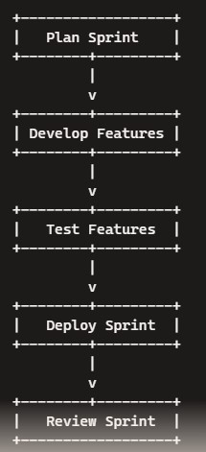

- DevOps and ITIL are not mutually exclusive? Justify.

DevOps and ITIL (Information Technology Infrastructure Library) can coexist and complement each other. Here's how:

  - ITIL: Provides a framework for IT service management, focusing on aligning IT services with business needs and improving service delivery.
  - DevOps: Emphasizes collaboration between development and operations teams, automation, continuous integration, and continuous delivery.

By integrating ITIL's structured processes with DevOps' agile and automation-focused approach, organizations can improve efficiency, speed, and quality of IT services. For example, ITIL's change management process can be automated and streamlined using DevOps practices, ensuring faster and safer deployments.

- Explain in detail about DevOps Continuous Delivery Pipeline

The DevOps Continuous Delivery (CD) Pipeline is a series of automated steps to deliver new software versions quickly and safely. It includes:

  - Version Control: Code changes are tracked using version control systems like Git.
  - Continuous Integration (CI): Developers' changes are merged into a shared repository frequently, with automated builds and tests ensuring code quality.
  - Automated Testing: Extensive testing, including unit, integration, and end-to-end tests, is automated to catch defects early.
  - Deployment Automation: Code is automatically deployed to various environments (development, testing, production) using tools like Jenkins, GitLab CI, or CircleCI.
  - Monitoring: Continuous monitoring of the application in production to detect issues and gather feedback.

This pipeline ensures code changes are tested, integrated, and delivered to production quickly and reliably.

- List the different possible cases for Bottlenecks in CI/CD

Common bottlenecks in Continuous Integration and Continuous Delivery (CI/CD) include:

  - Slow Build Processes: Long build times can delay the entire pipeline.
  - Long-running Tests: Extensive test suites can slow down the feedback loop.
  - Manual Approval Gates: Waiting for manual approvals can create delays.
  - Infrastructure Constraints: Limited resources can slow down deployment and testing.
  - Inefficient Deployment Processes: Manual or complex deployment processes can introduce delays.
  - Lack of Automated Rollbacks: If issues are detected, the absence of automated rollback mechanisms can complicate recovery.

- With an example explain DevOps Process
Let's take an example of a typical DevOps process:
- Code: A developer writes new code and commits it to a version control system like Git.
- Build: The CI server (e.g., Jenkins) detects the commit, pulls the code, and starts an automated build process.

- Test: Automated tests run to verify the code changes. If tests pass, the build proceeds.
- Deploy: The build is deployed to a staging environment for further testing and validation.
- Review: The changes are reviewed by the team and stakeholders. Feedback is gathered and any issues are addressed.
- Release: The code is deployed to production using automated deployment tools.
- Monitor: The application is monitored in production to ensure it performs as expected and any issues are quickly detected and resolved.

Essay Type Questions:

- Compare Agile and DevOps, and explain their complementary nature in achieving efficient software development and delivery.
- Discuss the principles and practices of DevOps that improve collaboration and efficiency in IT operations.
- Explain the significance of Continuous Delivery in DevOps and provide examples of organizations successfully implementing it.
- Describe release management in DevOps, its challenges, benefits, and real-world examples of successful implementation.
- Compare and contrast Scrum and Kanban as Agile methodologies, their support for DevOps, and contribution to software delivery.
- Explain the concept of a delivery pipeline in DevOps, its stages, and popular tools/technologies used.
- Identify common bottlenecks in DevOps, strategies to overcome them, and real-world examples of resolved bottlenecks.
- Analyze the relationship between DevOps and ITIL, and how to effectively incorporate ITIL practices within a DevOps culture.
- Explore the role of automation in DevOps, its benefits, challenges, and examples of popular automation tools.
- Investigate the importance of monitoring and feedback loops in DevOps, and how organizations can leverage them for continuous improvement, with examples.

UNIT 2

Short Answer Questions:

- Explain DevOps Life-cycle for Business Agility?
- Discuss about Continuous Testing in DevOps?
- Explain in detail about Monolithic Architecture with a neat diagram?
- How to handle Database Migrations?
- Explain in detail about Microservices Architecture with a neat diagram?
- Discuss about Resilience in DevOps?

- Explain DevOps Life-cycle for Business Agility

The DevOps lifecycle is a series of stages that focus on enhancing collaboration between development and operations teams to achieve continuous delivery and business agility. Here are the key stages:

  - Plan: Involves planning and defining project goals, including requirements and tasks.
  - Code: Development of the software, focusing on writing and refining code.
  - Build: Compiling the code and turning it into an executable format.
  - Test: Automated and manual testing to ensure code quality and functionality.
  - Release: Preparing the code for deployment in the production environment.
  - Deploy: Deploying the code into production environments.
  - Operate: Managing and monitoring the application in production.
  - Monitor: Continuously monitoring the application for performance, security, and other metrics to identify issues and improve the system.

These stages are iterative and aim to improve agility by enabling faster and more reliable software delivery.

- Discuss about Continuous Testing in DevOps

Continuous Testing is an essential practice in DevOps that involves automated tests integrated into the continuous integration and continuous delivery (CI/CD) pipeline. Its primary purpose is to provide immediate feedback on code changes, ensuring that any defects are identified and addressed quickly. Key aspects include:

- Automated Test Suites: Integration of unit, integration, and end-to-end tests that run automatically.
- Feedback Loop: Immediate feedback on code quality, allowing developers to address issues promptly.
- Shift-left Testing: Testing early in the development cycle to catch defects sooner.
- Continuous Improvement: Using test results to continuously improve the testing process and code quality.

- Explain in detail about Monolithic Architecture with a neat diagram

A Monolithic Architecture is a traditional software design where all components of an application are interconnected and interdependent. Here, the application is built as a single, cohesive unit. Key characteristics include:

- Single Codebase: All functionality is contained in a single codebase.

- Tightly Coupled: Components are tightly coupled, meaning changes to one component can affect the entire system.
- Single Deployment: The entire application is deployed as one unit.

Example Diagram:
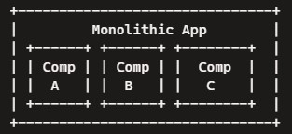

- How to handle Database Migrations

Database migrations involve changing the database schema as the application evolves. Here are some best practices:

- Version Control: Keep track of database schema changes using version control tools.
- Automated Migrations: Use migration tools like Flyway or Liquibase to automate the migration process.
- Backward Compatibility: Ensure changes are backward compatible to prevent breaking existing functionality.
- Testing: Test migrations in staging environments before applying them to production.
- Rollback Mechanisms: Have mechanisms in place to roll back changes if something goes wrong.

- Explain in detail about Microservices Architecture with a neat diagram

Microservices Architecture is an architectural style that structures an application as a collection of small, loosely coupled, and independently deployable services. Key characteristics include:

- Independently Deployable: Each service can be developed, deployed, and scaled independently.
- Decentralized Data Management: Each microservice manages its own database.
- Inter-Service Communication: Services communicate over lightweight protocols like HTTP/REST or messaging queues.

Example Diagram:
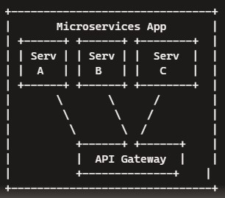

- Discuss about Resilience in DevOps

Resilience in DevOps refers to the ability of systems to handle and recover from failures gracefully. Key practices include:

- Fault Tolerance: Designing systems to continue operating despite failures (e.g., using redundancy).
- Automated Recovery: Implementing automated recovery mechanisms, such as auto- scaling and self-healing.
- Monitoring and Alerts: Continuously monitoring system health and performance, with alerts for anomalies.
- Chaos Engineering: Intentionally introducing failures to test system resilience and improve recovery strategies (e.g., using tools like Chaos Monkey).

Essay Type Questions:

- Discuss the impact of DevOps on achieving business agility and provide examples of companies that have adopted DevOps for faster software delivery and increased customer responsiveness.
- Explore continuous testing in DevOps, its contribution to software quality, and the challenges and benefits of implementing it.
- Explain the influence of DevOps on software architecture, focusing on factors like modularity, separation of concerns, and database migrations.
- Compare monolithic and microservices architectures in the context of DevOps, discussing their advantages and disadvantages and providing real-world examples.
- Discuss how DevOps ensures the resilience and robustness of software systems and provide examples of organizations using DevOps for building resilient architectures.
- Explain the concept of separation of concerns in software architecture and provide real-world examples of its implementation.
- Explore the challenges and best practices for handling database migrations in DevOps and discuss available tools.
- Investigate the relationship between software architecture and DevOps, focusing on how a well-designed architecture supports DevOps principles.
- Discuss the impact of DevOps on software quality and reliability, providing examples of improvements achieved through DevOps practices.
- Analyze the challenges and benefits of implementing microservices in the data tier, considering the alignment with DevOps principles and implications for data management, scalability, and maintenance.

UNIT 3

Short Answer Questions:

- What is the need of Source Code Control?
- In DevOps, how is Source Code Management useful for different roles?
- Explain the migrations of different Source Code Management Systems?
- Write short notes on Shared Authentication?
- Explain in detail about Hosted Git Servers?
- Write short notes on Dekker's Algorithm?
- Discuss the Pull Request Model?
- Explain in detail about GitLab?

- What is the need of Source Code Control?
Source Code Control (also known as Version Control) is essential for managing changes to source code over time. Here are the key reasons for its necessity:

  - Collaboration: Multiple developers can work on the same project simultaneously without overwriting each other's changes.
  - History Tracking: Keeps a detailed history of changes, allowing developers to revert to previous versions if needed.
  - Backup and Recovery: Provides a backup of the codebase, ensuring that code can be recovered in case of data loss.
  - Branching and Merging: Allows developers to work on different features or fixes in isolation (branches) and merge them back into the main codebase.
  - Accountability: Tracks who made specific changes and why, enhancing transparency and accountability.

- In DevOps, how is Source Code Management useful for different roles?
Source Code Management (SCM) is crucial in DevOps for various roles:

  - Developers: Use SCM to manage code changes, collaborate with team members, and maintain code quality through versioning and branching.
  - Testers: Access different branches to test new features or bug fixes in isolated environments.
  - Operations: Use SCM to manage infrastructure as code, ensuring that configuration changes are versioned and auditable.
  - Project Managers: Monitor progress, track changes, and ensure that development aligns with project goals.
  - Release Managers: Manage releases by merging branches, resolving conflicts, and deploying code to production environments.

- Explain the migrations of different Source Code Management Systems?
Migrating between SCM systems involves several steps:
  - Assessment: Evaluate the current system and identify the target system's requirements and capabilities.
  - Planning: Plan the migration process, including timelines, resources, and impact on development.
  - Data Export: Export data from the current SCM system, including repository history, branches, and tags.

  - Data Import: Import the data into the target SCM system, ensuring that history and metadata are preserved.
  - Validation: Validate the migration by comparing the data in both systems and conducting thorough testing.
  - Training: Provide training and documentation to help team members transition to the new system.

- Write short notes on Shared Authentication?
Shared Authentication refers to a method where multiple systems or services share a common authentication mechanism. Key points include:

  - Single Sign-On (SSO): Users can log in once and access multiple systems without re- entering credentials.
  - Centralized Management: Authentication is managed centrally, simplifying user management and access control.
  - Security: Enhances security by reducing the number of credentials users need to manage and minimizing the risk of password-related issues.
  - Interoperability: Enables different systems to work together seamlessly by using standardized authentication protocols (e.g., OAuth, SAML).

- Explain in detail about Hosted Git Servers?
Hosted Git Servers are platforms that provide Git repository hosting and related services. Here are the key features and benefits:

  - Repository Management: Create, manage, and collaborate on Git repositories in a centralized location.
  - Web Interface: Provides a user-friendly web interface for viewing code, managing repositories, and performing Git operations.
  - Access Control: Control access to repositories with fine-grained permissions and authentication mechanisms.
  - Collaboration Tools: Includes features like pull requests, code reviews, issue tracking, and wikis to facilitate collaboration.
  - Continuous Integration/Delivery (CI/CD): Integrate with CI/CD pipelines to automate builds, tests, and deployments.
  - Popular Hosted Git Servers: GitHub, GitLab, Bitbucket, and Azure Repos.

- Write short notes on Dekker's Algorithm?
Dekker's Algorithm is a mutual exclusion algorithm used in concurrent programming to avoid race conditions. Key points include:

  - Mutual Exclusion: Ensures that only one process accesses a critical section at a time, preventing race conditions.
  - Busy Waiting: Uses busy waiting (spinning) to wait for access to the critical section.
  - Flags and Turn Variables: Utilizes flags to indicate the intent to enter the critical section and a turn variable to manage access.
  - Historical Importance: One of the earliest solutions to the mutual exclusion problem in operating systems.

- Discuss the Pull Request Model?
The Pull Request (PR) Model is a workflow for contributing code changes in Git. Here's how it works:

  - Feature Branch: A developer creates a feature branch for their changes.
  - Commit Changes: The developer commits their changes to the feature branch.
  - Create Pull Request: The developer creates a pull request to merge the feature branch into the main branch.
  - Code Review: Team members review the code, provide feedback, and suggest improvements.
  - Merge: Once the code is approved, the pull request is merged into the main branch, incorporating the changes.
  - Benefits: Encourages code review, collaboration, and quality control, ensuring that only vetted changes are integrated into the codebase.

- Explain in detail about GitLab?
GitLab is a web-based DevOps platform that provides Git repository hosting and a comprehensive suite of tools for software development, integration, and delivery. Key features include:

  - Repository Management: Create, manage, and collaborate on Git repositories.
  - CI/CD Pipelines: Built-in CI/CD pipelines for automating builds, tests, and deployments.
  - Issue Tracking: Integrated issue tracking system for managing project tasks and bugs.
  - Merge Requests: Facilitates code reviews and collaboration through merge requests (similar to pull requests).
  - Container Registry: Built-in container registry for managing Docker images.
  - Security: Advanced security features like static and dynamic application security testing (SAST/DAST), dependency scanning, and container scanning.
  - Integration: Supports integration with various third-party tools and services, enhancing its capabilities.
  - Open Source and Enterprise: Available in both open-source and enterprise editions, catering to different needs and scales.

Essay Type Questions:

- Explain the significance of source code control in project management, its history, and its role in version control and collaboration.
- Discuss the roles of developers, testers, and release managers in source code management and how collaboration among them leads to project success.
- Explore source code management systems, their importance, key features, and how they enable efficient code management and version control.
- Investigate challenges and best practices for source code migrations, with examples of successful strategies.
- Discuss shared authentication for accessing source code repositories, its implementation, benefits, and associated risks.
- Compare hosted Git servers like GitHub, GitLab, and Bitbucket, discussing their features, advantages, and limitations.

- Explore different Git server implementations (self-hosted, cloud-based, enterprise solutions) and factors to consider when choosing one.
- Analyze Docker's role in source code management, its benefits for creating, packaging, and deploying software applications.
- Discuss Gerrit as a code review and collaboration tool, its features, and examples of successful implementation.

UNIT 4
Short Answer Questions:

- List out the different Build Systems available today?
- How to use Jenkins Build Server to create builds?
- Discuss about Build Slaves?
- Write short notes on Triggers?
- Explain in detail about Job Chaining and Build Pipelines?
- How to create builds by Dependency Order?

- List out the different Build Systems available today?
There are several popular build systems used in software development today:

  - Jenkins: An open-source automation server with a vast ecosystem of plugins for continuous integration and delivery.
  - Apache Maven: A build automation tool primarily used for Java projects, emphasizing dependency management.
  - Gradle: A flexible build automation tool that supports multiple languages and integrates well with other tools.
  - TeamCity: A commercial CI/CD server from JetBrains, known for its powerful build management features.
  - Travis CI: A cloud-based CI service used to build and test software projects hosted on GitHub.
  - CircleCI: A CI/CD platform that automates the software development process, with support for Docker.
  - Bamboo: A CI/CD server from Atlassian, designed to work seamlessly with JIRA and Bitbucket.
  - GitLab CI/CD: An integrated CI/CD system within GitLab that automates the building, testing, and deployment of code.
  - Azure DevOps Pipelines: Part of Azure DevOps Services, providing build and release management for cloud and on-premises solutions.
  - GitHub Actions: A CI/CD service that allows developers to automate workflows directly within GitHub repositories.

- How to use Jenkins Build Server to create builds?
To create builds using Jenkins Build Server, follow these steps:

- Install Jenkins: Download and install Jenkins on your server or use a cloud-based version.
- Set Up Jenkins: Configure Jenkins, including installing necessary plugins (e.g., Git plugin, Maven plugin).

- Create a New Job: In the Jenkins dashboard, click "New Item" to create a new job and choose the type of job (e.g., Freestyle project, Pipeline).
- Configure Source Code Management: Specify the repository URL (e.g., Git, SVN) and credentials for Jenkins to access the source code.
- Set Build Triggers: Define build triggers (e.g., Poll SCM, Git hooks) to automate the build process when code changes are detected.
- Define Build Steps: Add build steps to compile code, run tests, and package artifacts (e.g., using Maven, Gradle, or custom scripts).
- Post-build Actions: Specify post-build actions like archiving artifacts, sending notifications, or deploying code.
- Save and Run: Save the job configuration and run the build. Jenkins will execute the defined steps and provide build results.

- Discuss about Build Slaves?
Build Slaves (also known as Build Agents) are nodes in a Jenkins build environment that perform the actual build work. Here’s how they work:

  - Master-Slave Architecture: Jenkins operates in a master-slave architecture, where the master schedules build jobs and distributes them to slaves for execution.
  - Scalability: Using build slaves allows Jenkins to distribute build tasks across multiple nodes, improving scalability and performance.
  - Isolation: Slaves can be configured with specific environments, dependencies, and tools required for different builds.
  - Configuration: Slaves can be configured on different operating systems, virtual machines, or containers, providing flexibility in the build environment.
  - Communication: The master communicates with slaves through various protocols (e.g., SSH, JNLP) to manage build tasks.

- Write short notes on Triggers?
Triggers in build automation are mechanisms that initiate a build process based on specific events or conditions. Key points include:

  - Poll SCM: Periodically checks the source code repository for changes and triggers a build if changes are detected.
  - Webhook Triggers: Uses webhooks to automatically trigger builds when code changes are pushed to the repository.
  - Schedule Triggers: Configures builds to run at specified intervals (e.g., daily, weekly) using cron-like syntax.
  - Manual Triggers: Allows users to manually trigger builds from the Jenkins dashboard or command line.
  - Upstream/Downstream Triggers: Triggers builds based on the completion of other jobs, creating a chain of dependent builds.

- Explain in detail about Job Chaining and Build Pipelines?
Job Chaining and Build Pipelines in Jenkins are used to automate complex build processes by linking multiple jobs together. Here’s how they work:

  - Job Chaining: Configures a series of dependent jobs, where the completion of one job triggers the next job in the chain. This is useful for tasks like compiling code, running tests, and deploying artifacts in sequence.

  - Build Pipelines: Represents a series of automated steps that code goes through from development to production. Pipelines are defined using the Jenkinsfile, a script that outlines the stages, steps, and conditions for each part of the process.
  - Stages and Steps: Pipelines are divided into stages (e.g., Build, Test, Deploy), each containing a series of steps (e.g., shell commands, scripts).
  - Visualization: Jenkins provides visualizations of the pipeline, showing the progress and status of each stage, helping teams monitor and troubleshoot the build process.

Example Jenkins file:
groovy pipeline
{
agent any stages
{
stage('Build')
{
steps
{ sh 'make build' }
}
stage('Test')
{
steps
{ sh 'make test' }

}
stage('Deploy')
{ steps { sh 'make deploy' } } } }
- How to create builds by Dependency Order?
Creating builds by dependency order involves ensuring that builds are executed in the correct sequence based on their dependencies. Here’s how to achieve this:

- Identify Dependencies: Determine the dependencies between different components or modules in the project.
- Define Job Order: Configure jobs in Jenkins to respect the dependency order, ensuring that dependent jobs are triggered after their prerequisites.
- Use Upstream/Downstream Jobs: Configure upstream and downstream job relationships in Jenkins to manage build order. Upstream jobs are prerequisites for downstream jobs.
- Use Pipeline Syntax: Define the build order within a Jenkins pipeline using stages and steps, ensuring that stages are executed in the correct sequence.
- Conditional Execution: Use conditional statements in the pipeline to handle build dependencies dynamically.

Example:

groovy pipeline
{
agent any stages

{
stage('Build Library')
{
steps
{
sh 'make build-library'
}
}
stage('Build Application')
{
steps
{
sh 'make build-application'
}
}
stage('Test Application')
{
steps
{
sh 'make test-application'
}
}
}
}

This setup ensures that the library is built before the application and the application is tested after the build.

Essay Type Questions:

- Discuss the role of build systems in DevOps, their key components, and how they automate the software build process. Provide examples of popular build systems.
- Explore the features and capabilities of the Jenkins build server, its role in continuous integration and delivery, and the benefits and challenges of using Jenkins in DevOps.
- Explain the importance of managing build dependencies in software development, common challenges, and effective strategies using build automation tools.
- Discuss the significance of Jenkins plugins in extending its functionality for tasks like code analysis, testing, and deployment. Provide examples of popular Jenkins plugins.
- Analyze the importance of file system layout in build server configurations, its impact on the build process and artifact management, and best practices for designing an efficient layout.
- Explain the concept of build slaves in Jenkins, their role in distributed build execution, scalability, and performance improvement. Discuss strategies for configuring and managing build slaves effectively.
- Investigate triggers in build automation, the types available in Jenkins, and how they initiate the build process based on various scenarios.
- Explore job chaining and build pipelines in Jenkins, their role in automating complex build processes and deployment workflows, and the benefits of using them. Provide examples of successful implementations.
- Discuss infrastructure as code (IaC) in the context of build servers, its facilitation of provisioning, configuration, and management. Explain the advantages of using IaC tools for build server infrastructure.

- Compare alternative build servers like Bamboo, TeamCity, and CircleCI with Jenkins, discussing their features, advantages, limitations, and recommendations for choosing the appropriate one.
- Discuss the importance of collecting and analyzing quality metrics during the build process, such as code coverage, static code analysis, and test results. Explain how integrating quality measures enhances software quality and continuous improvement in DevOps.

UNIT 5
Short Answer Questions:

- What are the Pros and Cons of Automated Testing?
- Write short notes on Selenium? List out the features of it?
- Discuss about JavaScript Testing?
- Differentiate Test-driven development from REPL-driven development?
- Write short notes on:
  - i) Puppet
  - ii) Chef
  - iii) Ansible
  - iv) SaltStack

- What are the Pros and Cons of Automated Testing?
Pros:

  - Speed and Efficiency: Automated tests run faster than manual tests, allowing for quick feedback on code changes.
  - Consistency: Automated tests are less prone to human error and provide consistent results.
  - Reusability: Once written, automated tests can be reused across multiple projects and different environments.
  - Scalability: Automated testing can handle large volumes of tests that would be impractical to execute manually.
  - Cost-Effective in the Long Run: Although there is an initial investment in writing tests, automation reduces the cost of repeated testing.

Cons:

  - Initial Investment: Writing automated tests requires time and effort, which can be significant for large projects.
  - Maintenance: Automated tests need regular updates and maintenance to stay relevant with evolving code.
  - False Positives/Negatives: Automated tests can sometimes produce misleading results, requiring manual verification.
  - Lack of Human Insight: Automated tests may not catch certain issues that a human tester would, such as UI/UX problems or complex use cases.

- Write short notes on Selenium? List out the features of it?
Selenium: Selenium is an open-source framework used for automating web browsers. It supports multiple programming languages, including Java, C#, Python, and JavaScript, and can be integrated with various testing frameworks and CI/CD tools.

Features:

  - Cross-Browser Testing: Supports testing across different browsers like Chrome, Firefox, Safari, and Edge.
  - Cross-Platform Testing: Compatible with various operating systems, including Windows, macOS, and Linux.
  - Selenium WebDriver: Provides a programming interface to interact with web elements and simulate user actions.
  - Selenium Grid: Allows for parallel test execution on multiple machines, increasing testing efficiency.
  - Record and Playback: Selenium IDE offers a record and playback tool for creating test scripts without writing code.
  - Integration: Can be integrated with other tools like Maven, Jenkins, and TestNG for continuous testing and CI/CD pipelines.

- Discuss about JavaScript Testing?
JavaScript testing involves verifying the functionality and performance of JavaScript code using various testing frameworks and tools. Key aspects include:

  - Unit Testing: Focuses on testing individual functions or components in isolation. Popular frameworks include Jest, Mocha, and Jasmine.
  - Integration Testing: Tests how different parts of the application work together. Tools like Cypress and Protractor are commonly used.
  - End-to-End (E2E) Testing: Simulates user interactions with the entire application to ensure it works as expected from start to finish. Selenium and Cypress are popular choices.
  - Code Coverage: Measures the percentage of code executed during tests, helping identify untested parts of the codebase. Tools like Istanbul and Codecov provide coverage reports.
  - Automation: Automated JavaScript tests are often integrated into CI/CD pipelines to ensure code quality and reliability with every code change.

- Differentiate Test-driven development from REPL-driven development?
Test-driven Development (TDD):

  - Definition: TDD is a software development approach where tests are written before the actual code.
  - Process: Involves writing a failing test, writing the minimum code to pass the test, and then refactoring the code while keeping the test passing.
  - Benefits: Ensures code quality, encourages better design, and provides a safety net for refactoring.
  - Usage: Commonly used in Agile and DevOps practices for developing reliable and maintainable code.

REPL-driven Development (RDD):

  - Definition: RDD is a development approach where code is written and tested interactively in a Read-Eval-Print Loop (REPL) environment.
  - Process: Developers write small pieces of code, execute them immediately in the REPL, and see the results in real-time.
  - Benefits: Provides rapid feedback, allows for quick experimentation, and facilitates learning and debugging.
  - Usage: Often used in dynamic languages like Python, JavaScript, and Ruby for exploratory programming and quick prototyping.

- Write short notes on:
- Puppet: Puppet is an open-source configuration management tool that automates the provisioning, configuration, and management of infrastructure. It uses a declarative language to define system configurations and ensures that desired states are maintained across servers.

- Chef: Chef is a configuration management tool that automates infrastructure provisioning and application deployment. It uses a domain-specific language (DSL) based on Ruby to write "recipes" that define how systems should be configured.

- Ansible: Ansible is an open-source automation tool used for configuration management, application deployment, and task automation. It uses simple, human-readable YAML files called "playbooks" to define automation tasks and is agentless, relying on SSH for communication.

- SaltStack: SaltStack (Salt) is an open-source configuration management and orchestration tool. It uses a high-speed communication bus to manage and automate infrastructure tasks. Salt's configuration files, known as "states," are written in YAML and describe the desired state of systems.

Essay Type Questions:

  - Discuss the different types of testing in DevOps, their significance, and contributions to software quality. Provide examples of testing techniques and frameworks used.
  - Explore the benefits and challenges of test automation in software development, its impact on efficiency and accuracy, and best practices for implementing it in DevOps.
  - Explain the features and capabilities of Selenium as a popular testing tool, including web application testing. Discuss its advantages and limitations in a DevOps context.
  - Discuss the challenges and approaches for testing backend integration points in software applications. Provide examples of tools used in testing backend integrations in DevOps.
  - Explore test-driven development (TDD) and its role in ensuring code quality and test coverage. Discuss the principles, benefits, and challenges of implementing TDD in DevOps.
  - Discuss REPL-driven development and its benefits for iterative testing and rapid code prototyping. Explain how it aligns with DevOps principles and facilitates faster feedback loops.
  - Explore deployment systems and strategies in DevOps, including continuous deployment and delivery. Provide examples of popular deployment systems.
  - Discuss the role of virtualization stacks, including hypervisors and containerization platforms like Docker, in efficient and scalable application deployment. Explain their alignment with DevOps principles.

  - Explain the concept of client-side code execution in application deployment, its benefits, and challenges. Discuss considerations for deploying client-side code in a DevOps environment.
  - Compare and contrast deployment tools like Puppet, Ansible, Chef, Salt Stack, and Docker. Discuss their features, benefits, and use cases in automating deployment and infrastructure management in DevOps.

Assignment questions with mapping. Beyond the syllabus.
Self-learning syllabus. Tutorial hour documentation. Scheme of Evaluation.

